

**交管12123模拟**

C语言课程设计

**终**

**期**

**报**

**告**

**专业班级：自卓2201**

**小组成员：杨欣怡 U202215067**

**曹一迪 U202215160**

**指导老师：周纯杰、何顶新、彭刚、周凯波、桑农、**

**左峥嵘、高常鑫、汪国有、陈忠**

**上交时间：二〇二三年四月二十二日**

目录

[第一部分 前言 1](#_Toc1742)

[一 编写背景 1](#_Toc5645)

[二 编写目的 1](#_Toc10282)

[三 参考资料 2](#_Toc12727)

[四 参考软件 2](#_Toc5908)

[交管12123手机端 2](#_Toc23526)

[五 编者的话 2](#_Toc32225)

[第二部分 任务概述 3](#_Toc6411)

[一 目标功能 3](#_Toc3310)

[二 编写规范 6](#_Toc18195)

[第三部分 运行环境和配置 7](#_Toc25960)

[一 硬件接口 7](#_Toc14726)

[二 软件接口 7](#_Toc12169)

[三 控制 7](#_Toc14174)

[第四部分 需求分析与系统设计 7](#_Toc24438)

[一 需求分析 8](#_Toc28886)

[二 系统设计 11](#_Toc1641)

[第五部分 数据结构设计 25](#_Toc29835)

[数据结构设计 25](#_Toc14793)

[第六部分 界面设计 28](#_Toc9874)

[一 鼠标设计 28](#_Toc10331)

[二 界面流程设计 28](#_Toc4482)

[第七部分 函数声明及原型 30](#_Toc30138)

[第八部分 源代码 48](#_Toc26747)

[第九部分 时间安排 234](#_Toc30379)

# 前言

## 一 编写背景

“交管12123”是公安部官方互联网交通安全综合服务管理平台（以下简称互联网平台）的唯一手机客户端应用软件，由公安部交通管理科学研究所负责研发并提供技术支持。本软件服务对象为全国机动车车主、驾驶人等广大用户。

交管部门依托“交管12123”手机APP和互联网交通安全综合服务管理平台，在原有窗口及自助处理交通违法的基础上，推出非本人名下机动车在线绑定自助处理交通违法新举措。因该平台能够极大减少在交通违法处理窗口的等候时间和出行成本，北京市在3个多月的时间里，已有74万人成为该系统的新注册用户。

2018年8月29日，交管12123”手机APP交通违法自助处理功能进行了优化完善，包括扩大可备案非本人机动车范围、优化备案流程等，自助处理交通违法更为便捷。我们编写的程序将其几个主要功能进行了模拟性的实现。

## 二 编写目的

交管12123在商业化之前本身就是爱好者交流的论坛，是基于ACG爱好者“天下漫友是一家”的理念创立的。如今时光荏苒，山川不复对当年明月。但是这种共享互惠的互联网精神仍会在需要它的地方发挥它的作用。我们小组本着追忆互联网公司曾经的发展道路和体味互联网精神为目的，选择了本课题。

该项报告对于交管12123进行了全面的用户需求和功能分析。包括需求分析，系统功能设计，代码实现等等。本报告明确了本软件系统架构设计，软件结构与数据结构设计，各模块之间的接口和调用，系统界面设计，系统功能设计，具体算法设计以及整个软件的源代码。

同时，本报告也对两位同学的工作任务进行了详细的分工，有利于后期对于软件进行相关的调试与修改。

我们所编写的程序的受众是驾驶证考生和驾驶员等广大用户。

## 三 参考资料

1.王士元. C 高级实用程序设计. 北京: 清华大学出版社. 1996 年

2.周纯杰，何顶新等. 程序设计与应用（用 C/C++编程）北京: 机械工业出版社.2008年

3.[美] Prata. C Primer Plus（第六版）北京：人民邮电出版社. 2016 年

4.杨将新.C 语言开发全程指南，电子工业出版社.2008 年

## **四 参考软件**

交管12123手机端

## 五 编者的话

交管12123是一每一个考驾照人必备的软件，可以说是深受年轻人的欢迎。亲眼看着交通管理软件从原来的弱小、简陋，做到现在越来越好，网页也愈发精致，可以说这也是我们选择这个命题的一大原因。怀揣着对交通管理系统的好奇，又有对亲手用朴素的C语言模拟还原交管12123的挑战性。

交管12123的软件设计已经相当完善，充斥着繁杂的功能与动效。屏幕上所显示的每一个画面，都有着数十甚至上百个隐藏的与鼠标的动态交互或者超链接跳转，而在有限的时间内想用C语言在古老的Dos系统上，以孱弱的性能实现这一点，意味着必须写出高度模块化的代码，并且对程序作出相当程度的精简与优化。同时此代码会由两人共同编写完成，也就意味着函数之间应当有着较低的耦合性。

这些对于在此前毫无合作经验，且无图形化编程经验的我们来说，毫无疑问都是相当大的挑战。但是也并不意味着无法实现。通过对交管12123的模拟，想必也会令我们的代码能力得到进一步的提升，并且有着一段难忘的经历。

# 任务概述

## 一 目标功能

该交管12123模拟程序可以实现真正的交管12123软件中的几个主要功能，包括浏览器页面并行模拟，用户信息管理、功能分类和检索、新车登记和扣分记录和机动车检验预约等。用户可以在完成注册之后登录使用这些功能。

用户可以通过此程序对自己曾经的违规记录查询；也可以基于关键词、标签、分区等对自己想问的相关法规进行检索；还可以和其他用户共同对交规进行讨论。

1.用户信息与视频信息联动管理

2.页面并行

3.模块化的页面生成组织

4.提问检索功能

5.DOS单线程下的多线程使用体验模拟

12123APP是交管部门推出的一款用于驾驶证和车辆的软件，为交通参与者提供公安交管业务办理、预约、宣传，信息告知、查询等服务的“互联网+”[便民利民](https://www.zhihu.com/search?q=%E4%BE%BF%E6%B0%91%E5%88%A9%E6%B0%91&search_source=Entity&hybrid_search_source=Entity&hybrid_search_extra=%7b" \t "_blank)服务平台。个人可以通过交管12123办理新车[注册登记](https://www.zhihu.com/search?q=%E6%B3%A8%E5%86%8C%E7%99%BB%E8%AE%B0&search_source=Entity&hybrid_search_source=Entity&hybrid_search_extra=%7b" \t "_blank)预选号牌、补领[机动车号牌](https://www.zhihu.com/search?q=%E6%9C%BA%E5%8A%A8%E8%BD%A6%E5%8F%B7%E7%89%8C&search_source=Entity&hybrid_search_source=Entity&hybrid_search_extra=%7b" \t "_blank)、补领机动车行驶证、机动车检验预约、期满换证、电子监控处理、事故在线快速处理等业务。

手机交管12123APP的主要功能有：

机动车业务：新车注册登记预选号牌、补领机动车号牌、补领[机动车行驶证](https://www.zhihu.com/search?q=%E6%9C%BA%E5%8A%A8%E8%BD%A6%E8%A1%8C%E9%A9%B6%E8%AF%81&search_source=Entity&hybrid_search_source=Entity&hybrid_search_extra=%7b" \t "_blank)、机动车检验预约、变更机动车联系方式、换领机动车号牌、换领机动车行驶证、能源汽车换发号牌预约、[新能源汽车](https://www.zhihu.com/search?q=%E6%96%B0%E8%83%BD%E6%BA%90%E6%B1%BD%E8%BD%A6&search_source=Entity&hybrid_search_source=Entity&hybrid_search_extra=%7b" \t "_blank)换发号牌预选号牌、本地[二手车过户](https://www.zhihu.com/search?q=%E4%BA%8C%E6%89%8B%E8%BD%A6%E8%BF%87%E6%88%B7&search_source=Entity&hybrid_search_source=Entity&hybrid_search_extra=%7b" \t "_blank)预选号牌、异地转（迁）入预选号牌；

驾驶证业务：期满换证、遗失补证、延期换证、延期提交身体条件证明、变更驾驶证联系方式、延期审验、损毁换证、考试预约、取消考试预约、提交驾驶证照片、异地考试预约申请、优先考试预约、异地优先考试预约、考试费缴纳、、违法处理电子监控处理、缴纳罚款；

[事故处理](https://www.zhihu.com/search?q=%E4%BA%8B%E6%95%85%E5%A4%84%E7%90%86&search_source=Entity&hybrid_search_source=Entity&hybrid_search_extra=%7b" \t "_blank)：事故在线快速处理；

一键挪车：一键挪车；

用户[信息管理](https://www.zhihu.com/search?q=%E4%BF%A1%E6%81%AF%E7%AE%A1%E7%90%86&search_source=Entity&hybrid_search_source=Entity&hybrid_search_extra=%7b" \t "_blank)：备案非本人机动车、用户信息修改、修改用户[手机号](https://www.zhihu.com/search?q=%E6%89%8B%E6%9C%BA%E5%8F%B7&search_source=Entity&hybrid_search_source=Entity&hybrid_search_extra=%7b" \t "_blank)、用户注册、用户信息申诉、用户密码找回、绑定机动车、绑定驾驶证。

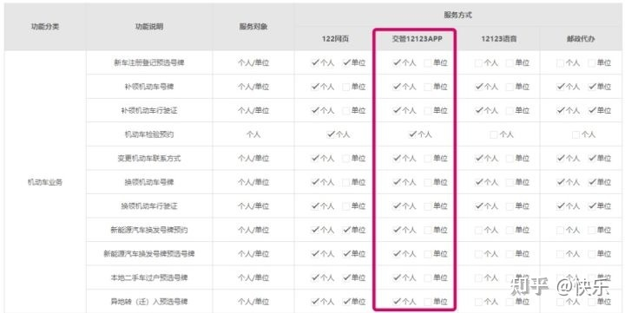

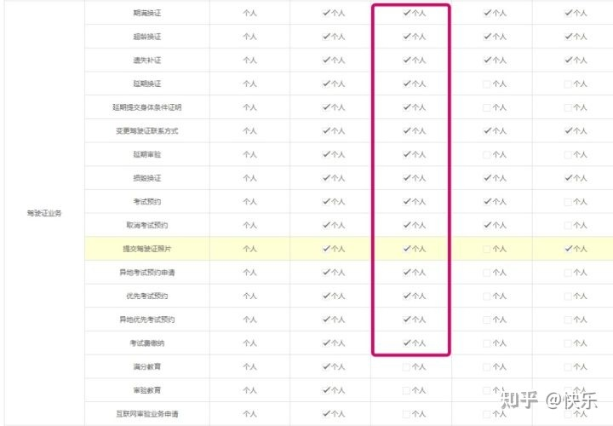

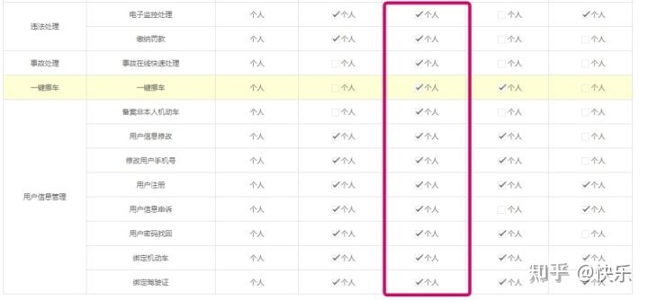

## 二 编写规范

**命名规范：**

变量命名，涉及用户以及视频信息的，应该尽量用英文或拼音表达其准确定义。其他类型变量名应给出详细注释以说明其主要功能。

函数命名应该用英文或拼音表达其确定含义

文件命名都用小写，并且表达出该文件所包含函数的主要功能。

涉及数据结构的命名应参考数据结构，并进行适当修改。

命名遵循一个名称中出现多个单词时，单词首字母大写或用\_连接的原则。

**函数设计规范：**

尽量拆分为小函数，已有功能尽量重复利用，提高模块化程度，降低函数耦合度。**注释规范:**

函数功能都要在函数原型后注明。

部分令测试者比较难以理解的算法和流程应该给出相应的注释。

# 运行环境和配置

## 一 硬件接口

处理器：Intel Pentium 166 MX 或以上。

硬盘：空间500MB 以上。

屏幕适配器：VGA 接口。

系统运行内存：要求32MB 以上。

## 二 软件接口

开发软件工具：Borland C++ 3.1

文字编辑工具：Visual Studio 2019 / Notepad++ / Dev C++

操作系统：DOS WINDOWS 9X/ME/2000/XP/WINDOWS 10

## 三 控制

该软件通过鼠标和键盘共同控制，键盘主要起在登陆注册及搜索时进行录入的作用，鼠标在移动时可以与可发生动态互动的部分发生互动，并且在点击对应功能模块时会触发相应功能。

# 需求分析与系统设计

## 一 需求分析

参考真正的交管12123手机端，我们为该交管12123模拟仿真项目做出了如下的功能需求分析：

1. 根据软件目标用户对于智能手机的高依赖度，我们需要设计基于手机号的用户账号注册和登录；
2. 为了使目标用户在使用本软件的过程中使用软件体验不断上升，我们需要设计基于用户的考证进程推出相应的功能
3. 根据目标用户对于问题所属下文字信息中具有特定关键词的信息检索，我们需要设计简单的搜索引擎功能；
4. 根据目标用户需要进行标准化输入的境况，我们需要设计大量基于鼠标输入的信息接口；
5. 根据防止机器人大量注册账号导致系统崩溃的需求，我们需要设计随机且不能在连续时间内的注册验证码；
6. 根据目标用户有可能忘记密码的需求，我们需要设计不仅基于密码而且可以基于手机短信的登录方式；
7. 根据目标用户有可能更改密码的需求，我们需要设计基于手机验证的密码更改机制；
8. 根据目标用户有可能第一次接触此类型网站的可能性这一需求，我们需要设计一系列简单美观的提示信息在用户注册和第一次登录时引导用户正确使用；
9. 根据让目标用户更简便地辨别显示页面的鼠标输入部分和键盘输入部分的需求，我们需要设计在不同分区显示不同形状的鼠标以及该分区对于鼠标操作的及时互动反馈；

将上述一系列需求分析分类汇总之后，我们得出如下总结：

经过分析后，将其主要功能模块划分为页面并行，相关页面绘制及其功能与用户信息和分数信息联动管理三大模块。页面并行主要是提供一个快捷索引的标签页，使得用户能够在各个已打开的页面中快速切换，并且保留各页面数据，模拟浏览器的形式，提供良好的界面交互。

页面主要分为主页和功能界面两部分以及每个页面中当有的精致的鼠标特效互动。

主页中应当包括对当前已有功能以及多个分区的详细推荐。真正的交管12123中细分了16种分区，模块数量繁多，功能丰富，但是经分析后可以发现其分区的推荐是按照一定的布局和算法逻辑模块化生成的，因此我们也将采用分区信息输入→函数生成，这样模块化的方式编写。精简代码，并提高可读性/可维护性。

此外还需要构建良好的用户数据信息库和视频信息库，能够让二者进行交互。比如用户查看计分与网办进度等，从而修改记录的相关数据。

一言以蔽之，该项目在以上需求下可分为如下所示的几个需求模块——

1. UI图形界面需求

此模块下我们需要设计能和用户友好交流的图形界面。具体来讲需要有能够通过视觉效果来给予用户按钮或视窗的功能示意的界面。例如：鼠标在按钮和输入框下不同的图形样式的切换、按钮和输入框对于鼠标信息输入的反馈、某些图形按键的形状图案对于其功能信息的提示以及对于不能以以上方式表达的提示予以必要的文字窗口的弹出说明与新手指引。

该模块的设计旨在满足对于不熟悉此类软件的用户进行温和的“训练”，使其能够愉悦地熟悉此类型软件的界面操作和信息输入，从而可以尽快地了解软件的架构，更好的享受软件对生活带来的便利。

1. 用户个人信息管理需求

此模块下我们需要设计基于每个用户id的对于特定用户操作信息的回溯和存储的功能。具体来讲我们需要设计基于手机号的用户注册功能和 登录功能，以及在此基础之上的密码等信息的修改，此外还有对于所浏览提问、违法处理功能的实现。此模块的设计要求我们满足用户的操作需求，给予用户足够的自由度来浏览计分，查看网板进度。丰富用户的软件使用体验，使软件对于用户的价值多元化、全面化、景观化、层次化。通过丰富的用户信息库的构建，使用户在软件中体验区别于物理世界的“生活”。

1. 计分记录与检索需求

此模块要求我们设计基于用户个人信息和软件固有常见问题分类架构的检索。具体来讲我们需要实现基于用户个人需求确定常见问题以及解答，给用户提供常见问题的解决方法

## 二 系统设计

**1.程序功能模块概述**

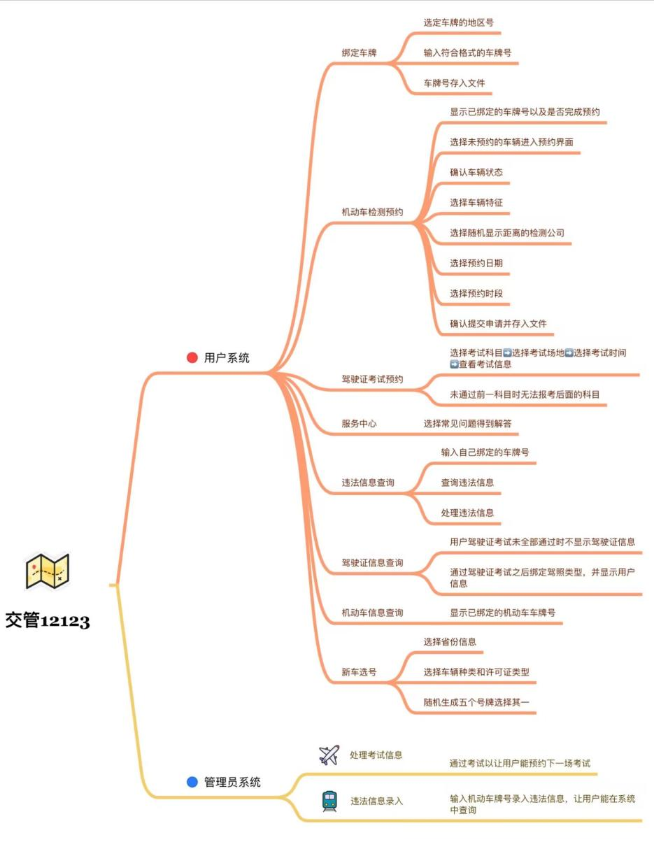

1. **界面绘制部分**

**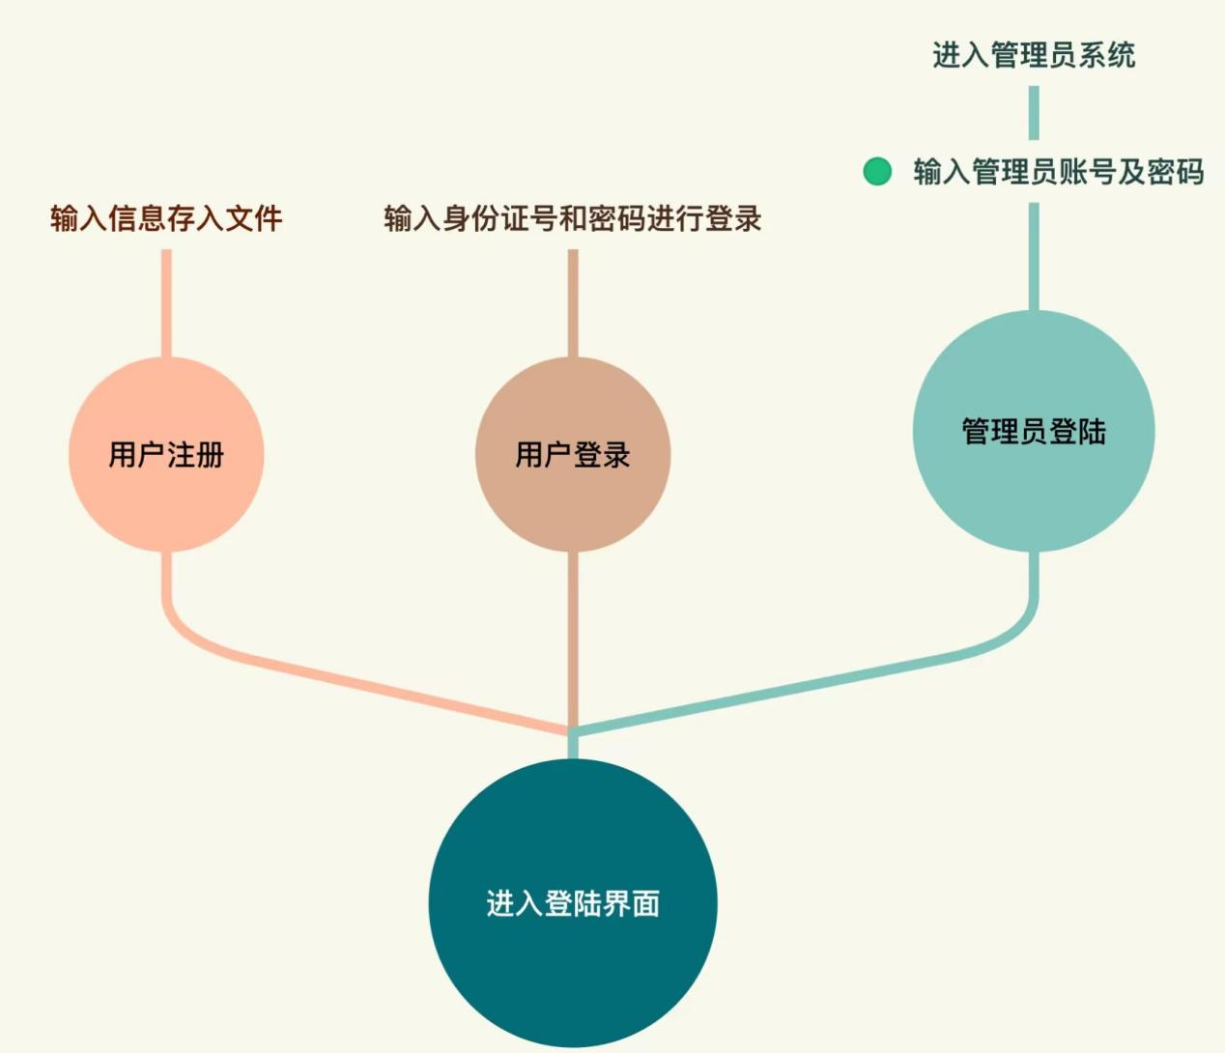**

交管12123模拟应当具有具备网站模拟功能，能够展示用户信息与驾驶证使用情况，大众常见问题的专业解答，车辆检查日期等信息

经过分析后，将其主要功能模块划分为页面并行，相关页面绘制及其功能与用户信息和视频信息联动式管理三大模块。页面并行主要是提供一个快捷索引的标签页，使得用户能够在各个已打开的页面中快速切换，并且保留各页面数据，模拟浏览器的形式，提供良好的界面交互。用户可以在登陆界面选择采用密码登录和短信登录两种模式，选择任意一种模式都是在本界面自由切换。

此外，新用户可以在登录界面的右下角选择注册，进入注册界面。

登录成功后会转入主页界面。

**（2）注册界面**



用户需在注册界面填入相应信息。

若信息格式均正确，则将信息录入到用户数据库中，否则会给出相应的提示信息。

注册成功后会自动跳入主页界面。

**（3）主页**

主页由八个部分模块构成。

首先显示出页头，包括机动车和驾驶证，从左到右依次显示两个方框。然后下部分是内容导航，能够在此快捷跳跃到各个分区。再下为内容展览。

再接下来的页面为模块化生成的分区块。可以单击换页键在各页间切换，分区为：服务中心，新车选号，考试预约，车牌绑定，违法查询，检测预约。页面布局为上半部分两个主要信息显示功能，下面六个软件主要功能。

1. **机动车信息界面**
2. **驾驶证界面**

**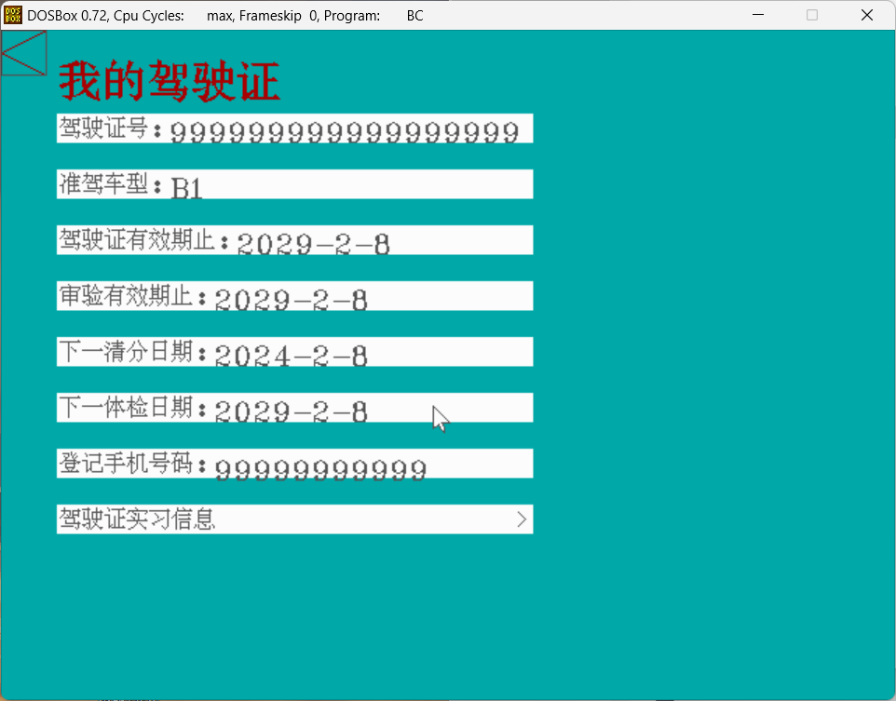**

**在用户完全通过考试之后即可选择驾驶证类型并在点击之后进入驾驶证信息显示界面，在此界面点击实习信息之后即可显示处于实习期间的信息**

**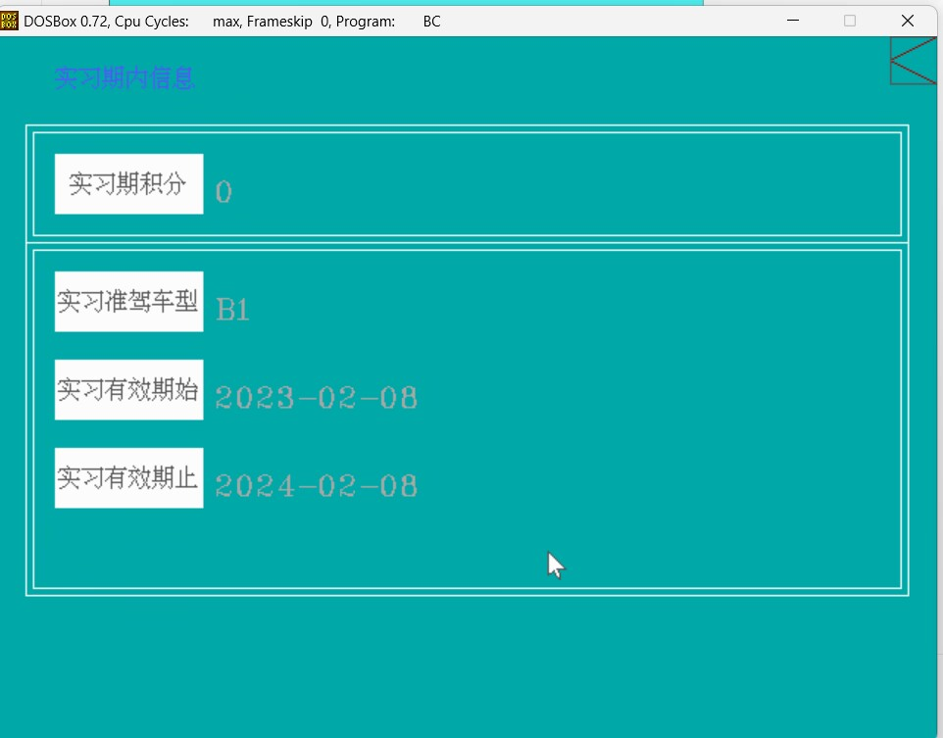**

1. **新车选号界面**

**进入新车选号功能之后，首先进行省市选择，确认之后在进入车辆信息确认及号牌种类选择界面**

**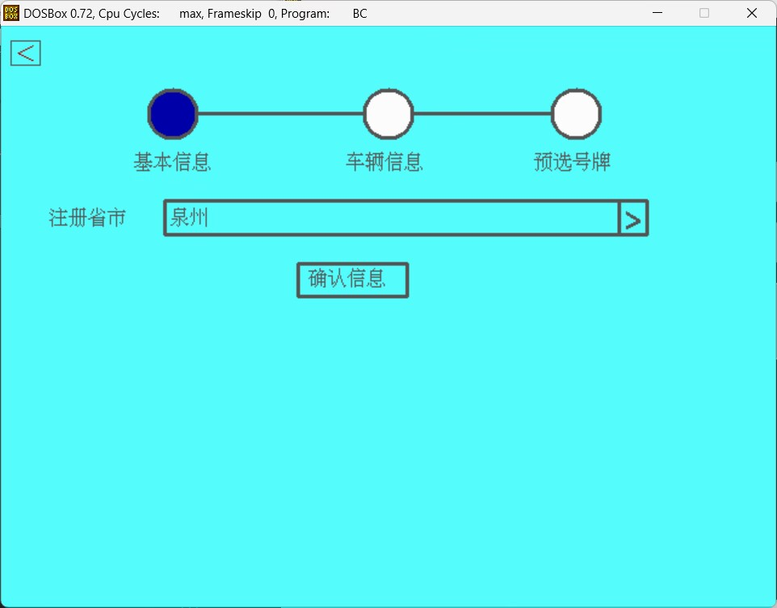**

**在以上界面进行注册省市的选择，点击确认信息进行下一步操作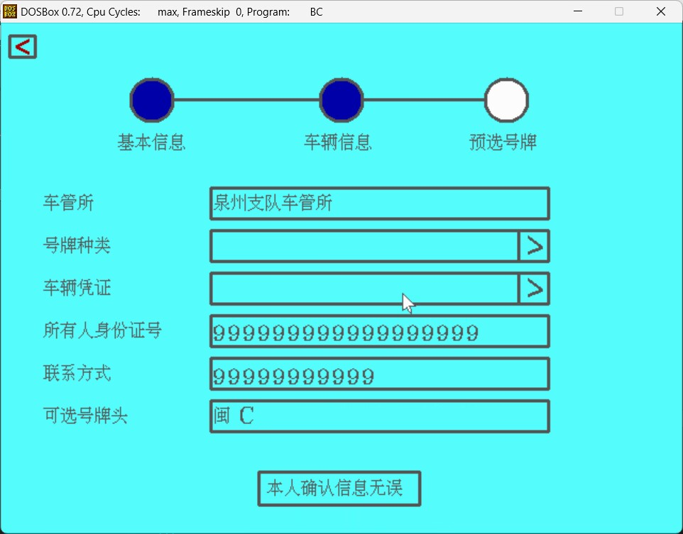**

**此界面将显示上一步选择的地区对应的车管所与用户信息，用户在此界面进行号牌种类和车辆凭证选择**

**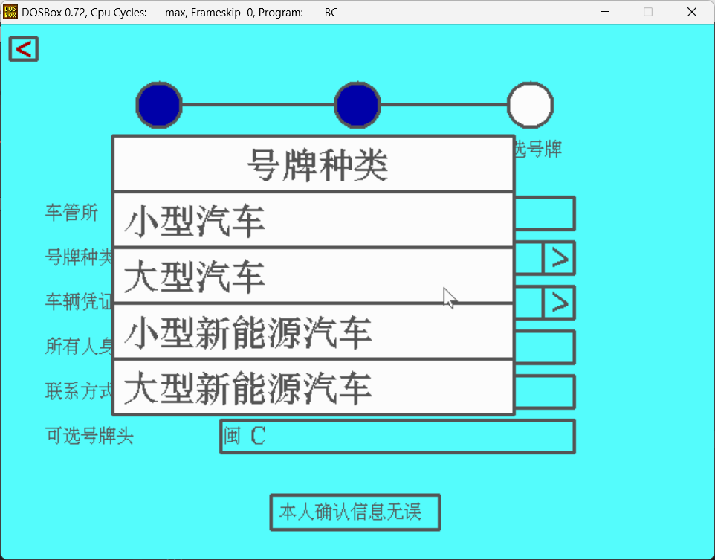**

**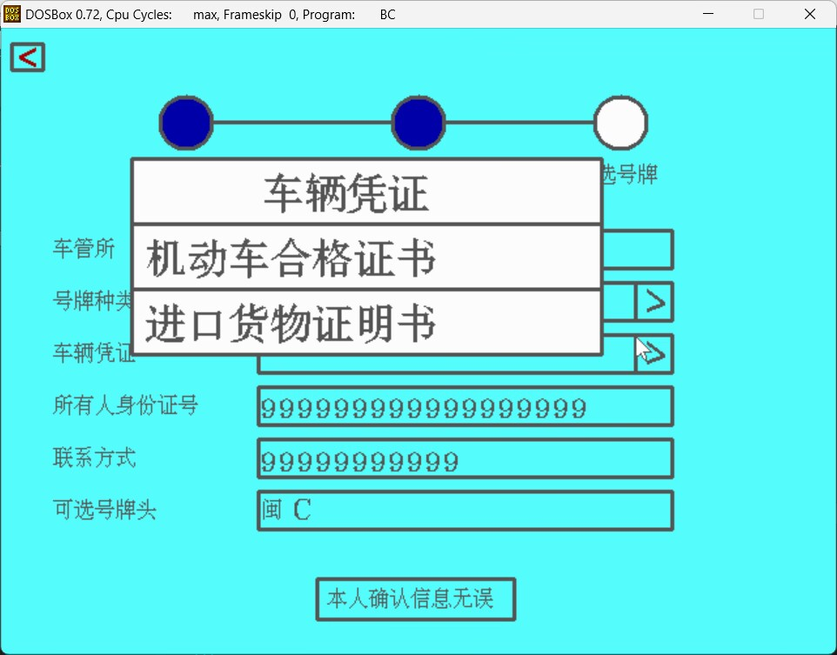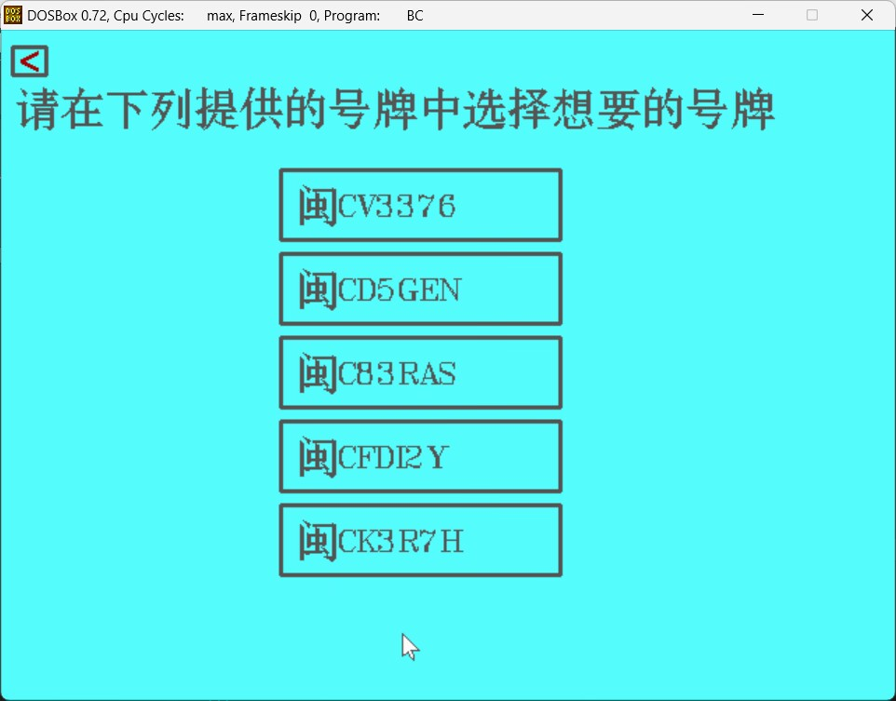**

**随后将根据所选地区随机生成五个号牌进行选择**

1. **考试预约界面**

**进入考试预约功能后首先进入科目选择界面，分为科一科二科三科四四块，下方用贴图的方式粘贴了小车图片**

**z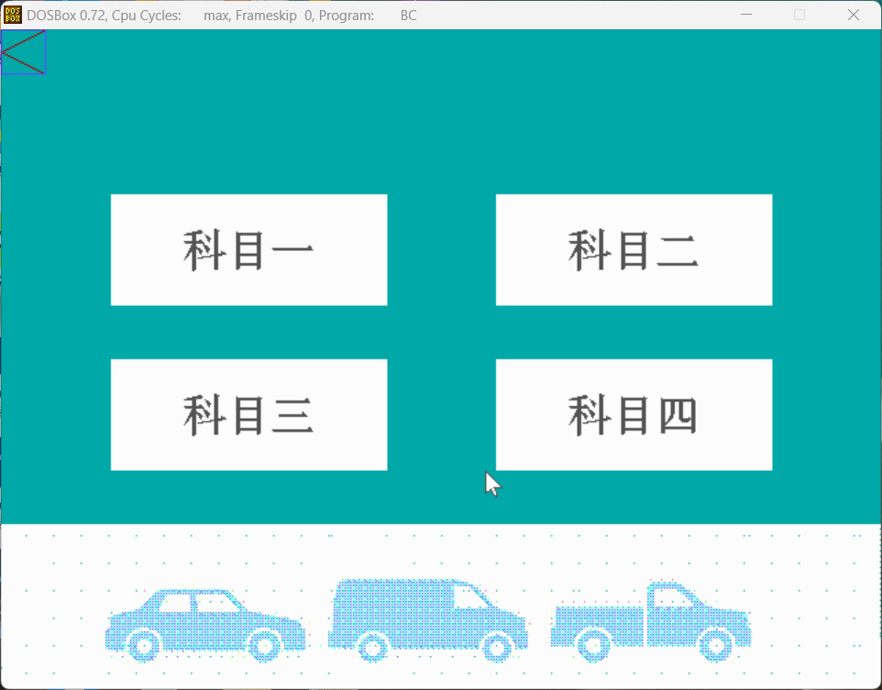**

**首次预约时，点击预约将进入选择考场时间界面，并进行选择**

**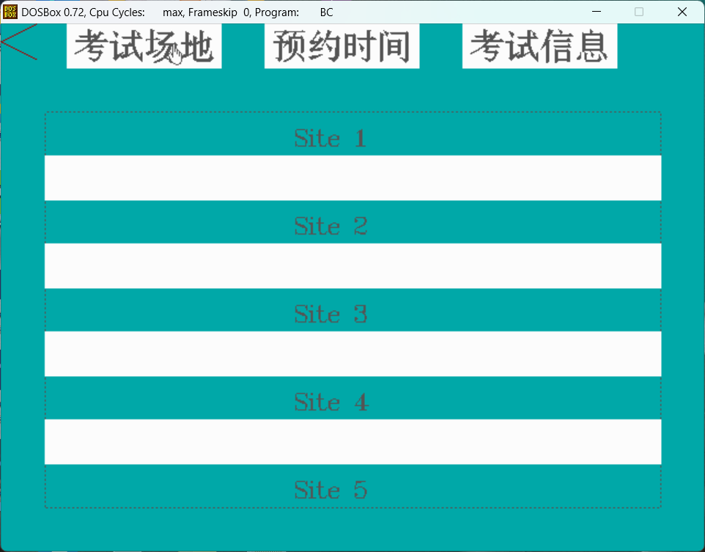**

**两项都进行了选择之后就会显示本科目的考试场地和考试时间信息，再次点进已选科目的时候就会直接显示考试信息，不会再次进行选择**

**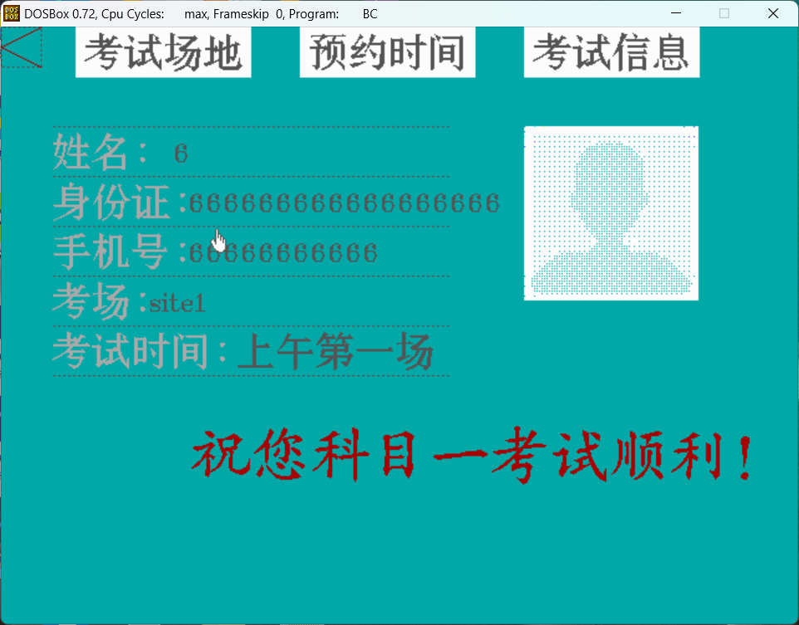**

**此外，如果前一科目不通过，将无法进行下一科考试的预约，并且显示上一科目未完成**

**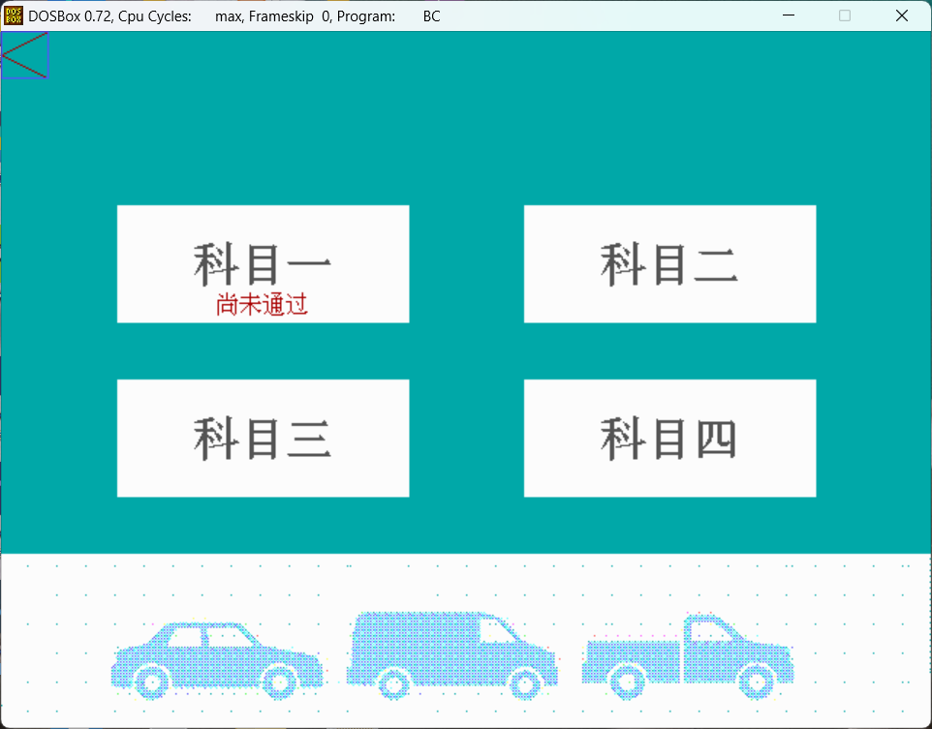**

1. **违章查询界面**

**该功能首先由管理员系统录入车辆违法信息，通过车牌对应车辆并进行信息录入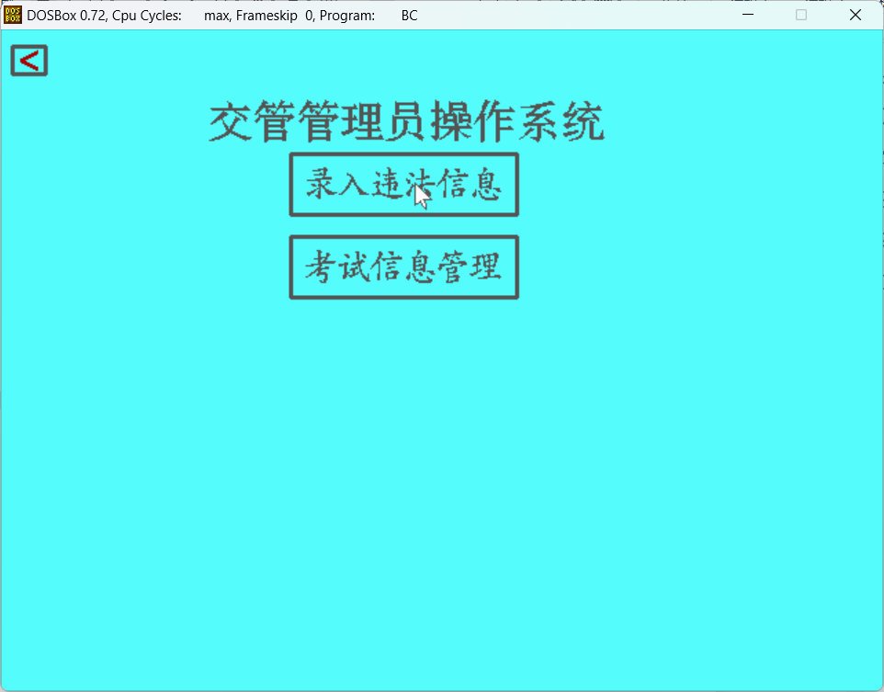**

**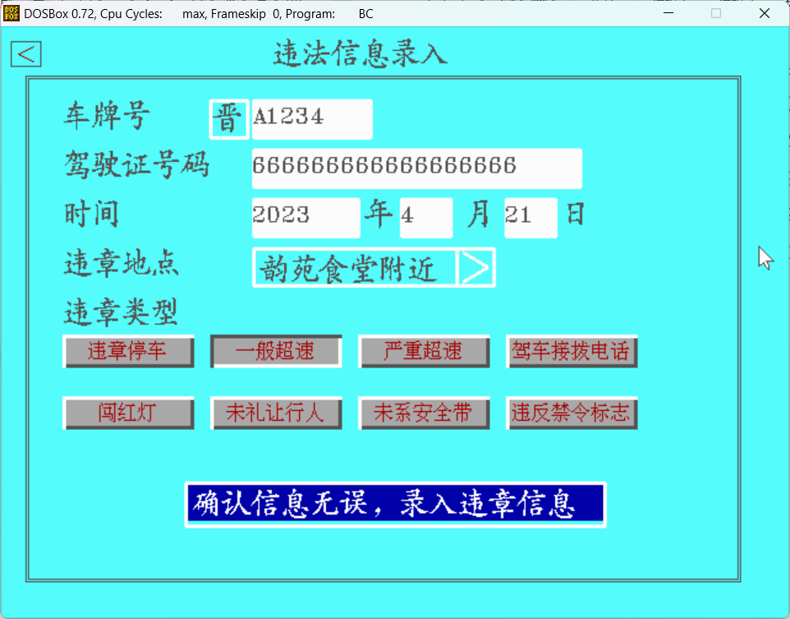**

1. **车辆绑定界面**

**分别选择车牌号的地区、号码、种类进行存储**

**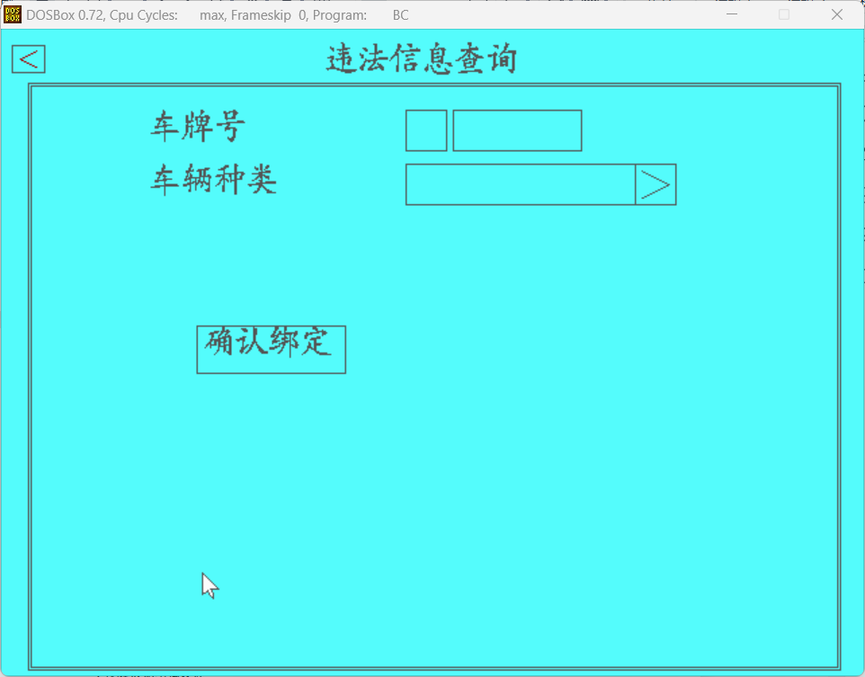**

1. **服务中心界面**

**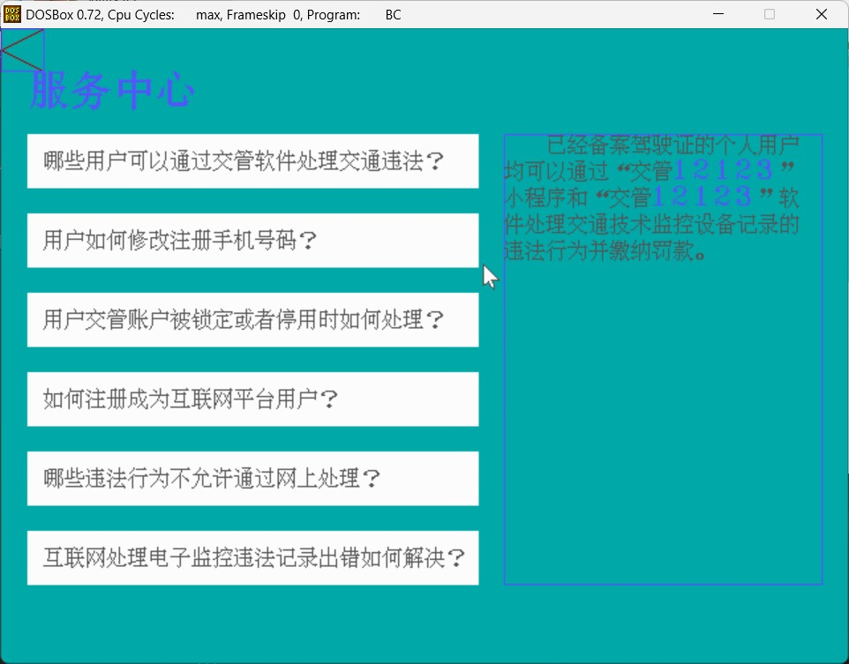**

**通过点击切换问题并显示答案，通过函数控制答案在对应区域内显示并且自动换行以及同时输出汉字与数字**

1. **检测预约界面**

**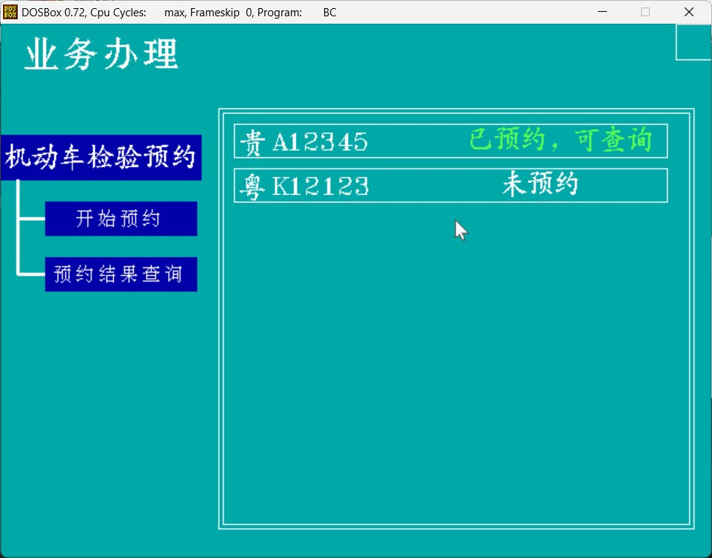**

**通过鼠标点击来选择想要检验预约的车辆**

**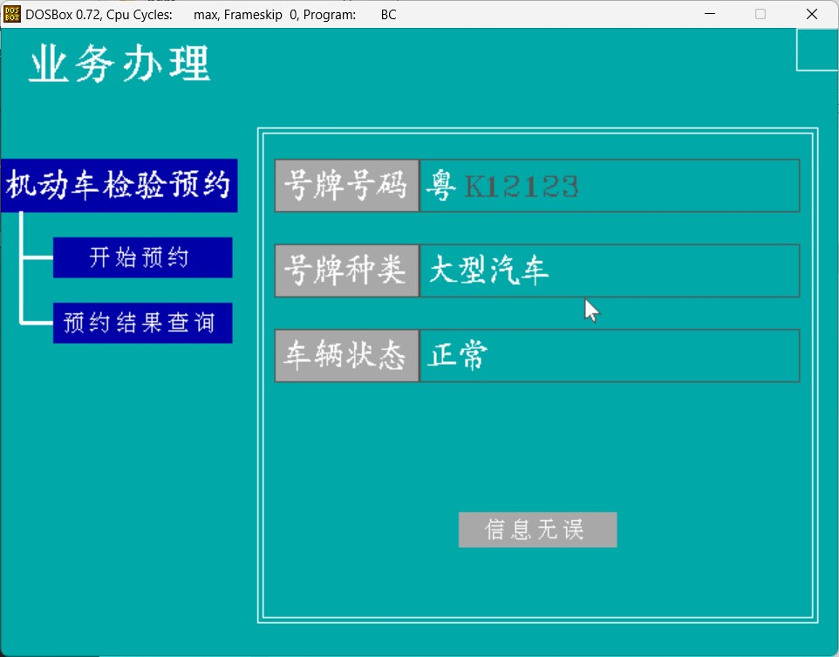**

**确认车辆信息无误**

**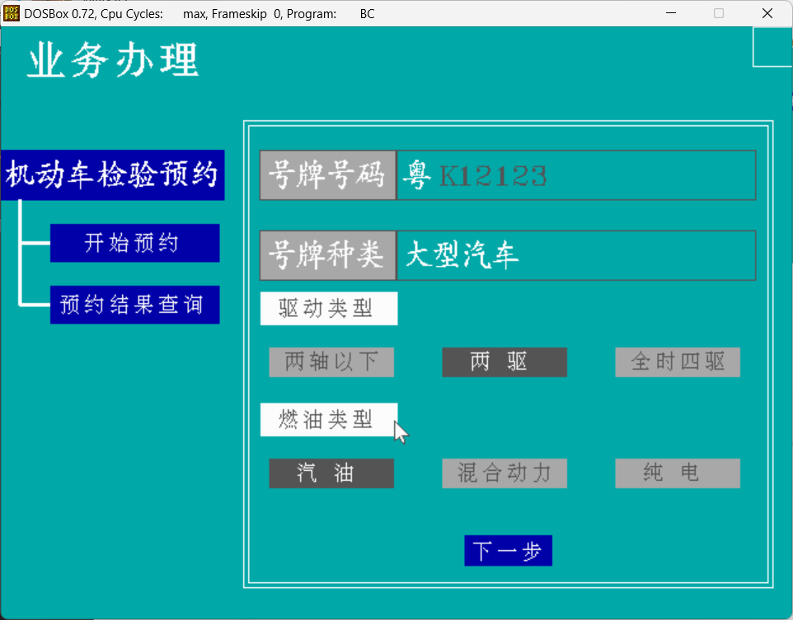**

**选择车辆驱动类型和燃油类型**

**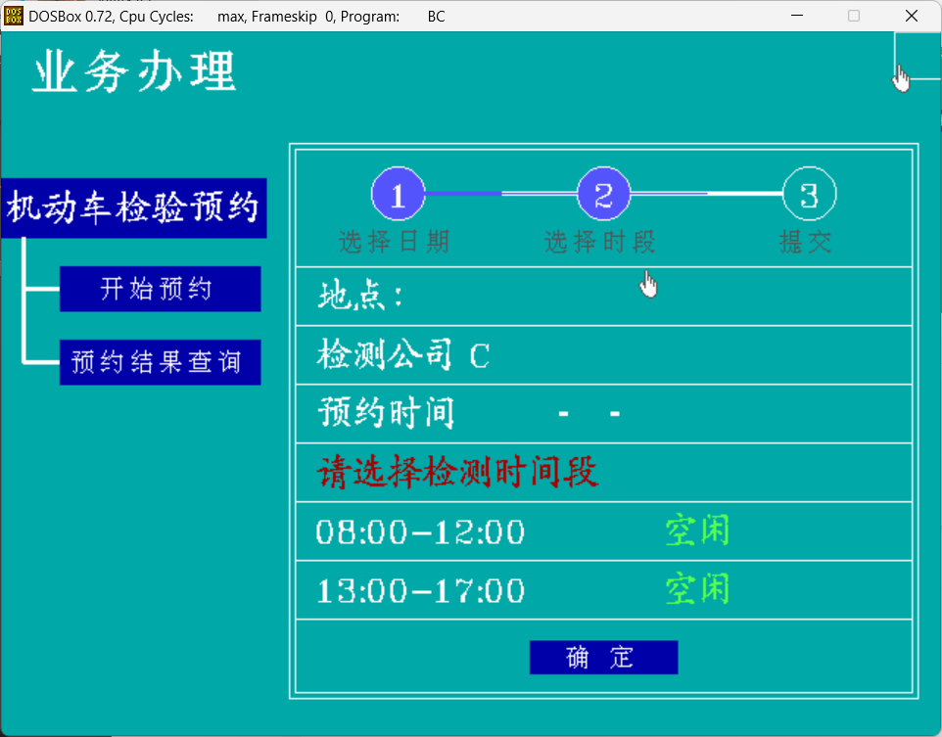**

**选择希望的检测时间段**

# 数据结构设计

## 数据结构设计

1. **用户违法信息**

**typedef struct {**

**char haopai[16];**

**char id[20];**

**char year[10];**

**char month[10];**

**char day[10];**

**char didian[26];**

**char leixing[20];**

**int koufen;**

**int fakuan;**

**char haopaitou[6];**

**char haopai1[8];**

**int zhuangtai;**

**}ACCIDENT;**

1. **车辆预约**

**Typedef struct**

**{char appoint[2];**

**char head[3];**

**char number[7];**

**char type[10];**

**char year[5];**

**char month[5];**

**char day[5];**

**}CAR\_CON;**

1. **用户车辆储存**

**typedef struct{**

**char haopaitou[5];**

**char haopai1[8];**

**char haopai[10];**

**char zhonglei[10];**

**}CAR;**

1. **存入文件的用户车辆储存**

**typedef struct{**

**char haopaitou[5];**

**char haopai1[8];**

**char haopai[10];**

**char zhonglei[10];**

**}CAR;**

1. **用户登录信息**

**struct U{**

**char id[20];**

**char name[10];**

**char phone[15];**

**char password[15];**

**};**

1. **车辆违法信息显示（用于链表）**

**typedef struct weifa{**

**ACCIDENT illegal;**

**struct weifa \*next;**

**}ILLEGAL\_NODE;**

**7.** **struct xuanhao{**

**char province[20];**

**char city[20];**

**char haopaitou1[5];**

**char haopaitou2[5];**

**char haopaitou[10];**

**char zhonglei[30];**

**char pingzheng[30];**

**char haopai[15];**

**};车辆选号时用户信息结构体**

# 界面设计

## 一 鼠标设计

一开始采用黄子昊学长修改后的一版调用中断的鼠标，而后在上机时发现，纯粹调用0x33号中断的鼠标，在真正的dos下只能保证功能正常，鼠标界面无法正常绘制。

于是结合邓述民学长的鼠标，对二者进行了结合重制。使用邓述民学长的逻辑进行绘制，同时使用IMouse内的功能函数。

## 二 界面流程设计

1. 车辆检测预约功能

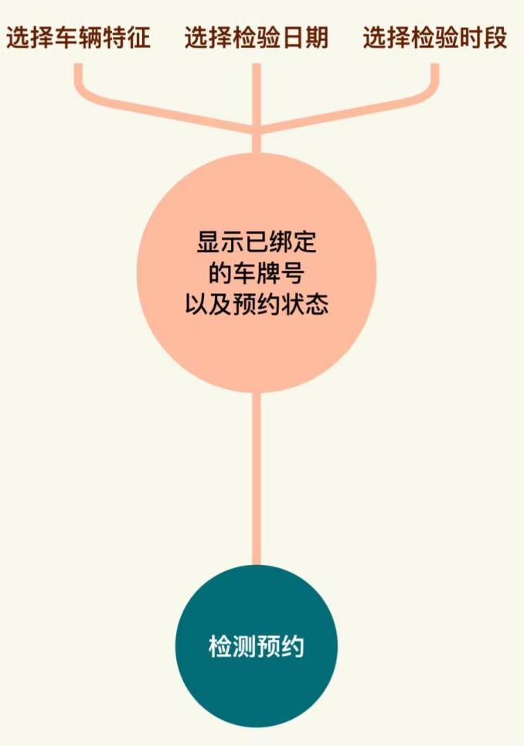

1. 违章查询功能

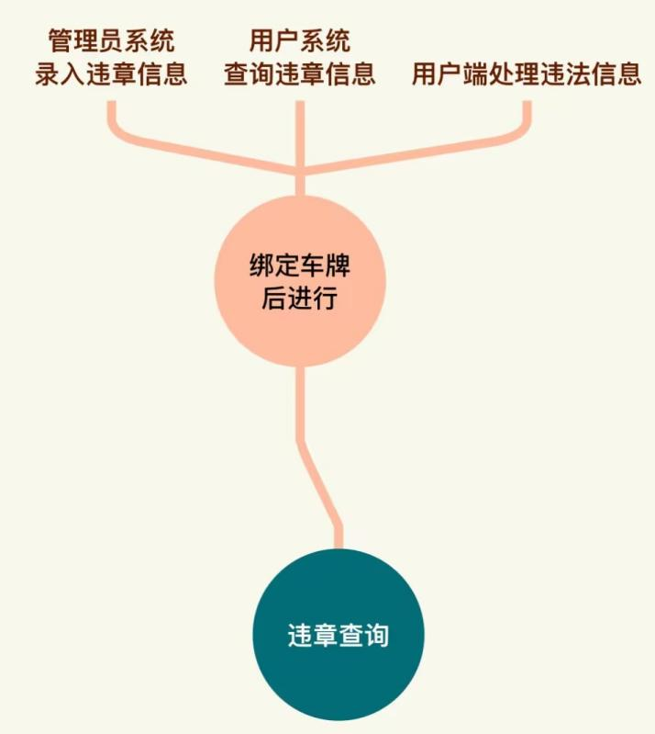

1. 考试预约功能

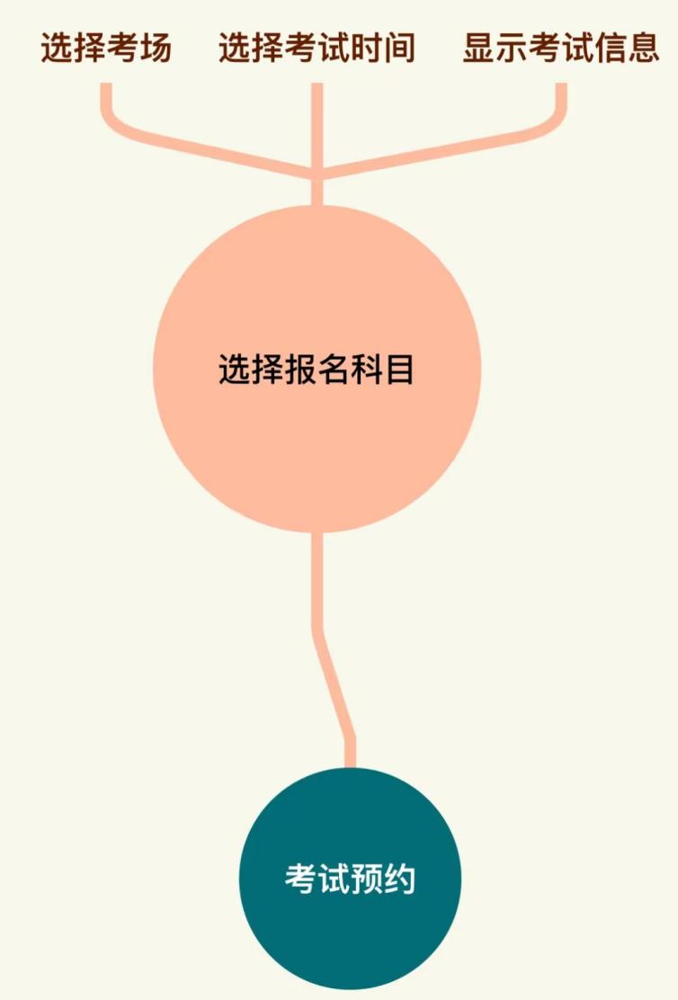

1. 新车选号功能

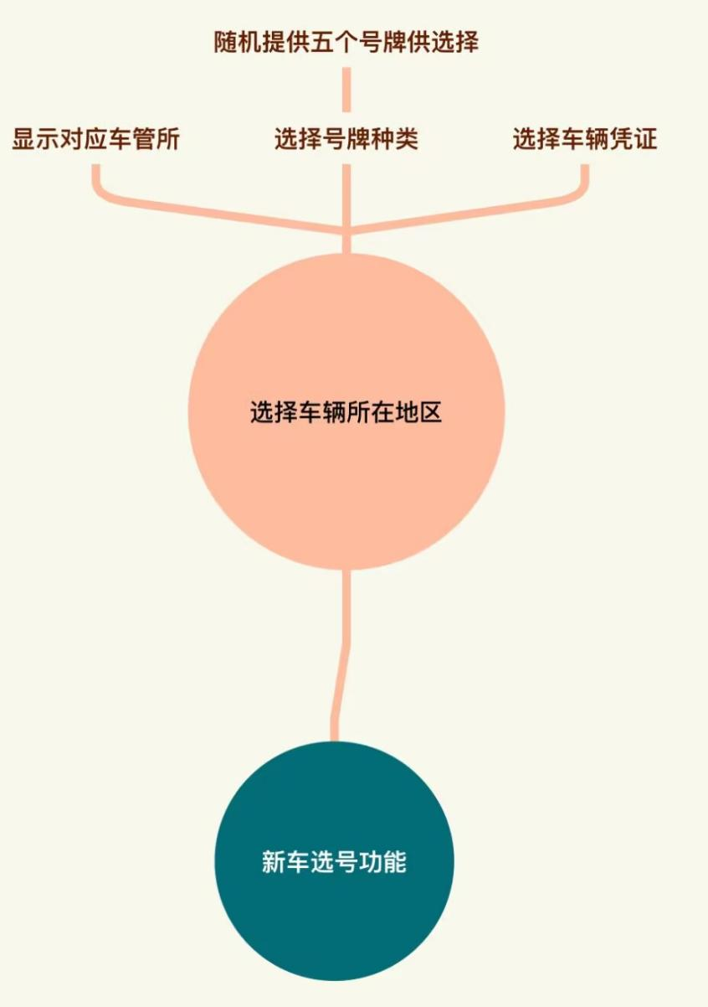

# 函数声明及原型

1. **int s\_adlogin()；**

功能：管理员登陆功能函数

1. **void** g\_login（）；

功能：管理员登陆画图函数

1. **void inputad(char password[], int x1, int y1,int x2,int y2);**

传入参数：储存的数组password，输入框左上角和右下角坐标

功能：输入管理员账号及密码

1. **int s\_admin();**

功能：管理员功能主控函数

1. **int s\_adjiemian(int \*x);**

传入参数：用来控制页面是否跳转进入首页的参数

功能：管理员界面控制函数

1. **int s\_luru(ACCIDENT \*weifa);**

传入参数：违法信息结构体

功能：用户违法信息储存功能函数

1. **void g\_luru();**

功能：用户违法信息画图函数

1. **void g\_admin();**

功能：用户违法信息画图函数

1. **void g\_tuichu();**

功能：确认退出弹窗画图函数

1. **int s\_tuichu(int queren,int quxiao);**

传入参数：确认的返回值，退出的返回值

功能：退出弹窗功能函数

1. **void inputchepai(char password[], int x1, int y1,int x2,int y2);**

传入参数：储存车牌号的数组，输入框左上角和右下角的坐标

功能：车牌号输入函数

1. **void inputjiashizheng(char password[], int x1, int y1,int x2,int y2);**

传入参数：储存驾驶证号的数组，输入框左上角和右下角的坐标

功能：驾驶证的输入函数

1. **void inputyear(char password[], int x1, int y1,int x2,int y2);**

传入参数：储存年份的数组，输入框的左上角坐标和右下角坐标

功能：年份的输入函数

1. **void inputmonth(char password[], int x1, int y1,int x2,int y2);**

传入参数：储存月份的数组，输入框的左上角坐标和右下角坐标

功能：月份的输入函数

1. **void inputday(char password[], int x1, int y1,int x2,int y2);**  
   传入参数：储存日期的函数，输入框的左上角和右下角坐标

功能：日期的输入函数

1. **void brightpress(int x,int y);**

传入参数：画按键起始位置

功能：画违章信息按键

1. **void brightpress2(int x, int y);**

传入参数：画按键起始位置

功能：进行按键高亮

1. **void get\_date(int \*year, int \*month, int \*day);**

传入参数：日期，月份，年份

功能：获取当前具体时间

1. **int check\_date(ACCIDENT \*weifa,int year,int month, int day);**

传入参数：违法结构体，日期，月份，年份

功能：检查时间输入是否合法

1. **int choose\_haopaitou(ACCIDENT \*weifa);**

传入参数：违法信息   
功能： 号牌头选择

1. **void g\_choose\_haopaitou();**   
   功能：号牌头选择界面画图函数
2. **void** void g\_didian();

功能：违法地点选择画图函数

**int s\_didian(ACCIDENT \*weifa);**

传入参数： 违法信息结构体

功能：违法地点选择

。

1. **void accidentintofile(ACCIDENT \*weifa);**

传入参数： 违法信息结构体  
功能：违法信息写入文件

1. **Void creataccidentfile(char \*filepath,ACCIDENT \*weifa);**

传入参数： 储存路径的数组，违法信息结构体  
功能：为用户创建路径

1. **void creatusercarfile(char \*filepath1,char \*filepath2,ACCIDENT \*weifa);**

传入参数： 违法信息结构体，储存路径的数组  
功能：为用户车辆创建路径

1. **void** g\_examchuli();  
   功能：考试信息处理画图函数
2. **int s\_examchuli(char \*id);**   
   功能：考试信息处理功能函数

int s\_checkexam(char \*filepath,int \*page);传入参数： 窗口参数结构体。  
功能：判断鼠标是否位于窗口内，是则返回1，否则返回0。

1. **int** s\_checkexam(char \*filepath,int \*page);

传入参数： 用户路径，用于页面跳转的标志。  
功能：检查用户当前的考试状态

1. **void g\_carbangding();**   
   功能：用户车辆绑定界面画图函数。
2. **Int s\_carbangding(CAR \*car,int \*x,struct U \*user1,CAR1 \*car1)**

传入参数： 用户信息结构体，车辆结构体，用于页面跳转的标志  
功能： 车辆绑定功能函数

1. **void g\_carzhonglei();**

功能： 车辆种类界面画图函数

1. int s\_carzhonglei(CAR \*car);

传入参数： 车辆信息结构体  
功能：车辆种类选择

1. int carcheck(CAR \*car,struct U \*user1);  
   功能： 检查车辆输入是否正确

**void s\_creatcarfile(struct U \*user1);**传入参数： 视频和用户编号  
功能： 绘制评论页

1. **void** s\_creatcarfile(struct U \*user1）；

传入参数：用户信息结构体  
功能：为车辆创建路径

1. int s\_carhaopaitou(CAR \*car);

传入参数： 车辆信息结构体  
功能： 选择车辆号牌头

1. int s\_carbd(struct U \*user1);

传入参数：用户信息结构体  
功能： 车辆绑定主控函数

1. int s\_add\_con(CAR1 \*car,struct U \*user1);

传入参数： 车辆结构体，用户信息结构体  
功能：车辆信息写入文件

1. **int** geren(**int** u, yemian\* y, **int**\* i);

传入参数： 页面结构体和页面和用户  
功能： 绘制个人中心

1. **Void g\_login();**  
   功能： 用户登录界面画图函数
2. Void g\_adlogin();  
   功能： 管理员登陆界面画图函数
3. **int s\_chaxun(struct U \*user1);**

传入参数： 用户结构体  
功能： 违法信息查询主控函数

1. void g\_search\_weifa();

功能： 违法信息查询界面画图函数

1. **int s\_search\_weifa(struct U \*user1,char \*head,char \*chepai);**

传入参数：用户结构体，号牌头，车牌号  
功能： 违法信息查询

1. int s\_showdetail(ILLEGAL\_NODE \*\*head1,int \*count,struct U \*user1,char \*chepai,int total);

传入参数： 链表头，文件中信息个数，用户结构体，车牌号，当前页数  
功能： 违法信息显示

1. void write\_state(ILLEGAL\_NODE\*\*temp,char \*chepai,struct U \*user1,int count,int number);

传入参数： 链表头，车牌号，用户结构体，当前页数，违法信息位置  
功能：处理违法信息

1. void creat\_listhead(ILLEGAL\_NODE \*\*head1);

功能： 链表头节点创建

1. void creat\_illegallist(ILLEGAL\_NODE\*\*head1,char\*head,char\*chepai,struct U \*user1);

传入参数： 链表头节点，号牌头，车牌号，用户结构体  
功能：链表读取文件

**void free\_list(ILLEGAL\_NODE\*head);**

1. **void** free\_list(ILLEGAL\_NODE \*head);

传入参数：链表头节点

功能：释放链表

1. Int s\_checkhaopai(char \*chepai,struct U \*user1,char \*filepath2);

传入参数： 车牌号，用户结构体，文件路径  
功能:检查车牌号输入是否正确

1. void chepai\_path(char \*chepai,struct U \*user1,char \*chepaipath);

传入参数：用户结构体，文件路径

功能:为车辆创建路径

1. int s\_haopaitou(char \*head);

传入参数：链表头

功能:号牌头选择

1. **Void g\_haopaitou();**

功能:号牌头选择界面画图

1. int creatdir(char \*filepath);

传入参数： 文件路径数组

功能:创建文件

1. int s\_signup();

功能:注册界面功能函数

1. void g\_signup();

功能:注册界面画图函数

1. void creatuserfile(char \*filename,char \*file);

传入参数： 文件路径，文件名

功能:创建文件

1. int iddetect(char \*id);

传入参数： id

功能:判断用户Id是否正确

1. **int checkpassword(struct U \*user,char \*password);**

传入参数： 密码和用户结构体

功能:检查密码是否正确

1. **void inputphone(struct U \*user,int x1,int y1,int x2,int y2);**

传入参数： 用户结构体，输入框左上角和右下角的坐标

功能:手机号输入

1. **void inputpassword(struct U \*user,int x1,int y1,int x2,int y2);**

传入参数： 用户结构体

功能:读取名称

1. **void inputname(struct U \*user,int x1,int y1);**

传入参数： 用户结构体，输入框左上角坐标

功能:输入用户名字

1. **void intofile(struct U \*user);**

传入参数： 用户结构体

功能:用户信息写入文件

1. **void inputpassword1(char \*p,int x1,int y1);**

传入参数： 坐标和储存密码的字符串

功能:输入密码

1. **int check(struct U \*user,char \*ckpassword);**

传入参数： 用户结构体，密码

功能:检测密码输入是否正确

1. **void bright(int x1,int y1,int x2,int y2,int bkcolor);**

传入参数： 坐标颜色

功能:按键高亮

**int s\_xuanhao(struct U \*user1);**

**int s\_jibenxinxi(struct xuanhao \*user,int \*x);**

**int s\_city(struct xuanhao \*user);**

**void g\_jibenxinxi();**

**void g\_cheliangxinxi(struct U \*user);**

**int s\_cheliangxinxi(struct xuanhao \*user,struct U \*user1);**

**void g\_cheliangzhonglei();**

**int s\_cheliangzhonglei(struct xuanhao \*user);**

**void g\_cheliangpingzheng();**

**int s\_cheliangpingzheng(struct xuanhao \*user);**

**void g\_haopaiyuxuan();**

**int s\_haopaiyuxuan(struct xuanhao \*user,int \*flag);**

**void g\_province();**

**void g\_anhui();**

**int s\_anhui(struct xuanhao \*user);**

**void g\_fujian();**

**int s\_fujian(struct xuanhao \*user);**

**void g\_guangdong();**

**int s\_guangdong(struct xuanhao \*user);**

**void g\_guangxi();**

**int s\_guangxi(struct xuanhao \*user);**

**void g\_guizhou();**

**int s\_guizhou(struct xuanhao \*user);**

**void g\_gansu();**

**int s\_gansu(struct xuanhao \*user);**

**void g\_hebei();**

**int s\_hebei(struct xuanhao \*user);**

**void g\_jilin();**

**int s\_jilin(struct xuanhao \*user);**

**void g\_heilongjiang();**

**int s\_heilongjiang(struct xuanhao \*user);**

**void g\_jiangsu();**

**int s\_jiangsu(struct xuanhao \*user);**

**void g\_jiangxi();**

**int s\_jiangxi(struct xuanhao \*user);**

**void g\_henan();**

**int s\_henan(struct xuanhao \*user);**

**void g\_hubei();**

**int s\_hubei(struct xuanhao \*user);**

**void g\_hunan();**

**int s\_hunan(struct xuanhao \*user);**

**void g\_hainan();**

**int s\_hainan(struct xuanhao \*user);**

**void g\_shianxi();**

**int s\_shianxi(struct xuanhao \*user);**

**void g\_neimenggu();**

**int s\_neimenggu(struct xuanhao \*user);**

**void g\_liaoning();**

**int s\_liaoning(struct xuanhao \*user);**

**void g\_shandong();**

**int s\_shandong(struct xuanhao \*user);**

**void g\_sichuan();**

**int s\_sichuan(struct xuanhao \*user);**

**void g\_shanxi();**

**int s\_shanxi(struct xuanhao \*user);**

**void g\_qinghai();**

**int s\_qinghai(struct xuanhao \*user);**

**void g\_ningxia();**

**int s\_ningxia(struct xuanhao \*user);**传入参数： 坐标和状态值

功能:画投币图

1. **int s\_xuanhao(struct U \*user1);**

传入参数：用户信息结构体

功能：选号功能主控函数

1. **int s\_jibenxinxi(struct xuanhao \*user,int \*x);**

传入参数： 选号信息结构体，用于页面跳转的标志

功能:基本信息功能函数

1. **int s\_city(struct xuanhao \*user);**;

传入参数： 用户信息结构体

功能: 选省份

1. **void g\_jibenxinxi();**;

功能: 基本信息界面画图函数

1. **void g\_cheliangxinxi(struct U \*user);**

传入参数： 用户信息结构体

功能: 车辆信息界面画图

1. **int s\_cheliangxinxi(struct xuanhao \*user,struct U \*user1);**

传入参数： 用户信息结构体

功能: 车辆信息界面功能函数

1. **void g\_cheliangzhonglei();**

功能: 车辆种类界面画图

1. **int s\_cheliangzhonglei(struct xuanhao \*user);**

传入参数： 用户信息结构体

功能: 车辆种类界面功能

1. **void g\_cheliangpingzheng();**

功能:车辆凭证界面画图

1. **int s\_cheliangpingzheng(struct xuanhao \*user);**

传入参数：用户信息结构体

功能:车辆凭证界面功能函数

1. **void g\_haopaiyuxuan();**

功能:号牌预选界面画图函数

1. **int s\_haopaiyuxuan(struct xuanhao \*user,int \*flag);**

传入参数： 用户信息结构体，用于页面跳转的标志

功能:号牌预选功能函数

1. **void g\_province();**

功能:省份选择界面

1. **void g\_anhui();**

功能:安徽省画图函数

1. **int s\_anhui(struct xuanhao \*user);**

传入参数： 用户信息结构体

功能:安徽省城市选择

1. **void g\_fujian()**;

功能:福建省画图函数

1. **int s\_fujian(struct xuanhao \*user)**;

传入参数：用户

功能:福建省选城市

1. **void g\_guangdong()**;

功能:广东省画图

1. **int s\_guangdong(struct xuanhao \*user)**;

传入参数：用户

功能:广东省选城市

1. **void g\_guangxi();**

功能:广西省画图

1. **int s\_guangxi(struct xuanhao \*user);**

传入参数：用户

功能:广西省选城市

1. void g\_guizhou();

功能：贵州省画图

1. **int s\_guizhou(struct xuanhao \*user);**

传入参数：用户

功能:贵州省选城市

1. **void g\_gansu();**

功能:甘肃省画图

1. **int s\_gansu(struct xuanhao \*user);**

传入参数：用户

功能:甘肃省选城市

1. **void g\_hebei();**

功能:河北省画图

1. **int s\_hebei(struct xuanhao \*user);**

传入参数： 用户

功能:河北省选城市

1. **void g\_jilin();**

功能:吉林省画图

1. **int s\_jilin(struct xuanhao \*user);**

传入参数： 用户

功能:吉林省选城市

1. **void g\_heilongjiang()**

功能:黑龙江画图

1. int s\_heilongjiang(struct xuanhao \*user);

传入参数：用户

功能:黑龙江选城市

1. **void g\_jiangsu();**

功能:江苏省画图

1. **int s\_jiangsu(struct xuanhao \*user);**

功能:江苏省选城市

1. **void g\_jiangxi();**

功能：江西省画图

1. **int s\_jiangxi(struct xuanhao \*user);**

传入参数：用户

功能:江西省选城市

1. **void g\_henan();**)

功能:河南

1. **int s\_henan(struct xuanhao \*user);**

传入参数：用户

功能:河南选城市

1. **void g\_hubei();**

功能:湖北省画图

1. **int s\_hubei(struct xuanhao \*user);**

传入参数：用户

功能:湖北省选城市

1. **void g\_hunan();**

功能:湖南省画图

1. **int s\_hunan(struct xuanhao \*user);**

传入参数：用户

功能:湖南省选城市

1. **void g\_hainan();**

功能:海南省画图

1. **int s\_hainan(struct xuanhao \*user);**;

传入参数：用户

功能:海南省选城市

1. **int s\_shianxi(struct xuanhao \*user);**

传入参数：陕西

功能:山西省选城市

1. **void g\_shianxi();**

功能: 陕西省画图

1. **void g\_neimenggu();**

功能:内蒙古画图

1. **int s\_neimenggu(struct xuanhao \*user);**

传入参数： 用户

功能:内蒙古选城市

1. **void g\_liaoning();**

功能:辽宁省画图

1. **int s\_liaoning(struct xuanhao \*user);**

传入参数：用户

功能:辽宁省选城市

1. **void g\_shandong();**

功能:山东省画图

1. **int s\_shandong(struct xuanhao \*user);**

传入参数：用户

功能:山东省选城市

1. **void g\_sichuan();**

功能:四川省画图

1. **int s\_sichuan(struct xuanhao \*user);**

传入参数：用户   
功能:四川省选城市

1. **void g\_shanxi();**

功能:山西省画图

1. **int s\_shanxi(struct xuanhao \*user);**

传入参数：用户

功能: 山西省选城市

1. **void g\_qinghai();**

功能:青海省画图

1. **int s\_qinghai(struct xuanhao \*user);**

传入参数：用户

功能:青海省选城市

1. **void g\_ningxia();**

功能:宁夏省画图

1. **int s\_ningxia(struct xuanhao \*user);**

传入参数：用户

功能:宁夏省选城市

1. **void g\_exam1();**;

传入参数： 用户

功能:考试预约总界面

1. **void g\_exam2();**

传入参数：用户

功能:科目一界面

1. **void g\_exam3();**

传入参数： 用户

功能：科目一考试场地

1. **void g\_exam4();**

传入参数： 用户

功能:科目一考试时间

1. **void g\_exam5();**

传入参数： 用户

功能:科目一考试信息

1. **void g\_exam6();**

传入参数： 用户

功能:科目二

1. **void g\_exam7();**

传入参数：用户

功能:科目二考试场地

1. **void g\_exam8();**

传入参数：用户

功能:科目二考试时间

1. **void g\_exam9();**

传入参数： 用户

功能:科目二考试信息

1. **void g\_exam10();**

传入参数： 用户

功能:科三

1. **void g\_exam11();**

传入参数： 用户

功能科三考试场地

1. **void g\_exam12();**

传入参数： 用户

功能:科三考试时间

1. **void g\_exam13();**

传入参数： 用户

功能:科三考试信息

1. **void g\_exam14();**

传入参数： 用户

功能:科四

1. **void g\_exam15();**

传入参数：用户

功能:科四考试场地

1. **void g\_exam16();**

传入参数： 用户

功能:科四考试时间

1. **void g\_exam17();**

传入参数： 用户

功能:科四考试信息

1. **int c\_hexam();**

传入参数：用户

功能:考试预约首页控制

1. **int**  c\_subject1();

传入参数： 用户

功能:科一控制

1. **int c\_subject2();**

传入参数： 用户

功能：科二控制

1. **int c\_subject3();**

传入参数： 用户

功能:科三控制

1. **int c\_subject4();**

传入参数： 用户

功能科四控制

1. **void** CreateTXT(char\*s,char\*p1,char\*p2);

传入参数： 用户

功能:给TXT文件创建路径

1. **int licence(char\*id);**

传入参数：用户

功能:驾驶证信息显示

1. **int c\_licence(char\*id);**

传入参数： 用户

功能:驾驶证绑定总控制

1. **void type(char\*id);**

传入参数： 用户

功能:选择驾驶证类型

1. **int** hservice();

传入参数：无

功能:服务中心首页

1. **void**  service();

传入参数：无

功能:首页画图

1. **void**  service1();

传入参数：无

功能: 问题一显示

1. **void** service2();

传入参数：无

功能:问题二显示

1. **void** service3();

传入参数：无

功能: 问题三显示

1. **void service4();**;

传入参数：无

功能:问题四显示

1. **void** service5();

传入参数：无

功能: 问题五显示

1. **void** service6();

传入参数：无

功能:问题六显示

1. **int** c\_service();

传入参数：无

功能:服务中心控制

1. **void** MixOuttext(char\*s);

传入参数：结点指针

功能:混合显示汉字和数字

1. **int** delete\_single\_chat(**struct** video \* now,**struct** chat\_tmp \*\* nowchat\_t,**struct** shoot \* bullet);

传入参数：视频结点指针，要删除的弹幕二级指针，弹夹指针

功能:将某条弹幕从视频的弹幕列表中删除

1. **void** show\_car(char\*id);

传入参数：用户

功能:显示绑定车辆信息

# 源代码

一．Adlogin.c

1. #include "common.h"
2. #include "admin.h"
3. int s\_adlogin()
4. {
5. int page=5;
6. char id[10];
7. char password[10];
8. strcpy(id,"\0");
9. strcpy(password,"\0");
10. clrmouse(MouseX,MouseY);
11. g\_adlogin();
12. while(page==5)
13. {
14. newmouse(&MouseX,&MouseY,&press);
15. if(MouseX>192 && MouseX<448 && MouseY>64 && MouseY<96)//输入管理员账号
16. {
17. if(mouse\_press(192,64,448,96)==1)
18. {
19. inputad(id,192,64,448,96);
20. }
21. }
22. else if(MouseX>192 && MouseX<448 && MouseY>128 && MouseY<160)//输入管理员密匙
23. {
24. if(mouse\_press(192,128,448,160)==1)
25. {
26. inputad(password,192,128,448,160);
27. }
28. }else if(mouse\_press(256,244,370,276)==1){//点击登录
29. if((strcmp(id,"12123")==0)&&(strcmp(password,"1037")==0)){
30. puthz(240,200,"登陆成功！",16,16,RED);
31. delay(300);
32. page=6;
33. }
34. }else if(MouseX>370 && MouseX<450 && MouseY>450 && MouseY<470)//注册按钮
35. {
36. if(mouse\_press(370,450,450,470)==1)
37. {
38. page=2;
39. }
40. }else if(mouse\_press(170,450,250,470)==1)//用户登录按钮
41. {
42. page=1;
43. }
44. }
45. return page;
46. }
47. void g\_adlogin()
48. {
49. cleardevice();
50. setbkcolor(LIGHTBLUE);
51. setcolor(WHITE);
52. setlinestyle(0,0,1);
53. rectangle(192,64,448,96);
54. rectangle(192,128,448,160);
55. settextstyle(0,0,3);
56. puthz(28,64,"管理员账号",32,32,WHITE);
57. puthz(28,128,"管理员密匙",32,32,WHITE);
58. puthz(256,244,"登录",32,80,WHITE);
59. rectangle(256,244,370,276);
60. puthz(180,452,"用户登录",16,16,WHITE);
61. puthz(380,452,"用户注册",16,16,WHITE);
62. rectangle(170,450,250,470);
63. rectangle(370,450,450,470);
64. settextstyle(0,0,5);
65. outtextxy(220,300,"12123");
66. puthz(280,350,"安全畅通",16,16,WHITE);
67. }
68. void inputad(char password[], int x1, int y1,int x2,int y2)//输入
69. {
70. int i = 0;
71. char t;
72. char a[2];
73. strcpy(password,"\0");
74. clrmouse(MouseX, MouseY);
75. setfillstyle(SOLID\_FILL, LIGHTGRAY);
76. setlinestyle(SOLID\_LINE, 0, NORM\_WIDTH);
77. bright(x1, y1, x2, y2, LIGHTBLUE);
78. setcolor(WHITE);
79. rectangle(x1,y1,x2,y2);
80. settextstyle(TRIPLEX\_FONT, HORIZ\_DIR, 2);
81. settextjustify(LEFT\_TEXT, TOP\_TEXT);
83. while (1)
84. {
85. t = bioskey(0);
86. if (i < 11)
87. {
88. if (t != '\n'
89. && t != '\r'
90. && t != ' ')
91. {
92. if (t != '\b')
93. {
94. password[i] = t;
95. a[0] = t;
96. a[1] = '\0';
97. password[i + 1] = '\0';
98. outtextxy(2 + x1 + i \* 10, y1 - 2, a);
99. i++;
100. }
101. else if (t == '\b' && i > 0)
102. {
103. bar(x1 + i \* 10 - 8, y1+2, x1 + i \* 10 + 4, y1 + 22);
104. i--;
105. password[i] = '\0';
106. }
107. }
108. else
109. {
110. setfillstyle(SOLID\_FILL, LIGHTGRAY);
111. break;
112. }
113. }
114. else if (i >= 11)
115. {
116. if (t != '\n'
117. && t != '\r'
118. && t != ' '
119. && t != 033)//Esc
120. {
121. if (t == '\b' && i > 0)
122. {
123. bar(x1 + i \* 10 - 8, y1+2 , x1 + i \* 10 + 4, y1 + 22);
124. i--;
125. password[i] = '\0';
126. }
127. }
128. else
129. {
130. setfillstyle(SOLID\_FILL, LIGHTGRAY);
131. break;
132. }
133. }
134. }
135. bright(x1, y1,x2, y2, LIGHTBLUE);
136. rectangle(x1,y1,x2,y2);
137. outtextxy(x1 + 2, y1 - 2, password);
138. }

二.admin.c

1. #include "common.h"
2. #include "admin.h"
3. int s\_admin()
4. {
5. int page=6;
6. int flag=1;
7. ACCIDENT \*weifa=(ACCIDENT \*)malloc(sizeof(ACCIDENT ));
8. char id[20];
9. strcpy(id,"\0");
10. memset(weifa,0,sizeof(ACCIDENT));
11. // strcpy(weifa->haopai,"\0");
12. // strcpy(weifa->id,"\0");
13. // strcpy(weifa->leixing,"\0");
14. // strcpy(weifa->year,"\0");
15. // strcpy(weifa->month,"\0");
16. // strcpy(weifa->day,"\0");
17. // strcpy(weifa->didian,"\0");
18. // strcpy(weifa->haopaitou,"\0");
19. // weifa->zhuangtai=0;
20. // weifa->koufen=0;
21. // weifa->fakuan=0;
22. mkdir("accident");
23. while(page==6){
24. newmouse(&MouseX,&MouseY,&press);
25. switch(flag)
26. {
27. case 1:
28. flag=s\_adjiemian(&page);
29. break;
30. case 2:
31. flag=s\_luru(weifa);
32. break;
33. case 3:
34. flag=s\_didian(weifa);
35. break;
36. case 4:
37. if(s\_tuichu(1,4)==1){
38. free(weifa);
39. flag=5;
40. page=1;
41. }else if(s\_tuichu(1,4)==4){
42. flag=1;
43. }
44. break;
45. case 5:
46. break;
47. case 6:
48. flag=s\_choose\_haopaitou(weifa);
49. break;
50. case 7:
51. flag=s\_examchuli(id);
52. break;



57. }
58. }
59. return page;
60. }
61. int s\_adjiemian(int \*x)//管理员系统功能函数
62. {
63. int page=1;
64. clrmouse(MouseX,MouseY);
65. g\_admin();
66. while(page==1){
67. newmouse(&MouseX,&MouseY,&press);
68. if(mouse\_press(210,90,374,134)==1){//违法信息录入
69. delay(300);
70. page=2;
71. }else if(mouse\_press(8,12,32,32)==1){
72. page=4;
73. }else if(mouse\_press(210,150,374,194)==1){
74. page=7;
75. }
76. }
77. return page;
78. }
79. int s\_luru(ACCIDENT \*weifa)//违法信息录入系统
80. {
81. int page=2;
82. int i=0;
83. int j=0;
84. int x=-1,y=-1;
85. int year=0,month=0,day=0;
86. get\_date(&year,&month,&day);
87. clrmouse(MouseX,MouseY);
88. g\_luru();
89. settextstyle(TRIPLEX\_FONT, HORIZ\_DIR, 1);
90. setcolor(DARKGRAY);
91. if(strcmp(weifa->haopai1,"\0")!=0){
92. outtextxy(205,60,weifa->haopai1);
93. }
94. if(strcmp(weifa->haopaitou,"\0")!=0){
95. puthz(172,62,weifa->haopaitou,24,24,DARKGRAY);
96. }
97. if(strcmp(weifa->didian+2,"\0")!=0){
98. puthz(210,185,weifa->didian+2,24,24,DARKGRAY);
99. }
101. if(strcmp(weifa->id,"\0")!=0){
102. outtextxy(205,100,weifa->id);
103. }
104. // for ( i=0;i<20;i++)
105. // {
106. // printf("%c",weifa->id[i]);
107. //
108. // }
109. //
110. if(strcmp(weifa->year,"\0")!=0){
111. outtextxy(205,140,weifa->year);
112. }
113. if(strcmp(weifa->month,"\0")!=0){
114. outtextxy(325,140,weifa->month);
115. }
116. if(strcmp(weifa->day,"\0")!=0){
117. outtextxy(410,140,weifa->day);
118. }
119. // if(strcmp(weifa->didian,"\0")!=0){
120. // puthz(205,180,weifa->didian,24,24,WHITE);
121. // }
122. while(page==2){
123. newmouse(&MouseX,&MouseY,&press);
124. if(mouse\_press(8,12,32,32)==1){
125. delay(250);
126. page=1;
127. }else if(mouse\_press(170,60,200,90)==1){//省份选择
128. page=6;
129. }else if(mouse\_press(205,60,300,90)==1){
130. inputchepai(weifa->haopai1,205,60,300,90);//车牌号
131. }else if(mouse\_press(205,100,470,130)==1){
132. inputjiashizheng(weifa->id,205,100,470,130);//驾驶证
133. }else if(mouse\_press(205,140,290,170)==1){
134. inputyear(weifa->year,205,140,290,170);//年
135. }else if(mouse\_press(325,140,365,170)==1){
136. inputmonth(weifa->month,325,140,365,170);//月
137. }else if(mouse\_press(410,140,450,170)==1){
138. inputday(weifa->day,410,140,450,170);//日
139. }else if(mouse\_press(370,180,400,210)==1){
140. page=3;
141. }else if(mouse\_press(50+0\*120,250+0\*50,156+0\*120,276+0\*50)==1){
142. strcpy(weifa->leixing,"违章停车");
143. if(x!=-1&&y!=-1){
144. brightpress(x,y);
145. }
146. brightpress2(0,0);
147. x=0,y=0;
148. weifa->koufen=3;
149. weifa->fakuan=200;
150. }else if(mouse\_press(50+1\*120,250+0\*50,156+1\*120,276+0\*50)==1){
151. strcpy(weifa->leixing,"一般超速");
152. if(x!=-1&&y!=-1){
153. brightpress(x,y);
154. }
155. brightpress2(0,1);
156. x=0,y=1;
157. weifa->koufen=3;
158. weifa->fakuan=200;
159. }else if(mouse\_press(50+2\*120,250+0\*50,156+2\*120,276+0\*50)==1){
160. strcpy(weifa->leixing,"严重超速");
161. if(x!=-1&&y!=-1){
162. brightpress(x,y);
163. }
164. brightpress2(0,2);
165. x=0,y=2;
166. weifa->koufen=6;
167. weifa->fakuan=600;
168. }else if(mouse\_press(50+3\*120,250+0\*50,156+3\*120,276+0\*50)==1){
169. strcpy(weifa->leixing,"驾车拨接电话");
170. if(x!=-1&&y!=-1){
171. brightpress(x,y);
172. }
173. brightpress2(0,3);
174. x=0,y=3;
175. weifa->koufen=2;
176. weifa->fakuan=200;
177. }else if(mouse\_press(50+0\*120,250+1\*50,156+0\*120,276+1\*50)==1){
178. strcpy(weifa->leixing,"闯红灯");
179. if(x!=-1&&y!=-1){
180. brightpress(x,y);
181. }
182. brightpress2(1,0);
183. x=1,y=0;
184. weifa->koufen=6;
185. weifa->fakuan=200;
186. }else if(mouse\_press(50+1\*120,250+1\*50,156+1\*120,276+1\*50)==1){
187. strcpy(weifa->leixing,"未礼让行人");
188. if(x!=-1&&y!=-1){
189. brightpress(x,y);
190. }
191. brightpress2(1,1);
192. x=1,y=1;
193. weifa->koufen=3;
194. weifa->fakuan=200;
195. }else if(mouse\_press(50+2\*120,250+1\*50,156+2\*120,276+1\*50)==1){
196. strcpy(weifa->leixing,"未系安全带");
197. if(x!=-1&&y!=-1){
198. brightpress(x,y);
199. }
200. brightpress2(1,2);
201. x=1,y=2;
202. weifa->koufen=2;
203. weifa->fakuan=200;
204. }else if(mouse\_press(50+3\*120,250+1\*50,156+3\*120,276+1\*50)==1){
205. strcpy(weifa->leixing,"违反禁令标志");
206. if(x!=-1&&y!=-1){
207. brightpress(x,y);
208. }
209. brightpress2(1,3);
210. x=1,y=3;
211. weifa->koufen=3;
212. weifa->fakuan=200;
213. }else if(mouse\_press(150,370,490,405)==1){
214. delay(300);
215. strcat(weifa->haopai,weifa->haopaitou);
216. strcat(weifa->haopai,weifa->haopai1);
217. printf("%d",strlen(weifa->id));
218. if(strlen(weifa->id)==18&&strcmp(weifa->didian,"\0")!=0&&weifa->haopai[2]>=65&&weifa->haopai[2]<=90&&check\_date(weifa,year,month,day)==1){
219. setfillstyle(1,LIGHTCYAN);
220. bar(350,350,580,368);
221. puthz(350,350,"录入成功！",16,16,DARKGRAY);
222. strcpy(weifa->haopaitou,"\0");
223. strcpy(weifa->didian,"\0");
224. accidentintofile(weifa);
225. memset(weifa,0,sizeof(ACCIDENT));
226. delay(500);
227. page=1;
228. }else {
229. setfillstyle(1,LIGHTCYAN);
230. bar(350,350,580,368);
231. puthz(350,350,"信息输入有误！",16,16,DARKGRAY);
232. memset(weifa,0,sizeof(ACCIDENT));
233. delay(200);
234. g\_luru();
235. delay(100);
237. }
238. }
240. }
241. return page;
242. }
243. int s\_didian(ACCIDENT \*weifa)
244. {
245. int page=3;
246. clrmouse(MouseX,MouseY);
247. g\_didian();
248. while(page==3){
249. newmouse(&MouseX,&MouseY,&press);
250. if(mouse\_press(0,238,640,257)==1){
251. strcpy(weifa->didian,"喻喻园大道");
252. delay(100);
253. page=2;
254. }else if(mouse\_press(130,50,277,142)==1){
255. strcpy(weifa->didian,"华华科附中附近");
256. delay(100);
257. page=2;
258. }else if(mouse\_press(240,173,345,230)==1){
259. strcpy(weifa->didian,"韵韵苑食堂附近");
260. delay(100);
261. page=2;
262. }else if(mouse\_press(345,55,568,154)==1||mouse\_press(442,227,568,227)==1){
263. strcpy(weifa->didian,"韵韵苑公寓附近");
264. delay(100);
265. page=2;
266. }else if(mouse\_press(82,293,190,455)==1){
267. strcpy(weifa->didian,"东东九楼附近");
268. delay(100);
269. page=2;
270. }else if(mouse\_press(303,271,362,368)==1){
271. strcpy(weifa->didian,"东东操附近");
272. delay(100);
273. page=2;
274. }else if(mouse\_press(237,381,378,450)==1){
275. strcpy(weifa->didian,"东东十二楼附近");
276. delay(100);
277. page=2;
278. }else if(mouse\_press(386,278,560,365)==1){
279. strcpy(weifa->didian,"韵韵体附近");
280. delay(100);
281. page=2;
282. }
283. }
284. return page;
285. }
286. void g\_didian()
287. {
288. cleardevice();
289. setbkcolor(LIGHTCYAN);
290. setlinestyle(0,0,1);
291. setcolor(WHITE);
292. line(0,33,640,33);
293. line(0,42,640,42);
295. line(0,238,640,238);
296. line(0,257,640,257);
297. puthz(253,238,"喻园大道",16,16,DARKGRAY);
299. line(17,33,17,238);
300. line(17,238,17,480);
301. line(30,33,30,238);
302. line(30,238,30,480);
304. line(590,33,590,238);
305. line(590,238,590,480);
306. line(605,33,605,238);
307. line(605,238,605,480);
309. setcolor(DARKGRAY);
310. rectangle(130,50,277,142);
311. puthz(145,75,"华科附中",16,16,DARKGRAY);
313. rectangle(240,173,345,230);
314. puthz(255,190,"韵苑食堂",16,16,DARKGRAY);
316. line(348,55,348,154);
317. line(348,154,442,154);
318. line(442,154,442,227);
319. line(442,227,568,227);
320. line(568,227,568,55);
321. line(568,55,348,55);
322. puthz(375,90,"韵苑学生公寓",16,16,DARKGRAY);

325. rectangle(82,293,190,455);
326. puthz(120,318,"东",16,16,DARKGRAY);
327. puthz(120,340,"九",16,16,DARKGRAY);
328. puthz(120,361,"楼",16,16,DARKGRAY);
330. rectangle(303,271,362,368);
331. puthz(320,290,"东",16,16,DARKGRAY);
332. puthz(320,310,"操",16,16,DARKGRAY);
334. rectangle(237,381,378,450);
335. puthz(250,405,"东十二楼",16,16,DARKGRAY);
337. rectangle(386,278,560,365);
338. puthz(410,305,"韵苑体育馆",16,16,DARKGRAY);
340. }
341. int s\_choose\_haopaitou(ACCIDENT \*weifa)
342. {
343. int page=5;
344. clrmouse(MouseX,MouseY);
345. g\_choose\_haopaitou();
346. while(page==5){
347. newmouse(&MouseX,&MouseY,&press);
348. if(mouse\_press(8,12,32,32)==1){
349. page=2;
350. }
351. if(mouse\_press(8,12,32,32)==1){
352. page=2;
353. }
354. if(mouse\_press(140+40\*0,140+40\*0,170+40\*0,170+40\*0)==1){
355. strcpy(weifa->haopaitou,"京");
356. page=2;
357. }
358. if(mouse\_press(140+40\*1,140+40\*0,170+40\*1,170+40\*0)==1){
359. strcpy(weifa->haopaitou,"皖");
360. page=2;
361. }
362. if(mouse\_press(140+40\*2,140+40\*0,170+40\*2,170+40\*0)==1){
363. strcpy(weifa->haopaitou,"闽");
364. page=2;
365. }
366. if(mouse\_press(140+40\*3,140+40\*0,170+40\*3,170+40\*0)==1){
367. strcpy(weifa->haopaitou,"粤");
368. page=2;
369. }
370. if(mouse\_press(140+40\*4,140+40\*0,170+40\*4,170+40\*0)==1){
371. strcpy(weifa->haopaitou,"桂");
372. page=2;
373. }
374. if(mouse\_press(140+40\*5,140+40\*0,170+40\*5,170+40\*0)==1){
375. strcpy(weifa->haopaitou,"渝");
376. page=2;
377. }
378. if(mouse\_press(140+40\*0,140+40\*1,170+40\*0,170+40\*1)==1){
379. strcpy(weifa->haopaitou,"贵");
380. page=2;
381. }
382. if(mouse\_press(140+40\*1,140+40\*1,170+40\*1,170+40\*1)==1){
383. strcpy(weifa->haopaitou,"甘");
384. page=2;
385. }
386. if(mouse\_press(140+40\*2,140+40\*1,170+40\*2,170+40\*1)==1){
387. strcpy(weifa->haopaitou,"冀");
388. page=2;
389. }
390. if(mouse\_press(140+40\*3,140+40\*1,170+40\*3,170+40\*1)==1){
391. strcpy(weifa->haopaitou,"吉");
392. page=2;
393. }
394. if(mouse\_press(140+40\*4,140+40\*1,170+40\*4,170+40\*1)==1){
395. strcpy(weifa->haopaitou,"苏");
396. page=2;
397. }
398. if(mouse\_press(140+40\*5,140+40\*1,170+40\*5,170+40\*1)==1){
399. strcpy(weifa->haopaitou,"赣");
400. page=2;
401. }
402. if(mouse\_press(140+40\*0,140+40\*2,170+40\*0,170+40\*2)==1){
403. strcpy(weifa->haopaitou,"鄂");
404. page=2;
405. }
406. if(mouse\_press(140+40\*1,140+40\*2,170+40\*1,170+40\*2)==1){
407. strcpy(weifa->haopaitou,"湘");
408. page=2;
409. }
410. if(mouse\_press(140+40\*2,140+40\*2,170+40\*2,170+40\*2)==1){
411. strcpy(weifa->haopaitou,"琼");
412. page=2;
413. }
414. if(mouse\_press(140+40\*3,140+40\*2,170+40\*3,170+40\*2)==1){
415. strcpy(weifa->haopaitou,"黑");
416. page=2;
417. }
418. if(mouse\_press(140+40\*4,140+40\*2,170+40\*4,170+40\*2)==1){
419. strcpy(weifa->haopaitou,"晋");
420. page=2;
421. }
422. if(mouse\_press(140+40\*5,140+40\*2,170+40\*5,170+40\*2)==1){
423. strcpy(weifa->haopaitou,"辽");
424. page=2;
425. }
426. if(mouse\_press(140+40\*0,140+40\*3,170+40\*0,170+40\*3)==1){
427. strcpy(weifa->haopaitou,"沪");
428. page=2;
429. }
430. if(mouse\_press(140+40\*1,140+40\*3,170+40\*1,170+40\*3)==1){
431. strcpy(weifa->haopaitou,"鲁");
432. page=2;
433. }
434. if(mouse\_press(140+40\*2,140+40\*3,170+40\*2,170+40\*3)==1){
435. strcpy(weifa->haopaitou,"陕");
436. page=2;
437. }
438. if(mouse\_press(140+40\*3,140+40\*3,170+40\*3,170+40\*3)==1){
439. strcpy(weifa->haopaitou,"青");
440. page=2;
441. }
442. if(mouse\_press(140+40\*4,140+40\*3,170+40\*4,170+40\*3)==1){
443. strcpy(weifa->haopaitou,"宁");
444. page=2;
445. }
446. if(mouse\_press(140+40\*5,140+40\*3,170+40\*5,170+40\*3)==1){
447. strcpy(weifa->haopaitou,"蒙");
448. page=2;
449. }
450. if(mouse\_press(140+40\*0,140+40\*4,170+40\*0,170+40\*4)==1){
451. strcpy(weifa->haopaitou,"津");
452. page=2;
453. }
454. if(mouse\_press(140+40\*1,140+40\*4,170+40\*1,170+40\*4)==1){
455. strcpy(weifa->haopaitou,"浙");
456. page=2;
457. }
458. if(mouse\_press(140+40\*2,140+40\*4,170+40\*2,170+40\*4)==1){
459. strcpy(weifa->haopaitou,"云");
460. page=2;
461. }
462. if(mouse\_press(140+40\*3,140+40\*4,170+40\*3,170+40\*4)==1){
463. strcpy(weifa->haopaitou,"藏");
464. page=2;
465. }
466. if(mouse\_press(140+40\*4,140+40\*4,170+40\*4,170+40\*4)==1){
467. strcpy(weifa->haopaitou,"新");
468. page=2;
469. }
470. if(mouse\_press(140+40\*5,140+40\*4,170+40\*5,170+40\*4)==1){
471. strcpy(weifa->haopaitou,"豫");
472. page=2;
473. }
474. if(mouse\_press(140+40\*0,140+40\*5,170+40\*0,170+40\*5)==1){
475. strcpy(weifa->haopaitou,"川");
476. page=2;
477. }
479. }
480. return page;
481. }
482. void g\_choose\_haopaitou()
483. {
484. int i,j;
485. cleardevice();
486. setbkcolor(LIGHTCYAN);
487. setcolor(DARKGRAY);
488. setlinestyle(0,0,1);
489. rectangle(8,12,32,32);
490. setcolor(RED);
491. line(26,16,14,22);
492. line(14,22,26,28);
493. setcolor(WHITE);
494. for(i=0;i<5;i++){
495. for(j=0;j<6;j++){
496. rectangle(140+40\*j,140+40\*i,170+40\*j,170+40\*i);
497. }
498. }
499. rectangle(140,140+40\*5,170,170+40\*5);
500. puthz(143+40\*0,143+40\*0,"京",24,24,DARKGRAY);
501. puthz(143+40\*1,143+40\*0,"皖",24,24,DARKGRAY);
502. puthz(143+40\*2,143+40\*0,"闽",24,24,DARKGRAY);
503. puthz(143+40\*3,143+40\*0,"粤",24,24,DARKGRAY);
504. puthz(143+40\*4,143+40\*0,"桂",24,24,DARKGRAY);
505. puthz(143+40\*5,143+40\*0,"渝",24,24,DARKGRAY);
506. puthz(143+40\*0,143+40\*1,"贵",24,24,DARKGRAY);
507. puthz(143+40\*1,143+40\*1,"甘",24,24,DARKGRAY);
508. puthz(143+40\*2,143+40\*1,"冀",24,24,DARKGRAY);
509. puthz(143+40\*3,143+40\*1,"吉",24,24,DARKGRAY);
510. puthz(143+40\*4,143+40\*1,"苏",24,24,DARKGRAY);
511. puthz(143+40\*5,143+40\*1,"赣",24,24,DARKGRAY);
512. puthz(143+40\*0,143+40\*2,"鄂",24,24,DARKGRAY);
513. puthz(143+40\*1,143+40\*2,"湘",24,24,DARKGRAY);
514. puthz(143+40\*2,143+40\*2,"琼",24,24,DARKGRAY);
515. puthz(143+40\*3,143+40\*2,"黑",24,24,DARKGRAY);
516. puthz(143+40\*4,143+40\*2,"晋",24,24,DARKGRAY);
517. puthz(143+40\*5,143+40\*2,"辽",24,24,DARKGRAY);
518. puthz(143+40\*0,143+40\*3,"沪",24,24,DARKGRAY);
519. puthz(143+40\*1,143+40\*3,"鲁",24,24,DARKGRAY);
520. puthz(143+40\*2,143+40\*3,"陕",24,24,DARKGRAY);
521. puthz(143+40\*3,143+40\*3,"青",24,24,DARKGRAY);
522. puthz(143+40\*4,143+40\*3,"宁",24,24,DARKGRAY);
523. puthz(143+40\*5,143+40\*3,"蒙",24,24,DARKGRAY);
524. puthz(143+40\*0,143+40\*4,"津",24,24,DARKGRAY);
525. puthz(143+40\*1,143+40\*4,"浙",24,24,DARKGRAY);
526. puthz(143+40\*2,143+40\*4,"云",24,24,DARKGRAY);
527. puthz(143+40\*3,143+40\*4,"藏",24,24,DARKGRAY);
528. puthz(143+40\*4,143+40\*4,"新",24,24,DARKGRAY);
529. puthz(143+40\*5,143+40\*4,"豫",24,24,DARKGRAY);
530. puthz(143+40\*0,143+40\*5,"川",24,24,DARKGRAY);
532. }
533. void g\_luru()
534. {
535. int i,j;
536. cleardevice();
537. setbkcolor(LIGHTCYAN);
538. setcolor(DARKGRAY);
539. setlinestyle(0,0,1);
540. rectangle(8,12,32,32);
541. setcolor(RED);
542. line(26,16,14,22);
543. line(14,22,26,28);
544. puthz(220,10,"违法信息录入",24,24,DARKGRAY);
545. setcolor(DARKGRAY);
546. setlinestyle(0,0,1);
547. rectangle(20,40,600,450);
548. rectangle(22,42,598,448);//边框
549. setcolor(WHITE);
550. setlinestyle(0,0,3);
551. puthz(50,60,"车牌号",24,24,DARKGRAY);
552. rectangle(170,60,200,90);//号牌头选择
553. rectangle(205,60,300,90);//车牌号
554. bright(205,60,300,90,WHITE);
555. puthz(50,100,"驾驶证号码",24,24,DARKGRAY);
556. rectangle(205,100,470,130);//驾驶证
557. bright(205,100,470,130,WHITE);
558. puthz(50,140,"时间",24,24,DARKGRAY);
559. rectangle(205,140,290,170);//年
560. bright(205,140,290,170,WHITE);
561. puthz(295,140,"年",24,24,DARKGRAY);
562. rectangle(325,140,365,170);//月
563. bright(325,140,365,170,WHITE);
564. puthz(377,140,"月",24,24,DARKGRAY);
565. rectangle(410,140,450,170);//日
566. bright(410,140,450,170,WHITE);
567. puthz(455,140,"日",24,24,DARKGRAY);
568. puthz(50,180,"违章地点",24,24,DARKGRAY);
569. rectangle(205,180,400,210);
570. line(370,180,370,210);
571. line(375,183,395,195);
572. line(395,195,375,207);
573. puthz(50,220,"违章类型",24,24,DARKGRAY);
574. for(i=0;i<2;i++){
575. for(j=0;j<4;j++){
576. setfillstyle(1,WHITE);
577. bar(50+j\*120,250+i\*50,156+j\*120,276+i\*50);
578. setfillstyle(1,DARKGRAY);
579. bar(156+j\*120,276+i\*50,53+j\*120,253+i\*50);
580. setfillstyle(1,LIGHTGRAY);
581. bar(53+j\*120,253+i\*50,153+j\*120,273+i\*50);
582. }
583. }
584. puthz(50+5+16,250+5,"违章停车",16,16,RED);
585. puthz(50+5+120+16,250+5,"一般超速",16,16,RED);
586. puthz(50+5+120\*2+16,250+5,"严重超速",16,16,RED);
587. puthz(50+5+120\*3,250+5,"驾车接拨电话",16,16,RED);
588. puthz(50+5+24,250+5+50,"闯红灯",16,16,RED);
589. puthz(50+5+120+8,250+5+50,"未礼让行人",16,16,RED);
590. puthz(50+5+120\*2+8,250+5+50,"未系安全带",16,16,RED);
591. puthz(50+5+120\*3,250+5+50,"违反禁令标志",16,16,RED);
592. setfillstyle(1,BLUE);
593. bar(150,370,490,400);
594. rectangle(150,370,490,405);
595. puthz(155,375,"确认信息无误，录入违章信息",24,24,WHITE);
597. }
598. void g\_admin()
599. {
600. cleardevice();
601. setbkcolor(LIGHTCYAN);
602. setcolor(DARKGRAY);
603. setlinestyle(0,0,3);
604. rectangle(8,12,32,32);
605. setcolor(RED);
606. line(26,16,14,22);
607. line(14,22,26,28);
608. setcolor(DARKGRAY);
609. puthz(150,50,"交管管理员操作系统",32,32,DARKGRAY);
610. puthz(220,100,"录入违法信息",24,24,DARKGRAY);
611. rectangle(210,90,374,134);
612. puthz(220,160,"考试信息管理",24,24,DARKGRAY);
613. rectangle(210,150,374,194);
614. }
615. int check\_date(ACCIDENT \*weifa,int year,int month, int day)//检测时间输入是否正确，返回0则输入有误，返回1则输入正确
616. {
617. int year1,month1,day1;
618. int flag=1;
619. year1=atoi(weifa->year);
620. month1=atoi(weifa->month);
621. day1=atoi(weifa->day);
622. if(year1>year){
623. flag=0;
624. return flag;
625. }
626. if(month1>12){
627. flag=0;
628. return flag;
629. }
630. if(day1>31){
631. flag=0;
632. return flag;
633. }
634. if(year1%4==0){
635. if(month1==2){
636. if(day1>29){
637. flag=0;
638. return flag;
639. }
640. }
641. }
642. if(year1%4!=0){
643. if(month1==2){
644. if(day1>28){
645. flag=0;
646. return flag;
647. }
648. }
649. }
650. if(year1==year){
651. if(month1==month){
652. if(day1>day){
653. flag=0;
654. return flag;
655. }
656. }
657. if(month1>month){
658. flag=0;
659. return flag;
660. }
661. }
662. if(month1==1||month1==3||month1==5||month1==7||month1==8||month1==10||month1==12){
663. if(day1>31){
664. flag=0;
665. return flag;
666. }
667. }
668. if(month1==4||month1==6||month1==9||month1==11){
669. if(day1>30){
670. flag=0;
671. return flag;
672. }
673. }
674. return flag;
675. }
676. void get\_date(int \*year, int \*month, int \*day)//获取当前日期的函数
677. {
678. time\_t now ;
679. struct tm \*current\_time;
680. time(&now);
681. current\_time = localtime(&now);
682. \*year = current\_time->tm\_year + 1900; // 年份需要加上 1900
683. \*month = current\_time->tm\_mon + 1; // 月份从 0 开始，需要加上 1
684. \*day = current\_time->tm\_mday; // 日期
685. }
686. void g\_tuichu()//确认退出弹窗画图
687. {
688. setcolor(DARKGRAY);
689. setfillstyle(1,WHITE);
690. setlinestyle(0,0,3);
691. bar(180,150,410,250);
692. rectangle(180,150,410,250);
693. puthz(200,170,"请确认是否退出",24,24,DARKGRAY);
694. puthz(230,200,"确认",16,16,DARKGRAY);
695. rectangle(225,195,267,221);//确认健
696. puthz(300,200,"取消",16,16,DARKGRAY);
697. rectangle(295,195,341,221);//返回键
699. }
700. int s\_tuichu(int queren,int quxiao)//确认退出功能函数
701. {
702. clrmouse(MouseX,MouseY);
703. g\_tuichu();
704. while(1)
705. {
706. newmouse(&MouseX,&MouseY,&press);
707. if(mouse\_press(225,195,267,221)==1){
708. return queren;
709. break;
710. }else if(mouse\_press(295,195,341,221)==1){
711. return quxiao;
712. break;
713. }
714. }
715. }
716. void inputchepai(char password[], int x1, int y1,int x2,int y2)//输入车牌号
717. {
718. int i = 0;
719. char t;
720. char a[2];
721. strcpy(password,"\0");
722. clrmouse(MouseX, MouseY);
723. setfillstyle(SOLID\_FILL, LIGHTGRAY);
724. setlinestyle(SOLID\_LINE, 0, NORM\_WIDTH);
725. bright(x1, y1, x2, y2, WHITE);
726. setcolor(DARKGRAY);
727. rectangle(x1,y1,x2,y2);
728. settextstyle(TRIPLEX\_FONT, HORIZ\_DIR, 2);
729. settextjustify(LEFT\_TEXT, TOP\_TEXT);
731. while (1)
732. {
733. t = bioskey(0);
734. if (i < 6)
735. {
736. if (t != '\n'
737. && t != '\r'
738. && t != ' ')
739. {
740. if (t != '\b')
741. {
742. password[i] = t;
743. a[0] = t;
744. a[1] = '\0';
745. password[i + 1] = '\0';
746. outtextxy(2 + x1 + i \* 10, y1 - 2, a);
747. i++;
748. }
749. else if (t == '\b' && i > 0)
750. {
751. bar(x1 + i \* 10 - 8, y1+2, x1 + i \* 10 + 4, y1 + 22);
752. i--;
753. password[i] = '\0';
754. }
755. }
756. else
757. {
758. setfillstyle(SOLID\_FILL, LIGHTGRAY);
759. break;
760. }
761. }
762. else if (i >= 6)
763. {
764. if (t != '\n'
765. && t != '\r'
766. && t != ' '
767. && t != 033)//Esc
768. {
769. if (t == '\b' && i > 0)
770. {
771. bar(x1 + i \* 10 - 8, y1+2 , x1 + i \* 10 + 4, y1 + 22);
772. i--;
773. password[i] = '\0';
774. }
775. }
776. else
777. {
778. setfillstyle(SOLID\_FILL, LIGHTGRAY);
779. break;
780. }
781. }
782. }
783. bright(x1, y1,x2, y2, WHITE);
784. rectangle(x1,y1,x2,y2);
785. outtextxy(x1 + 2, y1 - 2, password);
786. }
787. void inputjiashizheng(char password[], int x1, int y1,int x2,int y2)//输入驾驶证
788. {
789. int i = 0;
790. char t;
791. char a[2];
792. strcpy(password,"\0");
793. clrmouse(MouseX, MouseY);
794. setfillstyle(SOLID\_FILL, LIGHTGRAY);
795. setlinestyle(SOLID\_LINE, 0, NORM\_WIDTH);
796. bright(x1, y1, x2, y2, WHITE);
797. setcolor(DARKGRAY);
798. rectangle(x1,y1,x2,y2);
799. settextstyle(TRIPLEX\_FONT, HORIZ\_DIR, 2);
800. settextjustify(LEFT\_TEXT, TOP\_TEXT);
802. while (1)
803. {
804. t = bioskey(0);
805. if (i < 18)
806. {
807. if (t != '\n'
808. && t != '\r'
809. && t != ' ')
810. {
811. if (t != '\b')
812. {
813. password[i] = t;
814. a[0] = t;
815. a[1] = '\0';
816. password[i + 1] = '\0';
817. outtextxy(2 + x1 + i \* 10, y1 - 2, a);
818. i++;
819. }
820. else if (t == '\b' && i > 0)
821. {
822. bar(x1 + i \* 10 - 8, y1+2, x1 + i \* 10 + 4, y1 + 22);
823. i--;
824. password[i] = '\0';
825. }
826. }
827. else
828. {
829. setfillstyle(SOLID\_FILL, LIGHTGRAY);
830. break;
831. }
832. }
833. else if (i >= 18)
834. {
835. if (t != '\n'
836. && t != '\r'
837. && t != ' '
838. && t != 033)//Esc
839. {
840. if (t == '\b' && i > 0)
841. {
842. bar(x1 + i \* 10 - 8, y1+2 , x1 + i \* 10 + 4, y1 + 22);
843. i--;
844. password[i] = '\0';
845. }
846. }
847. else
848. {
849. setfillstyle(SOLID\_FILL, LIGHTGRAY);
850. break;
851. }
852. }
853. }
854. bright(x1, y1,x2, y2, WHITE);
855. rectangle(x1,y1,x2,y2);
856. outtextxy(x1 + 2, y1 - 2, password);
857. }
858. void inputyear(char password[], int x1, int y1,int x2,int y2)//输入年份
859. {
860. int i = 0;
861. char t;
862. char a[2];
863. strcpy(password,"\0");
864. clrmouse(MouseX, MouseY);
865. setfillstyle(SOLID\_FILL, LIGHTGRAY);
866. setlinestyle(SOLID\_LINE, 0, NORM\_WIDTH);
867. bright(x1, y1, x2, y2, WHITE);
868. setcolor(DARKGRAY);
869. rectangle(x1,y1,x2,y2);
870. settextstyle(TRIPLEX\_FONT, HORIZ\_DIR, 2);
871. settextjustify(LEFT\_TEXT, TOP\_TEXT);
873. while (1)
874. {
875. t = bioskey(0);
876. if (i < 4)
877. {
878. if (t != '\n'
879. && t != '\r'
880. && t != ' ')
881. {
882. if (t != '\b')
883. {
884. password[i] = t;
885. a[0] = t;
886. a[1] = '\0';
887. password[i + 1] = '\0';
888. outtextxy(2 + x1 + i \* 10, y1 - 2, a);
889. i++;
890. }
891. else if (t == '\b' && i > 0)
892. {
893. bar(x1 + i \* 10 - 8, y1+2, x1 + i \* 10 + 4, y1 + 22);
894. i--;
895. password[i] = '\0';
896. }
897. }
898. else
899. {
900. setfillstyle(SOLID\_FILL, LIGHTGRAY);
901. break;
902. }
903. }
904. else if (i >= 4)
905. {
906. if (t != '\n'
907. && t != '\r'
908. && t != ' '
909. && t != 033)//Esc
910. {
911. if (t == '\b' && i > 0)
912. {
913. bar(x1 + i \* 10 - 8, y1+2 , x1 + i \* 10 + 4, y1 + 22);
914. i--;
915. password[i] = '\0';
916. }
917. }
918. else
919. {
920. setfillstyle(SOLID\_FILL, LIGHTGRAY);
921. break;
922. }
923. }
924. }
925. bright(x1, y1,x2, y2, WHITE);
926. rectangle(x1,y1,x2,y2);
927. outtextxy(x1 + 2, y1 - 2, password);
928. }
929. void inputmonth(char password[], int x1, int y1,int x2,int y2)//输入月份
930. {
931. int i = 0;
932. char t;
933. char a[2];
934. strcpy(password,"\0");
935. clrmouse(MouseX, MouseY);
936. setfillstyle(SOLID\_FILL, LIGHTGRAY);
937. setlinestyle(SOLID\_LINE, 0, NORM\_WIDTH);
938. bright(x1, y1, x2, y2, WHITE);
939. setcolor(DARKGRAY);
940. rectangle(x1,y1,x2,y2);
941. settextstyle(TRIPLEX\_FONT, HORIZ\_DIR, 2);
942. settextjustify(LEFT\_TEXT, TOP\_TEXT);
944. while (1)
945. {
946. t = bioskey(0);
947. if (i < 2)
948. {
949. if (t != '\n'
950. && t != '\r'
951. && t != ' ')
952. {
953. if (t != '\b')
954. {
955. password[i] = t;
956. a[0] = t;
957. a[1] = '\0';
958. password[i + 1] = '\0';
959. outtextxy(2 + x1 + i \* 10, y1 - 2, a);
960. i++;
961. }
962. else if (t == '\b' && i > 0)
963. {
964. bar(x1 + i \* 10 - 8, y1+2, x1 + i \* 10 + 4, y1 + 22);
965. i--;
966. password[i] = '\0';
967. }
968. }
969. else
970. {
971. setfillstyle(SOLID\_FILL, LIGHTGRAY);
972. break;
973. }
974. }
975. else if (i >= 2)
976. {
977. if (t != '\n'
978. && t != '\r'
979. && t != ' '
980. && t != 033)//Esc
981. {
982. if (t == '\b' && i > 0)
983. {
984. bar(x1 + i \* 10 - 8, y1+2 , x1 + i \* 10 + 4, y1 + 22);
985. i--;
986. password[i] = '\0';
987. }
988. }
989. else
990. {
991. setfillstyle(SOLID\_FILL, LIGHTGRAY);
992. break;
993. }
994. }
995. }
996. bright(x1, y1,x2, y2, WHITE);
997. rectangle(x1,y1,x2,y2);
998. outtextxy(x1 + 2, y1 - 2, password);
999. }
1000. void inputday(char password[], int x1, int y1,int x2,int y2)//输入日期
1001. {
1002. int i = 0;
1003. char t;
1004. char a[2];
1005. strcpy(password,"\0");
1006. clrmouse(MouseX, MouseY);
1007. setfillstyle(SOLID\_FILL, LIGHTGRAY);
1008. setlinestyle(SOLID\_LINE, 0, NORM\_WIDTH);
1009. bright(x1, y1, x2, y2, WHITE);
1010. setcolor(DARKGRAY);
1011. rectangle(x1,y1,x2,y2);
1012. settextstyle(TRIPLEX\_FONT, HORIZ\_DIR, 2);
1013. settextjustify(LEFT\_TEXT, TOP\_TEXT);
1015. while (1)
1016. {
1017. t = bioskey(0);
1018. if (i < 2)
1019. {
1020. if (t != '\n'
1021. && t != '\r'
1022. && t != ' ')
1023. {
1024. if (t != '\b')
1025. {
1026. password[i] = t;
1027. a[0] = t;
1028. a[1] = '\0';
1029. password[i + 1] = '\0';
1030. outtextxy(2 + x1 + i \* 10, y1 - 2, a);
1031. i++;
1032. }
1033. else if (t == '\b' && i > 0)
1034. {
1035. bar(x1 + i \* 10 - 8, y1+2, x1 + i \* 10 + 4, y1 + 22);
1036. i--;
1037. password[i] = '\0';
1038. }
1039. }
1040. else
1041. {
1042. setfillstyle(SOLID\_FILL, LIGHTGRAY);
1043. break;
1044. }
1045. }
1046. else if (i >= 2)
1047. {
1048. if (t != '\n'
1049. && t != '\r'
1050. && t != ' '
1051. && t != 033)//Esc
1052. {
1053. if (t == '\b' && i > 0)
1054. {
1055. bar(x1 + i \* 10 - 8, y1+2 , x1 + i \* 10 + 4, y1 + 22);
1056. i--;
1057. password[i] = '\0';
1058. }
1059. }
1060. else
1061. {
1062. setfillstyle(SOLID\_FILL, LIGHTGRAY);
1063. break;
1064. }
1065. }
1066. }
1067. bright(x1, y1,x2, y2, WHITE);
1068. rectangle(x1,y1,x2,y2);
1069. outtextxy(x1 + 2, y1 - 2, password);
1070. }
1071. void accidentintofile(ACCIDENT \*weifa)//将用户违法信息写入文件
1072. {
1073. FILE \*fp;
1074. char filepath1[20];
1075. char filepath2[40];
1076. creataccidentfile(filepath1,weifa);
1077. creatusercarfile(filepath2,filepath1,weifa);
1078. creatdir(filepath1);
1079. //if ((fp = fopen(filepath2, "a")) == NULL)
1080. if ((fp = fopen(filepath2, "rb+")) == NULL)
1081. {
1082. if ((fp = fopen(filepath2, "wb+")) == NULL)
1083. {
1084. printf("file cannot be opened222\n");
1085. delay(3000);
1086. exit(1);
1087. }
1089. }
1090. // fprintf(fp,"%s %s %s %s %s %s %s %d %d %d\n",weifa->haopai,weifa->id,weifa->year,weifa->month,weifa->day,weifa->didian,weifa->leixing,weifa->koufen,weifa->fakuan,weifa->zhuangtai);
1091. fseek(fp,0,SEEK\_END);
1092. fwrite(weifa,sizeof(ACCIDENT),1,fp);
1093. fclose(fp);
1095. }
1096. void creataccidentfile(char \*filepath,ACCIDENT \*weifa)//为每个用户的违法信息创建路径
1097. {
1098. char \*str1="accident\\";
1099. char \*str2;
1100. int len1=strlen(str1);
1101. strcpy(str2,(weifa->id)+12);
1102. strcpy(filepath,str1);
1103. strcpy(filepath+len1,str2);
1105. }
1106. void creatusercarfile(char \*filepath1,char \*filepath2,ACCIDENT \*weifa)//创建每个用户每辆车对应的文件路径
1107. {
1108. char \*str1;
1109. char \*str2=".txt";
1110. char \*str3="//";
1111. int len3=strlen(str3);
1112. int len2=strlen(str2);
1113. int len1=strlen(filepath2);
1114. int len4;
1115. strcpy(filepath1,filepath2);
1116. strcpy(str1,(weifa->haopai)+2);
1117. strcpy(filepath1+len1,str3);
1118. strcpy(filepath1+len1+len3,str1);
1119. len4=strlen(str1);
1120. strcpy(filepath1+len1+len3+len4,str2);
1122. }
1123. void brightpress(int x,int y){//画按键
1124. clrmouse(MouseX,MouseY);
1125. setfillstyle(1,WHITE);
1126. bar(50+y\*120,250+x\*50,156+y\*120,276+x\*50);
1127. setfillstyle(1,DARKGRAY);
1128. bar(156+y\*120,276+x\*50,53+y\*120,253+x\*50);
1129. setfillstyle(1,LIGHTGRAY);
1130. bar(53+y\*120,253+x\*50,153+y\*120,273+x\*50);
1131. if(x==0&&y==0){
1132. puthz(50+5+16,250+5,"违章停车",16,16,RED);
1133. }
1134. if(x==0&&y==1){
1135. puthz(50+5+120+16,250+5,"一般超速",16,16,RED);
1136. }
1137. if(x==0&&y==2){
1138. puthz(50+5+120\*2+16,250+5,"严重超速",16,16,RED);
1139. }
1140. if(x==0&&y==3){
1141. puthz(50+5+120\*3,250+5,"驾车接拨电话",16,16,RED);
1142. }
1143. if(x==1&&y==0){
1144. puthz(50+5+24,250+5+50,"闯红灯",16,16,RED);
1145. }
1146. if(x==1&&y==1){
1147. puthz(50+5+120+8,250+5+50,"未礼让行人",16,16,RED);
1148. }
1149. if(x==1&&y==2){
1150. puthz(50+5+120\*2+8,250+5+50,"未系安全带",16,16,RED);
1151. }
1152. if(x==1&&y==3){
1153. puthz(50+5+120\*3,250+5+50,"违反禁令标志",16,16,RED);
1154. }
1156. }
1157. void brightpress2(int x, int y){//画按键凸显效果
1158. clrmouse(MouseX,MouseY);
1159. setfillstyle(1,DARKGRAY);
1160. bar(50+y\*120,250+x\*50,156+y\*120,276+x\*50);
1161. setfillstyle(1,WHITE);
1162. bar(156+y\*120,276+x\*50,53+y\*120,253+x\*50);
1163. setfillstyle(1,LIGHTGRAY);
1164. bar(53+y\*120,253+x\*50,153+y\*120,273+x\*50);
1165. if(x==0&&y==0){
1166. puthz(50+5+16,250+5,"违章停车",16,16,RED);
1167. }
1168. if(x==0&&y==1){
1169. puthz(50+5+120+16,250+5,"一般超速",16,16,RED);
1170. }
1171. if(x==0&&y==2){
1172. puthz(50+5+120\*2+16,250+5,"严重超速",16,16,RED);
1173. }
1174. if(x==0&&y==3){
1175. puthz(50+5+120\*3,250+5,"驾车接拨电话",16,16,RED);
1176. }
1177. if(x==1&&y==0){
1178. puthz(50+5+24,250+5+50,"闯红灯",16,16,RED);
1179. }
1180. if(x==1&&y==1){
1181. puthz(50+5+120+8,250+5+50,"未礼让行人",16,16,RED);
1182. }
1183. if(x==1&&y==2){
1184. puthz(50+5+120\*2+8,250+5+50,"未系安全带",16,16,RED);
1185. }
1186. if(x==1&&y==3){
1187. puthz(50+5+120\*3,250+5+50,"违反禁令标志",16,16,RED);
1188. }
1189. }
1190. void g\_examchuli()
1191. {
1192. cleardevice();
1193. setbkcolor(LIGHTCYAN);
1194. setcolor(DARKGRAY);
1195. setlinestyle(0,0,1);
1196. rectangle(8,12,32,32);
1197. setcolor(RED);
1198. line(26,16,14,22);
1199. line(14,22,26,28);
1200. setcolor(WHITE);
1201. rectangle(205,60,470,90);
1202. bright(205,60,470,90,WHITE);
1203. rectangle(480,60,540,90);
1204. bright(480,60,540,90,LIGHTBLUE);
1205. puthz(220,10,"考试信息管理",24,24,DARKGRAY);
1206. puthz(50,60,"驾驶证号码",24,24,DARKGRAY);
1207. puthz(485,63,"查询",24,24,WHITE);
1208. puthz(50,100,"当前考试",24,24,DARKGRAY);
1209. rectangle(170,100,255,130);
1210. bright(170,100,255,130,WHITE);
1211. rectangle(270,100,330,130);
1212. bright(270,100,330,130,WHITE);
1213. }
1214. int s\_examchuli(char \*id)
1215. {
1216. int page=7;
1217. int i=0;
1218. int x=0;
1219. char \*str1="user//";
1220. char \*str2=".txt";
1221. char filepath[30];
1222. char temp[50];
1223. clrmouse(MouseX,MouseY);
1224. g\_examchuli();
1225. while(page==7){
1226. newmouse(&MouseX,&MouseY,&press);
1227. if(mouse\_press(205,60,470,90)==1){
1228. inputjiashizheng(id,205,60,470,90);
1229. creatuserfile(id+12,filepath);
1230. // strcpy(filepath,str1);
1231. // strcat(filepath,id+12);
1232. // strcat(filepath,str2);
1233. }
1234. if(mouse\_press(480,60,540,90)==1){
1235. if(strlen(id)==18){
1236. x=s\_checkexam(filepath,&page);
1237. if(x==1){
1238. break;
1239. }
1240. }
1241. }
1242. if(mouse\_press(8,12,32,32)==1){
1243. delay(200);
1244. page=1;
1245. }
1246. }
1247. return page;
1248. }
1249. int s\_checkexam(char \*filepath,int \*page){
1250. FILE \*fp;
1251. int i=0;
1252. int x;
1253. char temp[50];
1254. clrmouse(MouseX,MouseY);
1255. if((fp=fopen(filepath,"r+"))==NULL){
1256. puthz(250,200,"无对应数据！",24,24,RED);
1257. \*page=1;
1258. x=1;
1259. }
1260. while(feof(fp)==0){
1261. fscanf(fp,"%s",temp);
1262. i+=1;
1263. }
1264. if(i==4){
1265. puthz(175,103,"无考试",24,24,DARKGRAY);
1266. }if(i==6){
1267. puthz(175,103,"科目一",24,24,DARKGRAY);
1268. puthz(275,103,"未过",24,24,DARKGRAY);
1269. rectangle(250,200,310,230);
1270. bright(250,200,310,230,WHITE);
1271. puthz(255,203,"处理",24,24,DARKGRAY);
1272. }if(i==7){
1273. puthz(175,103,"科目一",24,24,DARKGRAY);
1274. puthz(275,103,"已过",24,24,DARKGRAY);
1275. }if(i==9){
1276. puthz(175,103,"科目二",24,24,DARKGRAY);
1277. puthz(275,103,"未过",24,24,DARKGRAY);
1278. rectangle(250,200,310,230);
1279. bright(250,200,310,230,WHITE);
1280. puthz(255,203,"处理",24,24,DARKGRAY);
1281. }if(i==10){
1282. puthz(175,103,"科目二",24,24,DARKGRAY);
1283. puthz(275,103,"已过",24,24,DARKGRAY);
1284. }if(i==12){
1285. puthz(175,103,"科目三",24,24,DARKGRAY);
1286. puthz(275,103,"未过",24,24,DARKGRAY);
1287. rectangle(250,200,310,230);
1288. bright(250,200,310,230,WHITE);
1289. puthz(255,203,"处理",24,24,DARKGRAY);
1290. }if(i==13){
1291. puthz(175,103,"科目三",24,24,DARKGRAY);
1292. puthz(275,103,"已过",24,24,DARKGRAY);
1293. }if(i==15){
1294. puthz(175,103,"科目四",24,24,DARKGRAY);
1295. puthz(275,103,"未过",24,24,DARKGRAY);
1296. rectangle(250,200,310,230);
1297. bright(250,200,310,230,WHITE);
1298. puthz(255,203,"处理",24,24,DARKGRAY);
1299. }if(i==16){
1300. puthz(175,103,"科目四",24,24,DARKGRAY);
1301. puthz(275,103,"已过",24,24,DARKGRAY);
1302. }
1303. while(1){
1304. newmouse(&MouseX,&MouseY,&press);
1305. if(mouse\_press(250,200,310,230)==1){
1306. if(i==6||i==9||i==12||i==15){
1307. fseek(fp,0,SEEK\_END);
1308. fprintf(fp," %s","1");
1309. fclose(fp);
1310. puthz(200,150,"处理成功！",24,24,RED);
1311. delay(300);
1312. \*page=1;
1313. x=1;
1314. break;
1315. }
1316. }
1317. if(mouse\_press(8,12,32,32)==1){
1318. delay(100);
1319. \*page=1;
1320. x=1;
1321. break;
1322. }
1323. }
1324. return x;
1326. }

三．Bmp.c

1. #include<stdio.h>
2. #include<graphics.h>
3. #include<stdlib.h>
4. #include<math.h>
5. #include"bmp.h"
6. int changecolor(RGBQUAD rgb) //通过查表的方法，确定一个与原图颜色较为接近的颜色
7. {
8. int color;
9. if(rgb.rgbBlue==192&&rgb.rgbGreen==192&&rgb.rgbRed==192)
10. {
11. return LIGHTGRAY;
12. }
13. if(rgb.rgbBlue<=64) //b=0
14. {
15. if(rgb.rgbGreen<=64) //g=0
16. {
17. if(rgb.rgbRed<=64) //r=0
18. {
19. color=CYAN;
20. }
21. else if(rgb.rgbRed<=192) //r=128
22. {
23. color=RED;
24. }
25. else //r=256
26. {
27. color=LIGHTRED;
28. }
29. }
30. //b=0
31. else if(rgb.rgbGreen<=192) //g=128
32. {
33. if(rgb.rgbRed<=128)
34. {
35. color=GREEN;
36. }
37. else
38. {
39. color=BROWN;
40. }
41. }
42. //b=0
43. else //g=256
44. {
45. if(rgb.rgbRed<=128)
46. {
47. color=LIGHTGREEN;
48. }
49. else
50. {
51. color=YELLOW;
52. }
53. }
54. }
55. else if(rgb.rgbBlue<=192)
56. {
57. //b=128
58. if(rgb.rgbGreen<=128) //g=0
59. {
60. if(rgb.rgbRed<=128)
61. {
62. color=CYAN;
63. }
64. else
65. {
66. color=MAGENTA;
67. }
68. }
69. //b=128
70. else //g=128
71. {
72. if(rgb.rgbRed<=128) //灰色覆盖的范围太广，因此将颜色细分一下
73. {
74. color=CYAN;
75. }
76. else
77. {
78. if(fabs(rgb.rgbRed-rgb.rgbBlue)<10&&fabs(rgb.rgbRed+rgb.rgbBlue-2\*rgb.rgbGreen)>50)
79. {
80. color=LIGHTGREEN;
81. }
82. else if(fabs(rgb.rgbRed-rgb.rgbGreen)<10&&fabs(rgb.rgbRed+rgb.rgbGreen-2\*rgb.rgbBlue)>50)
83. {
84. color=LIGHTBLUE;
85. }
86. else if(fabs(rgb.rgbGreen-rgb.rgbBlue)<10&&fabs(rgb.rgbGreen+rgb.rgbBlue-2\*rgb.rgbRed)>50)
87. {
88. color=LIGHTRED;
89. }
90. else
91. {
92. color=CYAN;
93. }
94. }
95. }
96. }
97. else
98. {
99. if(rgb.rgbGreen<=128) //g=0
100. {
101. if(rgb.rgbRed<=128)
102. {
103. color=LIGHTBLUE;
104. }
105. else
106. {
107. color=LIGHTMAGENTA;
108. }
109. }
110. //b=256
111. else //g=256
112. {
113. if(rgb.rgbRed<=128)
114. {
115. color=LIGHTCYAN;
116. }
117. else
118. {
119. color=WHITE;
120. }
121. }
122. }
123. return color;
124. }
125. void showbmp(char \*filename,int x0,int y0,int bx0,int by0,int sizex,int sizey)
126. {
127. FILE \*fp;
128. int i,j;
129. int \*color; //将原图颜色转为dos下颜色
130. char \*tempdata;
131. BITMAPFILEHEADER bmphead;
132. BITMAPINFOHEADER bmpinfo;
133. RGBQUAD bmprgb;
134. if((fp=fopen(filename,"rb"))==NULL)
135. {
136. puts("cannot open bitmap file");
137. exit(0);
138. }
139. fread(&bmphead,sizeof(BITMAPFILEHEADER),1,fp); //读文件头
140. fread(&bmpinfo,sizeof(BITMAPINFOHEADER),1,fp); //读文件信息
141. if(bmpinfo.biBitCount==4)
142. {
143. bmpinfo.biWidth=((bmpinfo.biWidth%8!=0)+bmpinfo.biWidth/8)\*8; //bmp图要求数据长度为一个long即4字节的整数倍，故转化一下文件信息，方便读取
144. if((color=(int \*)malloc(16\*sizeof(int)))==NULL) //分配颜色表储存空间
145. {
146. puts("fail to get enough space");
147. }
148. for(i=0; i<16; i++) //读颜色表
149. {
150. fread(&bmprgb,sizeof(RGBQUAD),1,fp);
151. color[i]=changecolor(bmprgb);
152. }
153. fseek(fp,(bmpinfo.biHeight-by0-sizey)\*bmpinfo.biWidth/2+bmphead.bfoffBits,SEEK\_SET); //开始读文件数据
154. if(bx0>=0&&by0>=0&&sizex>=0&&sizey>=0)
155. {
156. if(sizex>640) //防止显示图标越界
157. sizex=640;
158. if(sizex+bx0>bmpinfo.biWidth)
159. sizex=bmpinfo.biWidth-bx0;
160. if(sizey>480)
161. sizey=480;
162. if(sizey+by0>bmpinfo.biHeight)
163. sizey=bmpinfo.biHeight-by0;
164. if((tempdata=(char \*)malloc(sizex/2+1))==NULL) //分配图标数据缓冲区
165. {
166. puts("fail to get enough space");
167. }
168. for(i=sizey-1; i>=0; i--) //bmp图片的数据是倒着存的，故循环也反过来
169. {
170. fseek(fp,bx0/2,SEEK\_CUR);
171. if(fread(tempdata,sizex/2,1,fp)==0)
172. {
173. puts("file ends before excepted");
174. break;
175. }
176. for(j=0; j<sizex; j++)
177. {
178. if(j%2==0)
179. {
180. putpixel(x0+j,y0+i,color[(tempdata[j/2]>>4)&0x0f]); //4位bmp每个字节存两个像素，分奇偶来显示
181. }
182. else
183. {
184. putpixel(x0+j,y0+i,color[tempdata[j/2]&0x0f]);
185. }
186. }
187. fseek(fp,(bmpinfo.biWidth-bx0-sizex)/2,SEEK\_CUR); //调整文件指针位置，保证每次都能读取需要的部分的文件信息
188. }
189. free(tempdata);
190. }
191. else
192. {
193. puts("illigal bmp size");
194. }
195. }
196. /\*\*\*8\*\*\*\*/
197. else if(bmpinfo.biBitCount==8)
198. {
199. bmpinfo.biWidth=((bmpinfo.biWidth%4!=0)+bmpinfo.biWidth/4)\*4;
200. if((color=(int \*)malloc(256\*sizeof(int)))==NULL)
201. {
202. puts("fail to get enough space");
203. }
204. for(i=0; i<256; i++)
205. {
206. fread(&bmprgb,sizeof(RGBQUAD),1,fp);
207. color[i]=changecolor(bmprgb);
208. }
209. fseek(fp,(bmpinfo.biHeight-by0-sizey)\*bmpinfo.biWidth+bmphead.bfoffBits,SEEK\_SET);
210. if(bx0>=0&&by0>=0&&sizex>=0&&sizey>=0)
211. {
212. if(sizex>640)
213. sizex=640;
214. if(sizex+bx0>bmpinfo.biWidth)
215. sizex=bmpinfo.biWidth-bx0;
216. if(sizey>480)
217. sizey=480;
218. if(sizey+by0>bmpinfo.biHeight)
219. sizey=bmpinfo.biHeight-by0;
220. if((tempdata=(char \*)malloc(sizex+1))==NULL)
221. {
222. puts("fail to get enough space");
223. }
224. for(i=sizey; i>0; i--)
225. {
226. fseek(fp,bx0,SEEK\_CUR);
227. if(fread(tempdata,sizex,1,fp)==0)
228. {
229. puts("file ends before excepted");
230. break;
231. }
232. for(j=0; j<sizex; j++)
233. {
234. putpixel(x0+j,y0+i,color[tempdata[j]]);
235. }
236. fseek(fp,(bmpinfo.biWidth-bx0-sizex),SEEK\_CUR);
237. }
238. free(tempdata);
239. }
240. else
241. {
242. puts("illigal bmp size");
243. }
244. }
245. else
246. {
247. puts("color depth must be 4 or 8");
248. }
249. free(color);
250. fclose(fp);
251. }

四.carbd.c

1. #include "common.h"
2. #include "admin.h"
3. void g\_carbangding()
4. {
5. cleardevice();
6. setbkcolor(LIGHTCYAN);
7. setcolor(DARKGRAY);
8. setlinestyle(0,0,1);
9. rectangle(8,12,32,32);
10. setcolor(RED);
11. line(26,16,14,22);
12. line(14,22,26,28);//画返回健
13. setcolor(DARKGRAY);
14. puthz(240,10,"违法信息查询",24,24,DARKGRAY);
15. rectangle(20,40,622,475);
16. rectangle(22,42,620,473);//边框
17. puthz(110,60,"车牌号",24,24,DARKGRAY);
18. rectangle(300,60,330,90);//号牌头选择
19. rectangle(335,60,430,90);//车牌号
20. puthz(110,100,"车辆种类",24,24,DARKGRAY);
21. rectangle(300,100,500,130);//车辆种类
22. line(470,100,470,130);
23. line(475,105,495,115);
24. line(495,115,475,125);//车辆种类选择
25. puthz(150,220,"确认绑定",24,24,DARKGRAY);
26. rectangle(145,220,255,255);
28. }
29. int s\_carbangding(CAR \*car,int \*x,struct U \*user1,CAR1 \*car1)
30. {
31. int page=1;
32. FILE \*fp;
33. char carfile[30];
34. char \*str1="car//";
35. char \*str2=(user1->id)+12;
36. char \*str3=".txt";
37. int total=0;
38. strcpy(carfile,"\0");
39. strcat(carfile,str1);
40. strcat(carfile,str2);
41. strcat(carfile,str3);
42. clrmouse(MouseX,MouseY);
43. g\_carbangding();
44. fp=fopen(carfile,"a+");
45. if(fp==NULL){
46. printf("error:file cant be opened");
47. delay(1000);
48. exit(1);
49. }
50. if(strcmp(car->haopaitou,"\0")!=0){
51. puthz(303,63,car->haopaitou,24,24,DARKGRAY);
52. }
53. if(strcmp(car->zhonglei,"\0")!=0){
54. puthz(305,105,car->zhonglei,24,24,DARKGRAY);
55. }
56. if(strcmp(car->haopai1,"\0")!=0){
57. setlinestyle(SOLID\_LINE, 0, NORM\_WIDTH);
58. setcolor(DARKGRAY);
59. outtextxy(340,65,car->haopai1);
60. }
61. while(page==1){
62. newmouse(&MouseX,&MouseY,&press);
63. if(mouse\_press(300,60,330,90)==1){
64. delay(100);
65. page=2;
66. }
67. else if(mouse\_press(8,12,32,32)==1){
68. \*x=3;
69. delay(100);
70. page=4;
71. }
72. else if(mouse\_press(335,60,430,90)==1){
73. inputchepai(car->haopai1,335,60,430,90);
74. }
75. else if(mouse\_press(470,100,500,130)==1){
76. delay(100);
77. page=3;
78. }
79. else if(mouse\_press(145,220,255,255)==1){
80. fseek(fp,0,SEEK\_END);
81. total=ftell(fp)/sizeof(CAR1);
82. if(total<3){
83. if(car->haopaitou&&car->haopai1){
84. strcpy(car->haopai,car->haopaitou);
85. strcpy(car->haopai+2,car->haopai1);
86. }
87. if(carcheck(car,user1)==0&&strcmp(car->zhonglei,"\0")!=0){
88. bright(150,150,300,195,LIGHTCYAN);
89. puthz(150,150,"绑定成功！",24,24,RED);
90. // fseek(fp,0,SEEK\_END);
91. strcpy(car1->haopai,car->haopai1);
92. strcpy(car1->zhonglei,car->zhonglei);
93. strcpy(car1->zhuangtai,"0");
94. strcpy(car1->haopaitou,car->haopaitou);
95. fwrite(car1,sizeof(CAR1),1,fp);
96. delay(500);
97. fclose(fp);
98. \*x=3;
99. delay(100);
100. page=4;
101. break;
102. }
103. if(carcheck(car,user1)==1){
104. bright(150,150,250,195,LIGHTCYAN);
105. puthz(150,150,"重复绑定！",24,24,RED);
106. }
107. if(carcheck(car,user1)==2){
108. bright(150,150,250,195,LIGHTCYAN);
109. puthz(150,150,"输入号牌有误！",24,24,RED);
110. }
111. }else if(total==3){
112. bright(150,150,250,195,LIGHTCYAN);
113. puthz(150,150,"已绑车辆已满！",24,24,RED);
114. delay(500);
115. fclose(fp);
116. \*x=3;
117. delay(100);
118. page=4;
119. break;
120. }
122. }
123. }
124. return page;
125. }
126. void g\_carzhonglei()
127. {
128. setlinestyle(0,0,1);
129. setcolor(DARKGRAY);
130. setfillstyle(1,WHITE);
131. rectangle(100,100,460,350);
132. bar(100,100,460,350);
133. rectangle(100,100,460,350);
134. puthz(220,110,"号牌种类",32,32,DARKGRAY);
135. line(100,150,460,150);
136. puthz(110,160,"小型汽车",32,32,DARKGRAY);
137. line(100,200,460,200);
138. puthz(110,210,"大型汽车",32,32,DARKGRAY);
139. line(100,250,460,250);
140. puthz(110,260,"小型新能源汽车",32,32,DARKGRAY);
141. line(100,300,460,300);
142. puthz(110,310,"大型新能源汽车",32,32,DARKGRAY);
144. }
145. int s\_carzhonglei(CAR \*car)
146. {
147. int page=3;
148. clrmouse(MouseX ,MouseY);
149. g\_carzhonglei();
150. while(page==3){
151. newmouse(&MouseX,&MouseY,&press);
152. if(mouse\_press(40,150,400,199)==1){
153. strcpy(car->zhonglei,"小型汽车");
154. delay(100);
155. page=1;
156. }if(mouse\_press(40,201,400,249)==1){
157. strcpy(car->zhonglei,"大型汽车");
158. delay(100);
159. page=1;
160. }if(mouse\_press(40,251,400,299)==1){
161. strcpy(car->zhonglei,"小型新能源汽车");
162. delay(100);
163. page=1;
164. }if(mouse\_press(40,301,400,349)==1){
165. strcpy(car->zhonglei,"大型新能源汽车");
166. delay(100);
167. page=1;
168. }
169. }
170. return page;
171. }
172. int carcheck(CAR \*car,struct U \*user1)//检测机动车号牌输入是否正确，返回0则输入正确，返回1则重复输入，返回2则号牌输入有误
173. {
174. FILE \*fp;
175. int flag=0;
176. char carfile[20];
177. char \*str1="car//";
178. char \*str2=(user1->id)+12;
179. char \*str3=".txt";
180. CAR temp;
181. strcat(carfile,str1);
182. strcat(carfile,str2);
183. strcat(carfile,str3);
184. while(!feof(fp)){
185. fread(&temp,sizeof(CAR),1,fp);
186. if(strcmp(temp.haopai,car->haopai)==0){
187. flag=1;
188. break;
189. }
190. }
191. if(car->haopai[2]>=65&&car->haopai[2]<=90&&strlen(car->haopai)==8){
192. flag=0;
193. }else {
194. flag=2;
195. }
196. fclose(fp);
197. return flag;
198. }
199. void s\_creatcarfile(struct U \*user1)
200. {
201. FILE \*fp;
202. char carfile[30];
203. char \*str1="car//";
204. char \*str2=(user1->id)+12;
205. char \*str3=".txt";
206. strcpy(carfile,"\0");
207. strcat(carfile,str1);
208. strcat(carfile,str2);
209. strcat(carfile,str3);
210. if((fp=fopen(carfile,"a+"))==NULL){
211. printf("\nfile can't open11111");
212. delay(1000);
213. exit(1);
214. }
215. fclose(fp);
216. }
217. int s\_carhaopaitou(CAR \*car)
218. {
219. int page=2;
220. clrmouse(MouseX,MouseY);
221. g\_haopaitou();
222. while(page==2){
223. newmouse(&MouseX,&MouseY,&press);
224. if(mouse\_press(8,12,32,32)==1){
225. page=1;
226. }
227. if(mouse\_press(140+40\*0,140+40\*0,170+40\*0,170+40\*0)==1){
228. strcpy(car->haopaitou,"京");
229. delay(100);
230. page=1;
231. }
232. if(mouse\_press(140+40\*1,140+40\*0,170+40\*1,170+40\*0)==1){
233. delay(100);
234. strcpy(car->haopaitou,"皖");
235. page=1;
236. }
237. if(mouse\_press(140+40\*2,140+40\*0,170+40\*2,170+40\*0)==1){
238. delay(100);
239. strcpy(car->haopaitou,"闽");
240. page=1;
241. }
242. if(mouse\_press(140+40\*3,140+40\*0,170+40\*3,170+40\*0)==1){
243. delay(100);
244. strcpy(car->haopaitou,"粤");
245. page=1;
246. }
247. if(mouse\_press(140+40\*4,140+40\*0,170+40\*4,170+40\*0)==1){
248. delay(100);
249. strcpy(car->haopaitou,"桂");
250. page=1;
251. }
252. if(mouse\_press(140+40\*5,140+40\*0,170+40\*5,170+40\*0)==1){
253. delay(100);
254. strcpy(car->haopaitou,"渝");
255. page=1;
256. }
257. if(mouse\_press(140+40\*0,140+40\*1,170+40\*0,170+40\*1)==1){
258. delay(100);
259. strcpy(car->haopaitou,"贵");
260. page=1;
261. }
262. if(mouse\_press(140+40\*1,140+40\*1,170+40\*1,170+40\*1)==1){
263. delay(100);
264. strcpy(car->haopaitou,"甘");
265. page=1;
266. }
267. if(mouse\_press(140+40\*2,140+40\*1,170+40\*2,170+40\*1)==1){
268. delay(100);
269. strcpy(car->haopaitou,"冀");
270. page=1;
271. }
272. if(mouse\_press(140+40\*3,140+40\*1,170+40\*3,170+40\*1)==1){
273. delay(100);
274. strcpy(car->haopaitou,"吉");
275. page=1;
276. }
277. if(mouse\_press(140+40\*4,140+40\*1,170+40\*4,170+40\*1)==1){
278. delay(100);
279. strcpy(car->haopaitou,"苏");
280. page=1;
281. }
282. if(mouse\_press(140+40\*5,140+40\*1,170+40\*5,170+40\*1)==1){
283. delay(100);
284. strcpy(car->haopaitou,"赣");
285. page=1;
286. }
287. if(mouse\_press(140+40\*0,140+40\*2,170+40\*0,170+40\*2)==1){
288. delay(100);
289. strcpy(car->haopaitou,"鄂");
290. page=1;
291. }
292. if(mouse\_press(140+40\*1,140+40\*2,170+40\*1,170+40\*2)==1){
293. delay(100);
294. strcpy(car->haopaitou,"湘");
295. page=1;
296. }
297. if(mouse\_press(140+40\*2,140+40\*2,170+40\*2,170+40\*2)==1){
298. delay(100);
299. strcpy(car->haopaitou,"琼");
300. page=1;
301. }
302. if(mouse\_press(140+40\*3,140+40\*2,170+40\*3,170+40\*2)==1){
303. delay(100);
304. strcpy(car->haopaitou,"黑");
305. page=1;
306. }
307. if(mouse\_press(140+40\*4,140+40\*2,170+40\*4,170+40\*2)==1){
308. delay(100);
309. strcpy(car->haopaitou,"晋");
310. page=1;
311. }
312. if(mouse\_press(140+40\*5,140+40\*2,170+40\*5,170+40\*2)==1){
313. delay(100);
314. strcpy(car->haopaitou,"辽");
315. page=1;
316. }
317. if(mouse\_press(140+40\*0,140+40\*3,170+40\*0,170+40\*3)==1){
318. delay(100);
319. strcpy(car->haopaitou,"沪");
320. page=1;
321. }
322. if(mouse\_press(140+40\*1,140+40\*3,170+40\*1,170+40\*3)==1){
323. delay(100);
324. strcpy(car->haopaitou,"鲁");
325. page=1;
326. }
327. if(mouse\_press(140+40\*2,140+40\*3,170+40\*2,170+40\*3)==1){
328. delay(100);
329. strcpy(car->haopaitou,"陕");
330. page=1;
331. }
332. if(mouse\_press(140+40\*3,140+40\*3,170+40\*3,170+40\*3)==1){
333. delay(100);
334. strcpy(car->haopaitou,"青");
335. page=1;
336. }
337. if(mouse\_press(140+40\*4,140+40\*3,170+40\*4,170+40\*3)==1){
338. delay(100);
339. strcpy(car->haopaitou,"宁");
340. page=1;
341. }
342. if(mouse\_press(140+40\*5,140+40\*3,170+40\*5,170+40\*3)==1){
343. delay(100);
344. strcpy(car->haopaitou,"蒙");
345. page=1;
346. }
347. if(mouse\_press(140+40\*0,140+40\*4,170+40\*0,170+40\*4)==1){
348. delay(100);
349. strcpy(car->haopaitou,"津");
350. page=1;
351. }
352. if(mouse\_press(140+40\*1,140+40\*4,170+40\*1,170+40\*4)==1){
353. delay(100);
354. strcpy(car->haopaitou,"浙");
355. page=1;
356. }
357. if(mouse\_press(140+40\*2,140+40\*4,170+40\*2,170+40\*4)==1){
358. delay(100);
359. strcpy(car->haopaitou,"云");
360. page=1;
361. }
362. if(mouse\_press(140+40\*3,140+40\*4,170+40\*3,170+40\*4)==1){
363. delay(100);
364. strcpy(car->haopaitou,"藏");
365. page=1;
366. }
367. if(mouse\_press(140+40\*4,140+40\*4,170+40\*4,170+40\*4)==1){
368. delay(100);
369. strcpy(car->haopaitou,"新");
370. page=1;
371. }
372. if(mouse\_press(140+40\*5,140+40\*4,170+40\*5,170+40\*4)==1){
373. delay(100);
374. strcpy(car->haopaitou,"豫");
375. page=1;
376. }
377. if(mouse\_press(140+40\*0,140+40\*5,170+40\*0,170+40\*5)==1){
378. delay(100);
379. strcpy(car->haopaitou,"川");
380. page=1;
381. }
383. }
384. return page;
385. }
386. int s\_carbd(struct U \*user1){
387. int page=8;
388. int flag=1;
389. CAR \*car=(CAR \*)malloc(sizeof(CAR));
390. CAR \*car1=(CAR1 \*)malloc(sizeof(CAR1));
391. memset(car,0,sizeof(CAR));
392. memset(car1,0,sizeof(CAR1));
393. creatdir("car");
394. s\_creatcarfile(user1);
395. clrmouse(MouseX,MouseY);
396. while(page==8){
397. newmouse(&MouseX,&MouseY,&press);
398. switch(flag){
399. case 1:flag=s\_carbangding(car,&page,user1,car1);
400. // printf("\*\*\*\*\n\*\*");
401. // printf("%d %d",page,flag);
402. // getchar();
403. break;
404. case 2:flag=s\_carhaopaitou(car);
405. break;
406. case 3:flag=s\_carzhonglei(car);
407. break;
408. case 4:break;
409. }
410. // printf("%d %d\*\*\*\*\*\*\*\*\*\*\*\*\*",page,flag);
411. }
412. free(car);
413. free(car1);
414. return page;
415. }

五．Exam.c

1. #include "common.h"
2. #include "exam.h"
3. /\*\*\*\*\*考试预约画图函数\*\*\*\*\*/
4. int c\_exam(struct U\*user1)//考试预约
5. {
6. int page=0,a,b,c,d;
7. int flag=9;
8. // initgraph(&gd,&gm,"C:\\BORLAND C\\BGI");
9. // mouseinit();
10. while(flag==9){
11. // getchar();
12. page=c\_hexam();
13. switch(page){
14. case 5:
15. page=c\_subject1(user1->id,user1);
16. break;
17. case 9:
18. page=c\_subject2(user1->id,user1);
19. break;
20. case 13:
21. page=c\_subject3(user1->id,user1);
22. break;
23. case 17:
24. page=c\_subject4(user1->id,user1);
25. break;
26. case 3:
27. flag=3;
28. break;
29. }
30. }
31. return flag;
32. }
33. void g\_exam1()//首页
34. {
35. int page;
36. page=4;
37. cleardevice();
38. setbkcolor(CYAN);
39. setcolor(RED);
40. line(32,0,0,16);
41. line(0,16,32,32);
42. setcolor(LIGHTBLUE);
43. setfillstyle(SOLID\_FILL,WHITE);
44. setlinestyle(0,0,1);
45. bar(80,120,280,200);
46. puthz(132,144,"科目一",32,32,DARKGRAY);
47. bar(360,120,560,200);
48. puthz(412,144,"科目二",32,32,DARKGRAY);
49. bar(80,240,280,320);
50. puthz(132,264,"科目三",32,32,DARKGRAY);
51. bar(360,240,560,320);
52. puthz(412,264,"科目四",32,32,DARKGRAY);
53. rectangle(0,0,32,32);
54. showbmp("xiaoche.bmp",0,360,0,0,640,120);
55. }
56. int c\_hexam()//考试预约首页控制
57. {
58. int page;
59. clrmouse(MouseX,MouseY);
60. delay(100);
61. cleardevice();//防止鼠标在跳转页面时留痕
62. g\_exam1();
63. // save\_bk\_mouse(MouseX,MouseY);
64. // drawmouse(MouseX,MouseY);
65. while(1)
66. {
67. while(1)
68. {
69. newmouse(&MouseX,&MouseY,&press);
70. MouseS=0;
71. if(MouseX>80 && MouseX<280 && MouseY>120 && MouseY<200)//科目一
72. {
73. MouseS=1;
74. break;
75. }
76. if(MouseX>360 && MouseX<560 && MouseY>120 && MouseY<200)//科目二
77. {
78. MouseS=1;
79. break;
80. }
81. if(MouseX>80 && MouseX<280 && MouseY>240 && MouseY<320)//科目三
82. {
83. MouseS=1;
84. break;
85. }
86. if(MouseX>360 && MouseX<560 && MouseY>240 && MouseY<320)//科目四
87. {
88. MouseS=1;
89. break;
90. }
91. if(MouseX>0 && MouseX<32 && MouseY>0 && MouseY<32)//返回
92. {
93. MouseS=1;
94. break;
95. }
96. }
97. newmouse(&MouseX,&MouseY,&press);
98. if(mouse\_press(80,120,280,200)==1)//科目一
99. {
101. page=5;
102. return page;
104. }
105. if(mouse\_press(360,120,560,200)==1)//科目二
106. {
108. page=9;
109. return page;
110. }
111. if(mouse\_press(80,240,280,320)==1)//科目三
112. {
114. page=13;
115. return page;
116. }
117. if(mouse\_press(360,240,560,320)==1)//科目四
118. {
120. page=17;
121. return page;
122. }
123. if(mouse\_press(0,0,32,32)==1)//返回
124. {
125. delay(100);
126. page=3;
127. return page;
128. }
129. }
130. return page;
131. }
132. void g\_exam2()//科目一
133. {
134. setbkcolor(CYAN);
135. setcolor(RED);
136. line(32,0,0,16);
137. line(0,16,32,32);
138. setcolor(WHITE);
139. setlinestyle(0,0,1);
140. bar(60,0,200,40);
141. puthz(66,4,"考试场地",32,32,DARKGRAY);
142. bar(240,0,380,40);
143. puthz(246,4,"预约时间",32,32,DARKGRAY);
144. bar(420,0,560,40);
145. puthz(426,4,"考试信息",32,32,DARKGRAY);
146. }
147. void g\_exam3()//科一考试场地界面
148. {
149. int page;
150. page=6;
151. cleardevice();
152. setbkcolor(CYAN);
153. setcolor(RED);
154. line(32,0,0,16);
155. line(0,16,32,32);
156. setcolor(WHITE);
157. setlinestyle(0,0,1);
158. bar(60,0,200,40);
159. puthz(66,4,"考试场地",32,32,DARKGRAY);
160. bar(240,0,380,40);
161. puthz(246,4,"预约时间",32,32,DARKGRAY);
162. bar(420,0,560,40);
163. puthz(426,4,"考试信息",32,32,DARKGRAY);
164. setcolor(DARKGRAY);
165. setlinestyle(DOTTED\_LINE,0,NORM\_WIDTH);
166. rectangle(40,80,600,440);
167. line(40,120,600,120);
168. line(40,160,600,160);
169. line(40,200,600,200);
170. line(40,240,600,240);
171. line(40,280,600,280);
172. line(40,320,600,320);
173. line(40,360,600,360);
174. line(40,400,600,400);
175. setcolor(DARKGRAY);
176. settextstyle(1,0,3);
177. outtextxy(268,88,"Site 1");
178. outtextxy(268,168,"Site 2");
179. outtextxy(268,248,"Site 3");
180. outtextxy(268,328,"Site 4");
181. outtextxy(268,408,"Site 5");
182. setcolor(WHITE);
183. bar(40,120,600,160);
184. bar(40,200,600,240);
185. bar(40,280,600,320);
186. bar(40,360,600,400);
187. }
188. void g\_exam4()//科一预约时间界面
189. {
190. int page;
191. page=7;
192. cleardevice();
193. setbkcolor(CYAN);
194. setcolor(RED);
195. line(32,0,0,16);
196. line(0,16,32,32);
197. setcolor(WHITE);
198. setlinestyle(0,0,1);
199. bar(60,0,200,40);
200. puthz(66,4,"考试场地",32,32,DARKGRAY);
201. bar(240,0,380,40);
202. puthz(246,4,"预约时间",32,32,DARKGRAY);
203. bar(420,0,560,40);
204. puthz(426,4,"考试信息",32,32,DARKGRAY);
205. setcolor(DARKGRAY);
206. setlinestyle(DOTTED\_LINE,0,NORM\_WIDTH);
207. rectangle(40,80,240,180);
208. bar(45,85,235,175);
209. puthz(60,98,"上午第一场",32,32,DARKGRAY);
210. settextstyle(1,0,3);
211. outtextxy(112,130,"8:00");
212. rectangle(380,80,580,180);
213. bar(385,85,575,175);
214. puthz(400,98,"上午第二场",32,32,DARKGRAY);
215. settextstyle(1,0,3);
216. outtextxy(452,130,"10:00");
217. rectangle(40,240,240,340);
218. bar(45,245,235,335);
219. puthz(60,258,"下午第一场",32,32,DARKGRAY);
220. settextstyle(1,0,3);
221. outtextxy(112,290,"13:00");
222. rectangle(380,240,580,340);
223. bar(385,245,575,335);
224. puthz(400,258,"下午第二场",32,32,DARKGRAY);
225. settextstyle(1,0,3);
226. outtextxy(452,290,"15:00");
227. }
228. void g\_exam5(char\*id)//科一考试信息界面
229. {
231. FILE\*fp;
232. char s[100],sfz[100],mz[100],dh[100],mm[100],kc1[100],sj1[100];
234. CreateTXT(s,"user",id+12);
235. fp=fopen(s,"r");
236. if(fp==NULL){
237. closegraph();
238. }
239. fscanf(fp,"%s",sfz);
240. fscanf(fp,"%s",mz);
241. fscanf(fp,"%s",dh);
242. fscanf(fp,"%s",mm);
243. fscanf(fp,"%s",kc1);
244. fscanf(fp,"%s",sj1);
245. fclose(fp);
246. clrmouse(MouseX,MouseY);
247. cleardevice();
248. setbkcolor(CYAN);
249. setcolor(RED);
250. line(32,0,0,16);
251. line(0,16,32,32);
252. setcolor(WHITE);
253. setlinestyle(0,0,1);
254. bar(60,0,200,40);
255. setcolor(LIGHTGRAY);
256. puthz(66,4,"考试场地",32,32,DARKGRAY);
257. bar(240,0,380,40);
258. puthz(246,4,"预约时间",32,32,DARKGRAY);
259. bar(420,0,560,40);
260. puthz(426,4,"考试信息",32,32,DARKGRAY);
261. setcolor(DARKGRAY);
262. setlinestyle(DOTTED\_LINE,0,NORM\_WIDTH);
263. line(40,80,360,80);
264. puthz(40,84,"姓名：",32,32,LIGHTGRAY);
265. settextstyle(1,0,2);
266. outtextxy(140,88,mz);
267. line(40,120,360,120);
268. puthz(40,124,"身份证：",32,32,LIGHTGRAY);
269. settextstyle(1,0,2);
270. outtextxy(152,128,sfz);
271. line(40,160,360,160);
272. puthz(40,164,"手机号：",32,32,LIGHTGRAY);
273. settextstyle(1,0,2);
274. outtextxy(152,168,dh);
275. line(40,200,360,200);
276. puthz(40,204,"考场：",32,32,LIGHTGRAY);
277. settextstyle(1,0,2);
278. outtextxy(120,208,kc1);
279. line(40,240,360,240);
280. puthz(40,244,"考试时间：",32,32,LIGHTGRAY);
281. puthz(188,244,sj1,32,32,DARKGRAY);
282. line(40,280,360,280);
283. puthz(152,320,"祝您科目一考试顺利！",48,48,RED);
284. rectangle(0,0,32,32);
285. showbmp("yxy.bmp",420,80,0,0,140,140);
286. }
288. //给TXT文件创建路径
289. void CreateTXT(char\*s,char\*p1,char\*p2){
290. int str1=strlen(p1);
291. int str2=strlen("\\");
292. int str3=strlen(p2);
293. strcpy(s,p1);
294. strcpy(s+str1,"\\");
295. strcpy(s+str1+str2,p2);
296. strcpy(s+str1+str2+str3,".txt");
297. }
298. int c\_subject1(char\*id,struct U \*user1)//科目一考场存储
299. {
300. FILE \*fp; //定义文件指针fp
301. int a=1,b=1;
302. char s[100],sfz[100],mz[100],dh[100],mm[100],kc1[100],sj1[100];
303. CreateTXT(s,"user",id+12);
304. // 以只读的方式打开文件
305. fp=fopen(s,"r");
306. fscanf(fp,"%s",sfz);
307. fscanf(fp,"%s",mz);
308. fscanf(fp,"%s",dh);
309. fscanf(fp,"%s",mm);
310. if(feof(fp)!=0){
311. fclose(fp);
312. fp=fopen(s,"a");
313. clrmouse(MouseX,MouseY);
314. delay(100);
315. cleardevice();//防止鼠标在跳转页面时留痕
316. g\_exam2();
317. while(1){
318. while(1)
319. {
320. if(MouseX>60 && MouseX<200 && MouseY>0 && MouseY<40)//考试场地
321. {
322. MouseS=1;
323. break;
324. }
325. else{
326. MouseS=0;
327. break;
328. }
329. }
330. newmouse(&MouseX,&MouseY,&press);
331. if(mouse\_press(60,0,200,40)==1)//考试场地
332. {
333. break;
334. }
335. }
336. g\_exam3();
337. save\_bk\_mouse(MouseX,MouseY);
338. drawmouse(MouseX,MouseY);
339. while(1){
340. newmouse(&MouseX,&MouseY,&press);
341. if(MouseX>60 && MouseX<200 && MouseY>0 && MouseY<40)//考试场地
342. {
343. MouseS=1;
344. }
345. else if(MouseX>240 && MouseX<380 && MouseY>0 && MouseY<40)//预约时间
346. {
347. MouseS=1;
348. }
349. else if(MouseX>420 && MouseX<560 && MouseY>0 && MouseY<40)//考试信息
350. {
351. MouseS=1;
352. }
353. else if(MouseX>40 && MouseX<600 && MouseY>80 && MouseY<120)//site1
354. {
355. MouseS=1;
356. }
357. else if(MouseX>40 && MouseX<600 && MouseY>160 && MouseY<200)//site2
358. {
359. MouseS=1;
360. }
361. else if(MouseX>40 && MouseX<600 && MouseY>240 && MouseY<280)//site3
362. {
363. MouseS=1;
364. }
365. else if(MouseX>40 && MouseX<600 && MouseY>320 && MouseY<360)//site4
366. {
367. MouseS=1;
368. }
369. else if(MouseX>40 && MouseX<600 && MouseY>400 && MouseY<440)//site5
370. {
371. MouseS=1;
372. }
373. else{
374. MouseS=0;
375. }
376. if(mouse\_press(40,80,600,120)==1)//site1
377. {
378. clrmouse(MouseX,MouseY);
379. delay(100);
380. setcolor(LIGHTBLUE);
381. settextstyle(1,0,3);
382. outtextxy(268,88,"Site 1");
383. setcolor(DARKGRAY);
384. settextstyle(1,0,3);
385. outtextxy(268,168,"Site 2");
386. outtextxy(268,248,"Site 3");
387. outtextxy(268,328,"Site 4");
388. outtextxy(268,408,"Site 5");
389. save\_bk\_mouse(MouseX,MouseY);
390. drawmouse(MouseX,MouseY);
391. a=1;
392. }
393. if(mouse\_press(40,160,600,200)==1)//site2
394. {
395. clrmouse(MouseX,MouseY);
396. delay(100);
397. setcolor(LIGHTBLUE);
398. settextstyle(1,0,3);
399. outtextxy(268,168,"Site 2");
400. setcolor(DARKGRAY);
401. settextstyle(1,0,3);
402. outtextxy(268,88,"Site 1");
403. outtextxy(268,248,"Site 3");
404. outtextxy(268,328,"Site 4");
405. outtextxy(268,408,"Site 5");
406. save\_bk\_mouse(MouseX,MouseY);
407. drawmouse(MouseX,MouseY);
408. a=2;
409. }
410. if(mouse\_press(40,240,600,280)==1)//site3
411. {
412. clrmouse(MouseX,MouseY);
413. delay(100);
414. setcolor(LIGHTBLUE);
415. settextstyle(1,0,3);
416. outtextxy(268,248,"Site 3");
417. setcolor(DARKGRAY);
418. settextstyle(1,0,3);
419. outtextxy(268,88,"Site 1");
420. outtextxy(268,168,"Site 2");
421. outtextxy(268,328,"Site 4");
422. outtextxy(268,408,"Site 5");
423. save\_bk\_mouse(MouseX,MouseY);
424. drawmouse(MouseX,MouseY);
425. a=3;
426. }
427. if(mouse\_press(40,320,600,360)==1)//site4
428. {
429. clrmouse(MouseX,MouseY);
430. delay(100);
431. setcolor(LIGHTBLUE);
432. settextstyle(1,0,3);
433. outtextxy(268,328,"Site 4");
434. setcolor(DARKGRAY);
435. settextstyle(1,0,3);
436. outtextxy(268,88,"Site 1");
437. outtextxy(268,168,"Site 2");
438. outtextxy(268,248,"Site 3");
439. outtextxy(268,408,"Site 5");
440. save\_bk\_mouse(MouseX,MouseY);
441. drawmouse(MouseX,MouseY);
442. a=4;
443. }
444. if(mouse\_press(40,400,600,440)==1)//site5
445. {
446. clrmouse(MouseX,MouseY);
447. delay(100);
448. setcolor(LIGHTBLUE);
449. settextstyle(1,0,3);
450. outtextxy(268,408,"Site 5");
451. setcolor(DARKGRAY);
452. settextstyle(1,0,3);
453. outtextxy(268,88,"Site 1");
454. outtextxy(268,168,"Site 2");
455. outtextxy(268,248,"Site 3");
456. outtextxy(268,328,"Site 4");
457. save\_bk\_mouse(MouseX,MouseY);
458. drawmouse(MouseX,MouseY);
459. a=5;
460. }
461. if(mouse\_press(240,0,380,40)==1)//预约时间
462. {
463. break;
464. }
465. }
466. switch(a){
467. case 1:
468. fprintf(fp," site1");
469. break;
470. case 2:
471. fprintf(fp," site2");
472. break;
473. case 3:
474. fprintf(fp," site3");
475. break;
476. case 4:
477. fprintf(fp,"site4");
478. break;
479. case 5:
480. fprintf(fp,"site5");
481. break;
482. }
483. fclose(fp);
484. g\_exam4();
485. fp=fopen(s,"a");
486. while(1){
487. while(1)
488. {
489. if(MouseX>60 && MouseX<200 && MouseY>0 && MouseY<40)//考试场地
490. {
491. MouseS=1;
492. break;
493. }
494. if(MouseX>240 && MouseX<380 && MouseY>0 && MouseY<40)//预约时间
495. {
496. MouseS=1;
497. break;
498. }
499. if(MouseX>420 && MouseX<560 && MouseY>0 && MouseY<40)//考试信息
500. {
501. MouseS=1;
502. break;
503. }
504. if(MouseX>40 && MouseX<240 && MouseY>80 && MouseY<180)//上一
505. {
506. MouseS=1;
507. break;
508. }
509. if(MouseX>380 && MouseX<580 && MouseY>80 && MouseY<180)//上二
510. {
511. MouseS=1;
512. break;
513. }
514. if(MouseX>40 && MouseX<240 && MouseY>240 && MouseY<340)//下一
515. {
516. MouseS=1;
517. break;
518. }
519. if(MouseX>380 && MouseX<580 && MouseY>240 && MouseY<340)//下二
520. {
521. MouseS=1;
522. break;
523. }
524. else{
525. MouseS=0;
526. break;
527. }
528. }
529. newmouse(&MouseX,&MouseY,&press);
530. if(mouse\_press(40,80,240,180)==1)//上一
531. {
532. b=1;
533. }
534. if(mouse\_press(40,160,580,180)==1)//上二
535. {
536. b=2;
537. }
538. if(mouse\_press(40,240,240,340)==1)//下一
539. {
540. b=3;
541. }
542. if(mouse\_press(40,320,580,340)==1)//下二
543. {
544. b=4;
545. }
546. if(mouse\_press(420,0,560,40)==1)//考试信息
547. {
548. break;
549. }
550. }
551. switch(b){
552. case 1:
553. fprintf(fp," 上午第一场");
554. break;
555. case 2:
556. fprintf(fp," 上午第二场");
557. break;
558. case 3:
559. fprintf(fp," 下午第一场");
560. break;
561. case 4:
562. fprintf(fp," 下午第二场");
563. break;
564. }
565. fclose(fp);
566. g\_exam5(user1->id);
567. save\_bk\_mouse(MouseX,MouseY);
568. drawmouse(MouseX,MouseY);
569. while(1){
570. newmouse(&MouseX,&MouseY,&press);
571. if(mouse\_press(0,0,32,32)==1)
572. {
573. break;
574. }
575. }
576. return 3;
577. }
578. else{
579. fclose(fp);
580. g\_exam5(user1->id);
581. // save\_bk\_mouse(MouseX,MouseY);
582. // drawmouse(MouseX,MouseY);
583. while(1){
584. newmouse(&MouseX,&MouseY,&press);
585. if(mouse\_press(0,0,32,32)==1)
586. {
587. delay(100);
588. break;
589. }
590. }
591. return 3;
592. }
593. }
595. void g\_exam6()//科目二
596. {
597. int page;
598. page=9;
599. cleardevice();
600. setbkcolor(CYAN);
601. setcolor(RED);
602. line(32,0,0,16);
603. line(0,16,32,32);
604. setcolor(WHITE);
605. setlinestyle(0,0,1);
606. bar(60,0,200,40);
607. puthz(66,4,"考试场地",32,32,DARKGRAY);
608. bar(240,0,380,40);
609. puthz(246,4,"预约时间",32,32,DARKGRAY);
610. bar(420,0,560,40);
611. puthz(426,4,"考试信息",32,32,DARKGRAY);
612. }
613. void g\_exam7()//科二考试场地界面
614. {
615. int page;
616. page=10;
617. cleardevice();
618. setbkcolor(CYAN);
619. setcolor(RED);
620. line(32,0,0,16);
621. line(0,16,32,32);
622. setcolor(WHITE);
623. setlinestyle(0,0,1);
624. bar(60,0,200,40);
625. puthz(66,4,"考试场地",32,32,DARKGRAY);
626. bar(240,0,380,40);
627. puthz(246,4,"预约时间",32,32,DARKGRAY);
628. bar(420,0,560,40);
629. puthz(426,4,"考试信息",32,32,DARKGRAY);
630. setcolor(DARKGRAY);
631. setlinestyle(DOTTED\_LINE,0,NORM\_WIDTH);
632. rectangle(40,80,600,440);
633. line(40,120,600,120);
634. line(40,160,600,160);
635. line(40,200,600,200);
636. line(40,240,600,240);
637. line(40,280,600,280);
638. line(40,320,600,320);
639. line(40,360,600,360);
640. line(40,400,600,400);
641. setcolor(DARKGRAY);
642. settextstyle(1,0,3);
643. outtextxy(268,88,"Site 1");
644. outtextxy(268,168,"Site 2");
645. outtextxy(268,248,"Site 3");
646. outtextxy(268,328,"Site 4");
647. outtextxy(268,408,"Site 5");
648. setcolor(WHITE);
649. bar(40,120,600,160);
650. bar(40,200,600,240);
651. bar(40,280,600,320);
652. bar(40,360,600,400);
653. }
654. void g\_exam8()//科二预约时间界面
655. {
656. int page;
657. page=11;
658. cleardevice();
659. setbkcolor(CYAN);
660. setcolor(RED);
661. line(32,0,0,16);
662. line(0,16,32,32);
663. setcolor(WHITE);
664. setlinestyle(0,0,1);
665. bar(60,0,200,40);
666. puthz(66,4,"考试场地",32,32,DARKGRAY);
667. bar(240,0,380,40);
668. puthz(246,4,"预约时间",32,32,DARKGRAY);
669. bar(420,0,560,40);
670. puthz(426,4,"考试信息",32,32,DARKGRAY);
671. setcolor(DARKGRAY);
672. setlinestyle(DOTTED\_LINE,0,NORM\_WIDTH);
673. rectangle(40,80,240,180);
674. bar(45,85,235,175);
675. puthz(60,98,"上午第一场",32,32,DARKGRAY);
676. settextstyle(1,0,3);
677. outtextxy(112,130,"8:00");
678. rectangle(380,80,580,180);
679. bar(385,85,575,175);
680. puthz(400,98,"上午第二场",32,32,DARKGRAY);
681. settextstyle(1,0,3);
682. outtextxy(452,130,"10:00");
683. rectangle(40,240,240,340);
684. bar(45,245,235,335);
685. puthz(60,258,"下午第一场",32,32,DARKGRAY);
686. settextstyle(1,0,3);
687. outtextxy(112,290,"13:00");
688. rectangle(380,240,580,340);
689. bar(385,245,575,335);
690. puthz(400,258,"下午第二场",32,32,DARKGRAY);
691. settextstyle(1,0,3);
692. outtextxy(452,290,"15:00");
693. }
694. void g\_exam9(char\*id)//科二考试信息界面
695. {
696. int page;
697. FILE\*fp;
698. char s[100],sfz[100],mz[100],dh[100],mm[100],kc1[100],sj1[100],kc2[100],sj2[100];
699. page=12;
700. CreateTXT(s,"user",id+12);
701. fp=fopen(s,"r");
702. fscanf(fp,"%s",sfz);
703. fscanf(fp,"%s",mz);
704. fscanf(fp,"%s",dh);
705. fscanf(fp,"%s",mm);
706. fscanf(fp,"%s",kc1);
707. fscanf(fp,"%s",sj1);
708. fscanf(fp,"%s",sj1);
709. fscanf(fp,"%s",kc2);
710. fscanf(fp,"%s",sj2);
711. fclose(fp);
712. cleardevice();
713. setbkcolor(CYAN);
714. setcolor(RED);
715. line(32,0,0,16);
716. line(0,16,32,32);
717. setcolor(WHITE);
718. setlinestyle(0,0,1);
719. bar(60,0,200,40);
720. puthz(66,4,"考试场地",32,32,DARKGRAY);
721. bar(240,0,380,40);
722. puthz(246,4,"预约时间",32,32,DARKGRAY);
723. bar(420,0,560,40);
724. puthz(426,4,"考试信息",32,32,DARKGRAY);
725. setcolor(DARKGRAY);
726. setlinestyle(DOTTED\_LINE,0,NORM\_WIDTH);
727. line(40,80,360,80);
728. puthz(40,84,"姓名：",32,32,LIGHTGRAY);
729. settextstyle(1,0,2);
730. outtextxy(140,88,mz);
731. line(40,120,360,120);
732. puthz(40,124,"身份证：",32,32,LIGHTGRAY);
733. settextstyle(1,0,2);
734. outtextxy(152,128,sfz);
735. line(40,160,360,160);
736. puthz(40,164,"手机号：",32,32,LIGHTGRAY);
737. settextstyle(1,0,2);
738. outtextxy(152,168,dh);
739. line(40,200,360,200);
740. puthz(40,204,"考场：",32,32,LIGHTGRAY);
741. settextstyle(1,0,2);
742. outtextxy(120,208,kc2);
743. line(40,240,360,240);
744. puthz(40,244,"考试时间：",32,32,LIGHTGRAY);
745. puthz(188,244,sj2,32,32,DARKGRAY);
746. line(40,280,360,280);
747. puthz(152,320,"祝您科目二考试顺利！",48,48,RED);
748. rectangle(0,0,32,32);
749. showbmp("yxy.bmp",420,80,0,0,140,140);
750. }
751. int c\_subject2(char\*id,struct U \*user1)//科目二考场存储
752. {
753. FILE \*fp; //定义文件指针fp
754. char s[100],sfz[100],mz[100],dh[100],mm[100],kc1[100],sj1[100],kc2[100],sj2[100];
755. int a,b,i;
756. CreateTXT(s,"user",&id[12]);
757. // 以追加只写的方式打开文件
758. fp=fopen(s,"r");
759. for(i=0;i<6;i++){
760. fscanf(fp,"%s",sfz);
761. if(feof(fp)!=0){
762. puthz(148,180,"尚未通过",16,16,RED);
763. delay(1000);
764. fclose(fp);
765. return 0;
766. }
767. }
768. fscanf(fp,"%s",sj1);
769. if(feof(fp)!=0){
770. fclose(fp);
771. fp=fopen(s,"a");
772. clrmouse(MouseX,MouseY);
773. delay(100);
774. cleardevice();//防止鼠标在跳转页面时留痕
775. g\_exam6();
776. while(1){
777. while(1)
778. {
779. if(MouseX>60 && MouseX<200 && MouseY>0 && MouseY<40)//考试场地
780. {
781. MouseS=1;
782. break;
783. }
784. else{
785. MouseS=0;
786. break;
787. }
788. }
789. newmouse(&MouseX,&MouseY,&press);
790. if(mouse\_press(60,0,200,40)==1)//考试场地
791. {
792. break;
793. }
794. }
795. g\_exam7();
796. save\_bk\_mouse(MouseX,MouseY);
797. drawmouse(MouseX,MouseY);
798. while(1){
799. while(1)
800. {
801. if(MouseX>60 && MouseX<200 && MouseY>0 && MouseY<40)//考试场地
802. {
803. MouseS=1;
804. break;
805. }
806. if(MouseX>240 && MouseX<380 && MouseY>0 && MouseY<40)//预约时间
807. {
808. MouseS=1;
809. break;
810. }
811. if(MouseX>420 && MouseX<560 && MouseY>0 && MouseY<40)//考试信息
812. {
813. MouseS=1;
814. break;
815. }
816. if(MouseX>40 && MouseX<600 && MouseY>80 && MouseY<120)//site1
817. {
818. MouseS=1;
819. break;
820. }
821. if(MouseX>40 && MouseX<600 && MouseY>160 && MouseY<200)//site2
822. {
823. MouseS=1;
824. break;
825. }
826. if(MouseX>40 && MouseX<600 && MouseY>240 && MouseY<280)//site3
827. {
828. MouseS=1;
829. break;
830. }
831. if(MouseX>40 && MouseX<600 && MouseY>320 && MouseY<360)//site4
832. {
833. MouseS=1;
834. break;
835. }
836. if(MouseX>40 && MouseX<600 && MouseY>400 && MouseY<440)//site5
837. {
838. MouseS=1;
839. break;
840. }
841. else{
842. MouseS=0;
843. break;
844. }
845. }
846. newmouse(&MouseX,&MouseY,&press);
847. if(mouse\_press(40,80,600,120)==1)//site1
848. {
849. clrmouse(MouseX,MouseY);
850. delay(100);
851. setcolor(LIGHTBLUE);
852. settextstyle(1,0,3);
853. outtextxy(268,88,"Site 1");
854. setcolor(DARKGRAY);
855. settextstyle(1,0,3);
856. outtextxy(268,168,"Site 2");
857. outtextxy(268,248,"Site 3");
858. outtextxy(268,328,"Site 4");
859. outtextxy(268,408,"Site 5");
860. save\_bk\_mouse(MouseX,MouseY);
861. drawmouse(MouseX,MouseY);
862. a=1;
863. }
864. if(mouse\_press(40,160,600,200)==1)//site2
865. {
866. clrmouse(MouseX,MouseY);
867. delay(100);
868. setcolor(LIGHTBLUE);
869. settextstyle(1,0,3);
870. outtextxy(268,168,"Site 2");
871. setcolor(DARKGRAY);
872. settextstyle(1,0,3);
873. outtextxy(268,88,"Site 1");
874. outtextxy(268,248,"Site 3");
875. outtextxy(268,328,"Site 4");
876. outtextxy(268,408,"Site 5");
877. save\_bk\_mouse(MouseX,MouseY);
878. drawmouse(MouseX,MouseY);
879. a=2;
880. }
881. if(mouse\_press(40,240,600,280)==1)//site3
882. {
883. clrmouse(MouseX,MouseY);
884. delay(100);
885. setcolor(LIGHTBLUE);
886. settextstyle(1,0,3);
887. outtextxy(268,248,"Site 3");
888. setcolor(DARKGRAY);
889. settextstyle(1,0,3);
890. outtextxy(268,88,"Site 1");
891. outtextxy(268,168,"Site 2");
892. outtextxy(268,328,"Site 4");
893. outtextxy(268,408,"Site 5");
894. save\_bk\_mouse(MouseX,MouseY);
895. drawmouse(MouseX,MouseY);
896. a=3;
897. }
898. if(mouse\_press(40,320,600,360)==1)//site4
899. {
900. clrmouse(MouseX,MouseY);
901. delay(100);
902. setcolor(LIGHTBLUE);
903. settextstyle(1,0,3);
904. outtextxy(268,328,"Site 4");
905. setcolor(DARKGRAY);
906. settextstyle(1,0,3);
907. outtextxy(268,88,"Site 1");
908. outtextxy(268,168,"Site 2");
909. outtextxy(268,248,"Site 3");
910. outtextxy(268,408,"Site 5");
911. save\_bk\_mouse(MouseX,MouseY);
912. drawmouse(MouseX,MouseY);
913. a=4;
914. }
915. if(mouse\_press(40,400,600,440)==1)//site5
916. {
917. clrmouse(MouseX,MouseY);
918. delay(100);
919. setcolor(LIGHTBLUE);
920. settextstyle(1,0,3);
921. outtextxy(268,408,"Site 5");
922. setcolor(DARKGRAY);
923. settextstyle(1,0,3);
924. outtextxy(268,88,"Site 1");
925. outtextxy(268,168,"Site 2");
926. outtextxy(268,248,"Site 3");
927. outtextxy(268,328,"Site 4");
928. save\_bk\_mouse(MouseX,MouseY);
929. drawmouse(MouseX,MouseY);
930. a=5;
931. }
932. if(mouse\_press(240,0,380,40)==1)//预约时间
933. {
934. break;
935. }
936. }
937. switch(a){
938. case 1:
939. fprintf(fp," site1");
940. break;
941. case 2:
942. fprintf(fp," site2");
943. break;
944. case 3:
945. fprintf(fp," site3");
946. break;
947. case 4:
948. fprintf(fp," site4");
949. break;
950. case 5:
951. fprintf(fp," site5");
952. break;
953. }
954. fclose(fp);
955. g\_exam8();
956. fp=fopen(s,"a");
957. while(1){
958. while(1)
959. {
960. if(MouseX>60 && MouseX<200 && MouseY>0 && MouseY<40)//考试场地
961. {
962. MouseS=1;
963. break;
964. }
965. if(MouseX>240 && MouseX<380 && MouseY>0 && MouseY<40)//预约时间
966. {
967. MouseS=1;
968. break;
969. }
970. if(MouseX>420 && MouseX<560 && MouseY>0 && MouseY<40)//考试信息
971. {
972. MouseS=1;
973. break;
974. }
975. if(MouseX>40 && MouseX<240 && MouseY>80 && MouseY<180)//上一
976. {
977. MouseS=1;
978. break;
979. }
980. if(MouseX>380 && MouseX<580 && MouseY>80 && MouseY<180)//上二
981. {
982. MouseS=1;
983. break;
984. }
985. if(MouseX>40 && MouseX<240 && MouseY>240 && MouseY<340)//下一
986. {
987. MouseS=1;
988. break;
989. }
990. if(MouseX>380 && MouseX<580 && MouseY>240 && MouseY<340)//下二
991. {
992. MouseS=1;
993. break;
994. }
995. else{
996. MouseS=0;
997. break;
998. }
999. }
1000. newmouse(&MouseX,&MouseY,&press);
1001. if(mouse\_press(40,80,240,180)==1)//上一
1002. {
1003. b=1;
1004. }
1005. if(mouse\_press(40,160,580,180)==1)//上二
1006. {
1007. b=2;
1008. }
1009. if(mouse\_press(40,240,240,340)==1)//下一
1010. {
1011. b=3;
1012. }
1013. if(mouse\_press(40,320,580,340)==1)//下二
1014. {
1015. b=4;
1016. }
1017. if(mouse\_press(420,0,560,40)==1)//考试信息
1018. {
1019. break;
1020. }
1021. }
1022. switch(b){
1023. case 1:
1024. fprintf(fp," 上午第一场");
1025. break;
1026. case 2:
1027. fprintf(fp," 上午第二场");
1028. break;
1029. case 3:
1030. fprintf(fp," 下午第一场");
1031. break;
1032. case 4:
1033. fprintf(fp," 下午第二场");
1034. break;
1035. }
1036. fclose(fp);
1037. g\_exam9(user1->id);
1038. save\_bk\_mouse(MouseX,MouseY);
1039. drawmouse(MouseX,MouseY);
1040. while(1){
1041. newmouse(&MouseX,&MouseY,&press);
1042. if(mouse\_press(0,0,32,32)==1)
1043. {
1044. break;
1045. }
1046. }
1047. return 0;
1048. }
1049. else{
1050. fclose(fp);
1051. g\_exam9(user1->id);
1052. save\_bk\_mouse(MouseX,MouseY);
1053. drawmouse(MouseX,MouseY);
1054. while(1){
1055. newmouse(&MouseX,&MouseY,&press);
1056. if(mouse\_press(0,0,32,32)==1)
1057. {
1058. break;
1059. }
1060. }
1061. return 0;
1062. }
1063. }
1064. void g\_exam10()//科目三
1065. {
1066. int page;
1067. page=13;
1068. cleardevice();
1069. setbkcolor(CYAN);
1070. setcolor(RED);
1071. line(32,0,0,16);
1072. line(0,16,32,32);
1073. setcolor(WHITE);
1074. setlinestyle(0,0,1);
1075. bar(60,0,200,40);
1076. puthz(66,4,"考试场地",32,32,DARKGRAY);
1077. bar(240,0,380,40);
1078. puthz(246,4,"预约时间",32,32,DARKGRAY);
1079. bar(420,0,560,40);
1080. puthz(426,4,"考试信息",32,32,DARKGRAY);
1081. }
1082. void g\_exam11()//科三考试场地界面
1083. {
1084. int page;
1085. page=14;
1086. cleardevice();
1087. setbkcolor(CYAN);
1088. setcolor(RED);
1089. line(32,0,0,16);
1090. line(0,16,32,32);
1091. setcolor(WHITE);
1092. setlinestyle(0,0,1);
1093. bar(60,0,200,40);
1094. puthz(66,4,"考试场地",32,32,DARKGRAY);
1095. bar(240,0,380,40);
1096. puthz(246,4,"预约时间",32,32,DARKGRAY);
1097. bar(420,0,560,40);
1098. puthz(426,4,"考试信息",32,32,DARKGRAY);
1099. setcolor(DARKGRAY);
1100. setlinestyle(DOTTED\_LINE,0,NORM\_WIDTH);
1101. rectangle(40,80,600,440);
1102. line(40,120,600,120);
1103. line(40,160,600,160);
1104. line(40,200,600,200);
1105. line(40,240,600,240);
1106. line(40,280,600,280);
1107. line(40,320,600,320);
1108. line(40,360,600,360);
1109. line(40,400,600,400);
1110. setcolor(DARKGRAY);
1111. settextstyle(1,0,3);
1112. outtextxy(268,88,"Site 1");
1113. outtextxy(268,168,"Site 2");
1114. outtextxy(268,248,"Site 3");
1115. outtextxy(268,328,"Site 4");
1116. outtextxy(268,408,"Site 5");
1117. setcolor(WHITE);
1118. bar(40,120,600,160);
1119. bar(40,200,600,240);
1120. bar(40,280,600,320);
1121. bar(40,360,600,400);
1122. }
1123. void g\_exam12()//科三预约时间界面
1124. {
1125. int page;
1126. page=15;
1127. cleardevice();
1128. setbkcolor(CYAN);
1129. setcolor(RED);
1130. line(32,0,0,16);
1131. line(0,16,32,32);
1132. setcolor(WHITE);
1133. setlinestyle(0,0,1);
1134. bar(60,0,200,40);
1135. puthz(66,4,"考试场地",32,32,DARKGRAY);
1136. bar(240,0,380,40);
1137. puthz(246,4,"预约时间",32,32,DARKGRAY);
1138. bar(420,0,560,40);
1139. puthz(426,4,"考试信息",32,32,DARKGRAY);
1140. setcolor(DARKGRAY);
1141. setlinestyle(DOTTED\_LINE,0,NORM\_WIDTH);
1142. rectangle(40,80,240,180);
1143. bar(45,85,235,175);
1144. puthz(60,98,"上午第一场",32,32,DARKGRAY);
1145. settextstyle(1,0,3);
1146. outtextxy(112,130,"8:00");
1147. rectangle(380,80,580,180);
1148. bar(385,85,575,175);
1149. puthz(400,98,"上午第二场",32,32,DARKGRAY);
1150. settextstyle(1,0,3);
1151. outtextxy(452,130,"10:00");
1152. rectangle(40,240,240,340);
1153. bar(45,245,235,335);
1154. puthz(60,258,"下午第一场",32,32,DARKGRAY);
1155. settextstyle(1,0,3);
1156. outtextxy(112,290,"13:00");
1157. rectangle(380,240,580,340);
1158. bar(385,245,575,335);
1159. puthz(400,258,"下午第二场",32,32,DARKGRAY);
1160. settextstyle(1,0,3);
1161. outtextxy(452,290,"15:00");
1162. }
1163. void g\_exam13(char\*id)//科三考试信息界面
1164. {
1165. int page;
1166. FILE\*fp;
1167. char s[100],sfz[100],mz[100],dh[100],mm[100],kc1[100],sj1[100],kc2[100],sj2[100],kc3[100],sj3[100];
1168. page=16;
1169. CreateTXT(s,"user",id+12);
1170. fp=fopen(s,"r");
1171. fscanf(fp,"%s",sfz);
1172. fscanf(fp,"%s",mz);
1173. fscanf(fp,"%s",dh);
1174. fscanf(fp,"%s",mm);
1175. fscanf(fp,"%s",kc1);
1176. fscanf(fp,"%s",sj1);
1177. fscanf(fp,"%s",sj1);
1178. fscanf(fp,"%s",kc2);
1179. fscanf(fp,"%s",sj2);
1180. fscanf(fp,"%s",sj2);
1181. fscanf(fp,"%s",kc3);
1182. fscanf(fp,"%s",sj3);
1183. cleardevice();
1184. setbkcolor(CYAN);
1185. setcolor(RED);
1186. line(32,0,0,16);
1187. line(0,16,32,32);
1188. setcolor(WHITE);
1189. setlinestyle(0,0,1);
1190. bar(60,0,200,40);
1191. puthz(66,4,"考试场地",32,32,DARKGRAY);
1192. bar(240,0,380,40);
1193. puthz(246,4,"预约时间",32,32,DARKGRAY);
1194. bar(420,0,560,40);
1195. puthz(426,4,"考试信息",32,32,DARKGRAY);
1196. setcolor(DARKGRAY);
1197. setlinestyle(DOTTED\_LINE,0,NORM\_WIDTH);
1198. line(40,80,360,80);
1199. puthz(40,84,"姓名：",32,32,LIGHTGRAY);
1200. settextstyle(1,0,2);
1201. outtextxy(140,88,mz);
1202. line(40,120,360,120);
1203. puthz(40,124,"身份证：",32,32,LIGHTGRAY);
1204. settextstyle(1,0,2);
1205. outtextxy(152,128,sfz);
1206. line(40,160,360,160);
1207. puthz(40,164,"手机号：",32,32,LIGHTGRAY);
1208. settextstyle(1,0,2);
1209. outtextxy(152,168,dh);
1210. line(40,200,360,200);
1211. puthz(40,204,"考场：",32,32,LIGHTGRAY);
1212. settextstyle(1,0,2);
1213. outtextxy(120,208,kc3);
1214. line(40,240,360,240);
1215. puthz(40,244,"考试时间：",32,32,LIGHTGRAY);
1216. puthz(188,244,sj3,32,32,DARKGRAY);
1217. line(40,280,360,280);
1218. puthz(152,320,"祝您科目三考试顺利！",48,48,RED);
1219. rectangle(0,0,32,32);
1220. showbmp("yxy.bmp",420,80,0,0,140,140);
1221. fclose(fp);
1222. }
1224. int c\_subject3(char\*id,struct U \*user1)//科目三考场存储
1225. {
1226. FILE \*fp; //定义文件指针fp
1227. char s[100],sfz[100],mz[100],dh[100],mm[100],kc1[100],sj1[100],kc2[100],sj2[100],kc3[100],sj3[100];
1228. int a,b,i;
1229. CreateTXT(s,"user",&id[12]);
1230. // 以追加只写的方式打开文件
1231. fp=fopen(s,"r");
1232. for(i=0;i<9;i++){
1233. fscanf(fp,"%s",sfz);
1234. if(feof(fp)!=0){
1235. puthz(428,180,"尚未通过",16,16,RED);
1236. delay(1000);
1237. fclose(fp);
1238. return 0;
1239. }
1240. }
1241. fscanf(fp,"%s",sj2);
1242. if(feof(fp)!=0){
1243. fclose(fp);
1244. fp=fopen(s,"a");
1245. clrmouse(MouseX,MouseY);
1246. delay(100);
1247. cleardevice();//防止鼠标在跳转页面时留痕
1248. g\_exam10();
1249. while(1){
1250. while(1)
1251. {
1252. if(MouseX>60 && MouseX<200 && MouseY>0 && MouseY<40)//考试场地
1253. {
1254. MouseS=1;
1255. break;
1256. }
1257. else{
1258. MouseS=0;
1259. break;
1260. }
1261. }
1262. newmouse(&MouseX,&MouseY,&press);
1263. if(mouse\_press(60,0,200,40)==1)//考试场地
1264. {
1265. break;
1266. }
1267. }
1268. g\_exam11();
1269. save\_bk\_mouse(MouseX,MouseY);
1270. drawmouse(MouseX,MouseY);
1271. while(1){
1272. while(1)
1273. {
1274. if(MouseX>60 && MouseX<200 && MouseY>0 && MouseY<40)//考试场地
1275. {
1276. MouseS=1;
1277. break;
1278. }
1279. if(MouseX>240 && MouseX<380 && MouseY>0 && MouseY<40)//预约时间
1280. {
1281. MouseS=1;
1282. break;
1283. }
1284. if(MouseX>420 && MouseX<560 && MouseY>0 && MouseY<40)//考试信息
1285. {
1286. MouseS=1;
1287. break;
1288. }
1289. if(MouseX>40 && MouseX<600 && MouseY>80 && MouseY<120)//site1
1290. {
1291. MouseS=1;
1292. break;
1293. }
1294. if(MouseX>40 && MouseX<600 && MouseY>160 && MouseY<200)//site2
1295. {
1296. MouseS=1;
1297. break;
1298. }
1299. if(MouseX>40 && MouseX<600 && MouseY>240 && MouseY<280)//site3
1300. {
1301. MouseS=1;
1302. break;
1303. }
1304. if(MouseX>40 && MouseX<600 && MouseY>320 && MouseY<360)//site4
1305. {
1306. MouseS=1;
1307. break;
1308. }
1309. if(MouseX>40 && MouseX<600 && MouseY>400 && MouseY<440)//site5
1310. {
1311. MouseS=1;
1312. break;
1313. }
1314. else{
1315. MouseS=0;
1316. break;
1317. }
1318. }
1319. newmouse(&MouseX,&MouseY,&press);
1320. if(mouse\_press(40,80,600,120)==1)//site1
1321. {
1322. clrmouse(MouseX,MouseY);
1323. delay(100);
1324. setcolor(LIGHTBLUE);
1325. settextstyle(1,0,3);
1326. outtextxy(268,88,"Site 1");
1327. setcolor(DARKGRAY);
1328. settextstyle(1,0,3);
1329. outtextxy(268,168,"Site 2");
1330. outtextxy(268,248,"Site 3");
1331. outtextxy(268,328,"Site 4");
1332. outtextxy(268,408,"Site 5");
1333. save\_bk\_mouse(MouseX,MouseY);
1334. drawmouse(MouseX,MouseY);
1335. a=1;
1336. }
1337. if(mouse\_press(40,160,600,200)==1)//site2
1338. {
1339. clrmouse(MouseX,MouseY);
1340. delay(100);
1341. setcolor(LIGHTBLUE);
1342. settextstyle(1,0,3);
1343. outtextxy(268,168,"Site 2");
1344. setcolor(DARKGRAY);
1345. settextstyle(1,0,3);
1346. outtextxy(268,88,"Site 1");
1347. outtextxy(268,248,"Site 3");
1348. outtextxy(268,328,"Site 4");
1349. outtextxy(268,408,"Site 5");
1350. save\_bk\_mouse(MouseX,MouseY);
1351. drawmouse(MouseX,MouseY);
1352. a=2;
1353. }
1354. if(mouse\_press(40,240,600,280)==1)//site3
1355. {
1356. clrmouse(MouseX,MouseY);
1357. delay(100);
1358. setcolor(LIGHTBLUE);
1359. settextstyle(1,0,3);
1360. outtextxy(268,248,"Site 3");
1361. setcolor(DARKGRAY);
1362. settextstyle(1,0,3);
1363. outtextxy(268,88,"Site 1");
1364. outtextxy(268,168,"Site 2");
1365. outtextxy(268,328,"Site 4");
1366. outtextxy(268,408,"Site 5");
1367. save\_bk\_mouse(MouseX,MouseY);
1368. drawmouse(MouseX,MouseY);
1369. a=3;
1370. }
1371. if(mouse\_press(40,320,600,360)==1)//site4
1372. {
1373. clrmouse(MouseX,MouseY);
1374. delay(100);
1375. setcolor(LIGHTBLUE);
1376. settextstyle(1,0,3);
1377. outtextxy(268,328,"Site 4");
1378. setcolor(DARKGRAY);
1379. settextstyle(1,0,3);
1380. outtextxy(268,88,"Site 1");
1381. outtextxy(268,168,"Site 2");
1382. outtextxy(268,248,"Site 3");
1383. outtextxy(268,408,"Site 5");
1384. save\_bk\_mouse(MouseX,MouseY);
1385. drawmouse(MouseX,MouseY);
1386. a=4;
1387. }
1388. if(mouse\_press(40,400,600,440)==1)//site5
1389. {
1390. clrmouse(MouseX,MouseY);
1391. delay(100);
1392. setcolor(LIGHTBLUE);
1393. settextstyle(1,0,3);
1394. outtextxy(268,408,"Site 5");
1395. setcolor(DARKGRAY);
1396. settextstyle(1,0,3);
1397. outtextxy(268,88,"Site 1");
1398. outtextxy(268,168,"Site 2");
1399. outtextxy(268,248,"Site 3");
1400. outtextxy(268,328,"Site 4");
1401. save\_bk\_mouse(MouseX,MouseY);
1402. drawmouse(MouseX,MouseY);
1403. a=5;
1404. }
1405. if(mouse\_press(240,0,380,40)==1)//预约时间
1406. {
1407. break;
1408. }
1409. }
1410. switch(a){
1411. case 1:
1412. fprintf(fp," site1");
1413. break;
1414. case 2:
1415. fprintf(fp," site2");
1416. break;
1417. case 3:
1418. fprintf(fp," site3");
1419. break;
1420. case 4:
1421. fprintf(fp," site4");
1422. break;
1423. case 5:
1424. fprintf(fp," site5");
1425. break;
1426. }
1427. fclose(fp);
1428. g\_exam12();
1429. fp=fopen(s,"a");
1430. while(1){
1431. while(1)
1432. {
1433. if(MouseX>60 && MouseX<200 && MouseY>0 && MouseY<40)//考试场地
1434. {
1435. MouseS=1;
1436. break;
1437. }
1438. if(MouseX>240 && MouseX<380 && MouseY>0 && MouseY<40)//预约时间
1439. {
1440. MouseS=1;
1441. break;
1442. }
1443. if(MouseX>420 && MouseX<560 && MouseY>0 && MouseY<40)//考试信息
1444. {
1445. MouseS=1;
1446. break;
1447. }
1448. if(MouseX>40 && MouseX<240 && MouseY>80 && MouseY<180)//上一
1449. {
1450. MouseS=1;
1451. break;
1452. }
1453. if(MouseX>380 && MouseX<580 && MouseY>80 && MouseY<180)//上二
1454. {
1455. MouseS=1;
1456. break;
1457. }
1458. if(MouseX>40 && MouseX<240 && MouseY>240 && MouseY<340)//下一
1459. {
1460. MouseS=1;
1461. break;
1462. }
1463. if(MouseX>380 && MouseX<580 && MouseY>240 && MouseY<340)//下二
1464. {
1465. MouseS=1;
1466. break;
1467. }
1468. else{
1469. MouseS=0;
1470. break;
1471. }
1472. }
1473. newmouse(&MouseX,&MouseY,&press);
1474. if(mouse\_press(40,80,240,180)==1)//上一
1475. {
1476. b=1;
1477. }
1478. if(mouse\_press(40,160,580,180)==1)//上二
1479. {
1480. b=2;
1481. }
1482. if(mouse\_press(40,240,240,340)==1)//下一
1483. {
1484. b=3;
1485. }
1486. if(mouse\_press(40,320,580,340)==1)//下二
1487. {
1488. b=4;
1489. }
1490. if(mouse\_press(420,0,560,40)==1)//考试信息
1491. {
1492. break;
1493. }
1494. }
1495. switch(b){
1496. case 1:
1497. fprintf(fp," 上午第一场");
1498. break;
1499. case 2:
1500. fprintf(fp," 上午第二场");
1501. break;
1502. case 3:
1503. fprintf(fp," 下午第一场");
1504. break;
1505. case 4:
1506. fprintf(fp," 下午第二场");
1507. break;
1508. }
1509. fclose(fp);
1510. g\_exam13(user1->id);
1511. save\_bk\_mouse(MouseX,MouseY);
1512. drawmouse(MouseX,MouseY);
1513. while(1){
1514. newmouse(&MouseX,&MouseY,&press);
1515. if(mouse\_press(0,0,32,32)==1)
1516. {
1517. break;
1518. }
1519. }
1520. return 0;
1521. }
1522. else{
1523. fclose(fp);
1524. g\_exam13(user1->id);
1525. save\_bk\_mouse(MouseX,MouseY);
1526. drawmouse(MouseX,MouseY);
1527. while(1){
1528. newmouse(&MouseX,&MouseY,&press);
1529. if(mouse\_press(0,0,32,32)==1)
1530. {
1531. break;
1532. }
1533. }
1534. return 0;
1535. }
1536. }
1538. void g\_exam14()//科目四
1539. {
1540. int page;
1541. page=17;
1542. cleardevice();
1543. setbkcolor(CYAN);
1544. setcolor(RED);
1545. line(32,0,0,16);
1546. line(0,16,32,32);
1547. setcolor(WHITE);
1548. setlinestyle(0,0,1);
1549. bar(60,0,200,40);
1550. puthz(66,4,"考试场地",32,32,DARKGRAY);
1551. bar(240,0,380,40);
1552. puthz(246,4,"预约时间",32,32,DARKGRAY);
1553. bar(420,0,560,40);
1554. puthz(426,4,"考试信息",32,32,DARKGRAY);
1555. }
1556. void g\_exam15()//科四考试场地界面
1557. {
1558. int page;
1559. page=18;
1560. cleardevice();
1561. setbkcolor(CYAN);
1562. setcolor(RED);
1563. line(32,0,0,16);
1564. line(0,16,32,32);
1565. setcolor(WHITE);
1566. setlinestyle(0,0,1);
1567. bar(60,0,200,40);
1568. puthz(66,4,"考试场地",32,32,DARKGRAY);
1569. bar(240,0,380,40);
1570. puthz(246,4,"预约时间",32,32,DARKGRAY);
1571. bar(420,0,560,40);
1572. puthz(426,4,"考试信息",32,32,DARKGRAY);
1573. setcolor(DARKGRAY);
1574. setlinestyle(DOTTED\_LINE,0,NORM\_WIDTH);
1575. rectangle(40,80,600,440);
1576. line(40,120,600,120);
1577. line(40,160,600,160);
1578. line(40,200,600,200);
1579. line(40,240,600,240);
1580. line(40,280,600,280);
1581. line(40,320,600,320);
1582. line(40,360,600,360);
1583. line(40,400,600,400);
1584. setcolor(DARKGRAY);
1585. settextstyle(1,0,3);
1586. outtextxy(268,88,"Site 1");
1587. outtextxy(268,168,"Site 2");
1588. outtextxy(268,248,"Site 3");
1589. outtextxy(268,328,"Site 4");
1590. outtextxy(268,408,"Site 5");
1591. setcolor(WHITE);
1592. bar(40,120,600,160);
1593. bar(40,200,600,240);
1594. bar(40,280,600,320);
1595. bar(40,360,600,400);
1596. }
1597. void g\_exam16()//科四预约时间界面
1598. {
1599. int page;
1600. page=19;
1601. cleardevice();
1602. setbkcolor(CYAN);
1603. setcolor(RED);
1604. line(32,0,0,16);
1605. line(0,16,32,32);
1606. setcolor(WHITE);
1607. setlinestyle(0,0,1);
1608. bar(60,0,200,40);
1609. puthz(66,4,"考试场地",32,32,DARKGRAY);
1610. bar(240,0,380,40);
1611. puthz(246,4,"预约时间",32,32,DARKGRAY);
1612. bar(420,0,560,40);
1613. puthz(426,4,"考试信息",32,32,DARKGRAY);
1614. setcolor(DARKGRAY);
1615. setlinestyle(DOTTED\_LINE,0,NORM\_WIDTH);
1616. rectangle(40,80,240,180);
1617. bar(45,85,235,175);
1618. puthz(60,98,"上午第一场",32,32,DARKGRAY);
1619. settextstyle(1,0,3);
1620. outtextxy(112,130,"8:00");
1621. rectangle(380,80,580,180);
1622. bar(385,85,575,175);
1623. puthz(400,98,"上午第二场",32,32,DARKGRAY);
1624. settextstyle(1,0,3);
1625. outtextxy(452,130,"10:00");
1626. rectangle(40,240,240,340);
1627. bar(45,245,235,335);
1628. puthz(60,258,"下午第一场",32,32,DARKGRAY);
1629. settextstyle(1,0,3);
1630. outtextxy(112,290,"13:00");
1631. rectangle(380,240,580,340);
1632. bar(385,245,575,335);
1633. puthz(400,258,"下午第二场",32,32,DARKGRAY);
1634. settextstyle(1,0,3);
1635. outtextxy(452,290,"15:00");
1636. }
1637. void g\_exam17(char\*id)//科四考试信息界面
1638. {
1639. int page;
1640. FILE\*fp;
1641. char s[100],sfz[100],mz[100],dh[100],mm[100],kc1[100],sj1[100],kc2[100],sj2[100],kc3[100],sj3[100],kc4[100],sj4[100];
1642. page=20;
1643. CreateTXT(s,"user",id+12);
1644. fp=fopen(s,"r");
1645. fscanf(fp,"%s",sfz);
1646. fscanf(fp,"%s",mz);
1647. fscanf(fp,"%s",dh);
1648. fscanf(fp,"%s",mm);
1649. fscanf(fp,"%s",kc1);
1650. fscanf(fp,"%s",sj1);
1651. fscanf(fp,"%s",sj1);
1652. fscanf(fp,"%s",kc2);
1653. fscanf(fp,"%s",sj2);
1654. fscanf(fp,"%s",sj2);
1655. fscanf(fp,"%s",kc3);
1656. fscanf(fp,"%s",sj3);
1657. fscanf(fp,"%s",sj3);
1658. fscanf(fp,"%s",kc4);
1659. fscanf(fp,"%s",sj4);
1660. cleardevice();
1661. setbkcolor(CYAN);
1662. setcolor(RED);
1663. line(32,0,0,16);
1664. line(0,16,32,32);
1665. setcolor(WHITE);
1666. setlinestyle(0,0,1);
1667. bar(60,0,200,40);
1668. puthz(66,4,"考试场地",32,32,DARKGRAY);
1669. bar(240,0,380,40);
1670. puthz(246,4,"预约时间",32,32,DARKGRAY);
1671. bar(420,0,560,40);
1672. puthz(426,4,"考试信息",32,32,DARKGRAY);
1673. setcolor(DARKGRAY);
1674. setlinestyle(DOTTED\_LINE,0,NORM\_WIDTH);
1675. line(40,80,360,80);
1676. puthz(40,84,"姓名：",32,32,LIGHTGRAY);
1677. settextstyle(1,0,2);
1678. outtextxy(140,88,mz);
1679. line(40,120,360,120);
1680. puthz(40,124,"身份证：",32,32,LIGHTGRAY);
1681. settextstyle(1,0,2);
1682. outtextxy(152,128,sfz);
1683. line(40,160,360,160);
1684. puthz(40,164,"手机号：",32,32,LIGHTGRAY);
1685. settextstyle(1,0,2);
1686. outtextxy(152,168,dh);
1687. line(40,200,360,200);
1688. puthz(40,204,"考场：",32,32,LIGHTGRAY);
1689. settextstyle(1,0,2);
1690. outtextxy(120,208,kc4);
1691. line(40,240,360,240);
1692. puthz(40,244,"考试时间：",32,32,LIGHTGRAY);
1693. puthz(188,244,sj4,32,32,DARKGRAY);
1694. line(40,280,360,280);
1695. puthz(152,320,"祝您科目四考试顺利！",48,48,RED);
1696. rectangle(0,0,32,32);
1697. showbmp("yxy.bmp",420,80,0,0,140,140);
1698. fclose(fp);
1699. }
1700. int c\_subject4(char\*id,struct U \*user1)//科目四考场存储
1701. {
1702. FILE \*fp; //定义文件指针fp
1703. char s[100],sfz[100],mz[100],dh[100],mm[100],kc1[100],sj1[100],kc2[100],sj2[100],kc3[100],sj3[100],kc4[100],sj4[100];
1704. int a,b,i;
1705. CreateTXT(s,"user",&id[12]);
1706. // 以追加只写的方式打开文件
1707. fp=fopen(s,"r");
1708. for(i=0;i<12;i++){
1709. fscanf(fp,"%s",sfz);
1710. if(feof(fp)!=0){
1711. puthz(148,300,"尚未通过",16,16,RED);
1712. delay(1000);
1713. fclose(fp);
1714. return 0;
1715. }
1716. }
1717. fscanf(fp,"%s",sj3);
1718. if(feof(fp)!=0){
1719. fclose(fp);
1720. fp=fopen(s,"a");
1721. clrmouse(MouseX,MouseY);
1722. delay(100);
1723. cleardevice();//防止鼠标在跳转页面时留痕
1724. g\_exam14();
1725. while(1){
1726. while(1)
1727. {
1728. if(MouseX>60 && MouseX<200 && MouseY>0 && MouseY<40)//考试场地
1729. {
1730. MouseS=1;
1731. break;
1732. }
1733. else{
1734. MouseS=0;
1735. break;
1736. }
1737. }
1738. newmouse(&MouseX,&MouseY,&press);
1739. if(mouse\_press(60,0,200,40)==1)//考试场地
1740. {
1741. break;
1742. }
1743. }
1744. g\_exam15();
1745. save\_bk\_mouse(MouseX,MouseY);
1746. drawmouse(MouseX,MouseY);
1747. while(1){
1748. while(1)
1749. {
1750. if(MouseX>60 && MouseX<200 && MouseY>0 && MouseY<40)//考试场地
1751. {
1752. MouseS=1;
1753. break;
1754. }
1755. if(MouseX>240 && MouseX<380 && MouseY>0 && MouseY<40)//预约时间
1756. {
1757. MouseS=1;
1758. break;
1759. }
1760. if(MouseX>420 && MouseX<560 && MouseY>0 && MouseY<40)//考试信息
1761. {
1762. MouseS=1;
1763. break;
1764. }
1765. if(MouseX>40 && MouseX<600 && MouseY>80 && MouseY<120)//site1
1766. {
1767. MouseS=1;
1768. break;
1769. }
1770. if(MouseX>40 && MouseX<600 && MouseY>160 && MouseY<200)//site2
1771. {
1772. MouseS=1;
1773. break;
1774. }
1775. if(MouseX>40 && MouseX<600 && MouseY>240 && MouseY<280)//site3
1776. {
1777. MouseS=1;
1778. break;
1779. }
1780. if(MouseX>40 && MouseX<600 && MouseY>320 && MouseY<360)//site4
1781. {
1782. MouseS=1;
1783. break;
1784. }
1785. if(MouseX>40 && MouseX<600 && MouseY>400 && MouseY<440)//site5
1786. {
1787. MouseS=1;
1788. break;
1789. }
1790. else{
1791. MouseS=0;
1792. break;
1793. }
1794. }
1795. newmouse(&MouseX,&MouseY,&press);
1796. if(mouse\_press(40,80,600,120)==1)//site1
1797. {
1798. clrmouse(MouseX,MouseY);
1799. delay(100);
1800. setcolor(LIGHTBLUE);
1801. settextstyle(1,0,3);
1802. outtextxy(268,88,"Site 1");
1803. setcolor(DARKGRAY);
1804. settextstyle(1,0,3);
1805. outtextxy(268,168,"Site 2");
1806. outtextxy(268,248,"Site 3");
1807. outtextxy(268,328,"Site 4");
1808. outtextxy(268,408,"Site 5");
1809. save\_bk\_mouse(MouseX,MouseY);
1810. drawmouse(MouseX,MouseY);
1811. a=1;
1812. }
1813. if(mouse\_press(40,160,600,200)==1)//site2
1814. {
1815. clrmouse(MouseX,MouseY);
1816. delay(100);
1817. setcolor(LIGHTBLUE);
1818. settextstyle(1,0,3);
1819. outtextxy(268,168,"Site 2");
1820. setcolor(DARKGRAY);
1821. settextstyle(1,0,3);
1822. outtextxy(268,88,"Site 1");
1823. outtextxy(268,248,"Site 3");
1824. outtextxy(268,328,"Site 4");
1825. outtextxy(268,408,"Site 5");
1826. save\_bk\_mouse(MouseX,MouseY);
1827. drawmouse(MouseX,MouseY);
1828. a=2;
1829. }
1830. if(mouse\_press(40,240,600,280)==1)//site3
1831. {
1832. clrmouse(MouseX,MouseY);
1833. delay(100);
1834. setcolor(LIGHTBLUE);
1835. settextstyle(1,0,3);
1836. outtextxy(268,248,"Site 3");
1837. setcolor(DARKGRAY);
1838. settextstyle(1,0,3);
1839. outtextxy(268,88,"Site 1");
1840. outtextxy(268,168,"Site 2");
1841. outtextxy(268,328,"Site 4");
1842. outtextxy(268,408,"Site 5");
1843. save\_bk\_mouse(MouseX,MouseY);
1844. drawmouse(MouseX,MouseY);
1845. a=3;
1846. }
1847. if(mouse\_press(40,320,600,360)==1)//site4
1848. {
1849. clrmouse(MouseX,MouseY);
1850. delay(100);
1851. setcolor(LIGHTBLUE);
1852. settextstyle(1,0,3);
1853. outtextxy(268,328,"Site 4");
1854. setcolor(DARKGRAY);
1855. settextstyle(1,0,3);
1856. outtextxy(268,88,"Site 1");
1857. outtextxy(268,168,"Site 2");
1858. outtextxy(268,248,"Site 3");
1859. outtextxy(268,408,"Site 5");
1860. save\_bk\_mouse(MouseX,MouseY);
1861. drawmouse(MouseX,MouseY);
1862. a=4;
1863. }
1864. if(mouse\_press(40,400,600,440)==1)//site5
1865. {
1866. clrmouse(MouseX,MouseY);
1867. delay(100);
1868. setcolor(LIGHTBLUE);
1869. settextstyle(1,0,3);
1870. outtextxy(268,408,"Site 5");
1871. setcolor(DARKGRAY);
1872. settextstyle(1,0,3);
1873. outtextxy(268,88,"Site 1");
1874. outtextxy(268,168,"Site 2");
1875. outtextxy(268,248,"Site 3");
1876. outtextxy(268,328,"Site 4");
1877. save\_bk\_mouse(MouseX,MouseY);
1878. drawmouse(MouseX,MouseY);
1879. a=5;
1880. }
1881. if(mouse\_press(240,0,380,40)==1)//预约时间
1882. {
1883. break;
1884. }
1885. }
1886. switch(a){
1887. case 1:
1888. fprintf(fp," site1");
1889. break;
1890. case 2:
1891. fprintf(fp," site2");
1892. break;
1893. case 3:
1894. fprintf(fp," site3");
1895. break;
1896. case 4:
1897. fprintf(fp," site4");
1898. break;
1899. case 5:
1900. fprintf(fp," site5");
1901. break;
1902. }
1903. fclose(fp);
1904. g\_exam16();
1905. fp=fopen(s,"a");
1906. while(1){
1907. while(1)
1908. {
1909. if(MouseX>60 && MouseX<200 && MouseY>0 && MouseY<40)//考试场地
1910. {
1911. MouseS=1;
1912. break;
1913. }
1914. if(MouseX>240 && MouseX<380 && MouseY>0 && MouseY<40)//预约时间
1915. {
1916. MouseS=1;
1917. break;
1918. }
1919. if(MouseX>420 && MouseX<560 && MouseY>0 && MouseY<40)//考试信息
1920. {
1921. MouseS=1;
1922. break;
1923. }
1924. if(MouseX>40 && MouseX<240 && MouseY>80 && MouseY<180)//上一
1925. {
1926. MouseS=1;
1927. break;
1928. }
1929. if(MouseX>380 && MouseX<580 && MouseY>80 && MouseY<180)//上二
1930. {
1931. MouseS=1;
1932. break;
1933. }
1934. if(MouseX>40 && MouseX<240 && MouseY>240 && MouseY<340)//下一
1935. {
1936. MouseS=1;
1937. break;
1938. }
1939. if(MouseX>380 && MouseX<580 && MouseY>240 && MouseY<340)//下二
1940. {
1941. MouseS=1;
1942. break;
1943. }
1944. else{
1945. MouseS=0;
1946. break;
1947. }
1948. }
1949. newmouse(&MouseX,&MouseY,&press);
1950. if(mouse\_press(40,80,240,180)==1)//上一
1951. {
1952. b=1;
1953. }
1954. if(mouse\_press(40,160,580,180)==1)//上二
1955. {
1956. b=2;
1957. }
1958. if(mouse\_press(40,240,240,340)==1)//下一
1959. {
1960. b=3;
1961. }
1962. if(mouse\_press(40,320,580,340)==1)//下二
1963. {
1964. b=4;
1965. }
1966. if(mouse\_press(420,0,560,40)==1)//考试信息
1967. {
1968. break;
1969. }
1970. }
1971. switch(b){
1972. case 1:
1973. fprintf(fp," 上午第一场");
1974. break;
1975. case 2:
1976. fprintf(fp," 上午第二场");
1977. break;
1978. case 3:
1979. fprintf(fp," 下午第一场");
1980. break;
1981. case 4:
1982. fprintf(fp," 下午第二场");
1983. break;
1984. }
1985. fclose(fp);
1986. g\_exam17(user1->id);
1987. save\_bk\_mouse(MouseX,MouseY);
1988. drawmouse(MouseX,MouseY);
1989. while(1){
1990. newmouse(&MouseX,&MouseY,&press);
1991. if(mouse\_press(0,0,32,32)==1)
1992. {
1993. break;
1994. }
1995. }
1996. return 0;
1997. }
1998. else{
1999. fclose(fp);
2000. g\_exam17(user1->id);
2001. save\_bk\_mouse(MouseX,MouseY);
2002. drawmouse(MouseX,MouseY);
2003. while(1){
2004. newmouse(&MouseX,&MouseY,&press);
2005. if(mouse\_press(0,0,32,32)==1)
2006. {
2007. break;
2008. }
2009. }
2010. return 0;
2011. }
2012. }

六．g\_home.c

1. #include "common.h"
2. /\*\*\*\*\*首页画图函数\*\*\*\*\*/
3. int g\_home()
4. {
5. int flag=3;
6. clrmouse(MouseX,MouseY);
7. cleardevice();
8. setlinestyle(0,0,1);
9. setcolor(DARKGRAY);
10. rectangle(8,12,32,32);
11. setcolor(RED);
12. line(26,16,14,22);
13. line(14,22,26,28);
14. setbkcolor(LIGHTCYAN);
15. setcolor(WHITE);
16. // rectangle(140,20,500,40);
17. puthz(250,20,"交管用户端系统",24,24,DARKGRAY);
18. settextstyle(0,0,3);
19. setfillstyle(1,WHITE);
20. bright(80,60,260,140,LIGHTBLUE);
21. rectangle(80,60,260,140);
22. //puthz(422,84,"驾驶证",32,32,DARKGRAY);
23. bright(380,60,560,140,LIGHTBLUE);
24. rectangle(380,60,560,140);
26. //puthz(8,188,"首",32,32,DARKGRAY);
27. //puthz(8,220,"页",32,32,DARKGRAY);
28. // bar(0,180,40,160);
29. // //puthz(8,308,"网",32,32,DARKGRAY);
30. // //puthz(8,340,"办",32,32,DARKGRAY);
31. // bar(0,300,40,380);
32. // bar(100,180,160,240);
33. // bar(100,300,160,360);
34. // bar(180,180,240,240);
35. // bar(180,300,240,360);
36. // bar(260,180,320,240);
37. // bar(260,300,320,360);
38. // bar(340,180,400,240);
39. // bar(340,300,400,360);
40. // bar(420,180,480,240);
41. // bar(420,300,480,360);
42. // bar(500,180,560,240);
43. // bar(500,300,560,360);
44. // bar(600,180,640,260);
45. // bar(600,300,640,380);
46. puthz(122,84,"机动车",32,32,WHITE);
47. puthz(422,84,"驾驶证",32,32,WHITE);
48. // puthz(8,188,"首",32,32,DARKGRAY);
49. // puthz(8,220,"页",32,32,DARKGRAY);
50. // puthz(600,188,"服",32,32,DARKGRAY);
51. // puthz(600,220,"务",32,32,DARKGRAY);
52. // puthz(600,308,"我",32,32,DARKGRAY);
53. // puthz(600,340,"的",32,32,DARKGRAY);
54. // puthz(10,308,"网",32,32,DARKGRAY);
55. // puthz(10,340,"办",32,32,DARKGRAY);
56. bright(80,160,190,195,LIGHTBLUE);
57. rectangle(80,160,190,195);
58. puthz(85,165,"新车选号",24,24,WHITE);
59. bright(260,160,370,195,LIGHTBLUE);
60. rectangle(260,160,370,195);
61. puthz(265,165,"考试预约",24,24,WHITE);
62. bright(440,160,550,195,LIGHTBLUE);
63. rectangle(440,160,550,195);
64. puthz(445,165,"违章查询",24,24,WHITE);
66. bright(80,220,190,255,LIGHTBLUE);
67. rectangle(80,220,190,255);
68. puthz(85,225,"车辆绑定",24,24,WHITE);
69. bright(260,220,370,255,LIGHTBLUE);
70. rectangle(260,220,370,255);
71. puthz(265,225,"服务中心",24,24,WHITE);
72. bright(440,220,550,255,LIGHTBLUE);
73. rectangle(440,220,550,255);
74. puthz(445,225,"检测预约",24,24,WHITE);






82. while(flag==3){
83. newmouse(&MouseX,&MouseY,&press);
84. if(mouse\_press(80,160,190,195)==1){
85. flag=4;
86. }
87. if(mouse\_press(8,12,32,32)==1){
88. flag=s\_tuichu(1,3);
89. if(s\_tuichu(1,3)==3){
90. g\_home();
91. }
92. }
93. if(mouse\_press(440,160,550,195)==1){
94. delay(100);
95. flag=7;
96. }
97. if(mouse\_press(80,220,190,255)==1){
98. delay(100);
99. flag=8;
100. }
101. if(mouse\_press(260,160,370,195)==1){
102. delay(100);
103. flag=9;
104. }
105. if(mouse\_press(260,220,370,255)==1){
106. delay(100);
107. flag=10;
108. }
109. if(mouse\_press(380,60,560,140)==1){
110. delay(100);
111. flag=11;
112. }
113. if(mouse\_press(440,220,550,255)==1){
114. delay(100);
115. flag=12;
116. }
117. }
118. return flag;
119. }

七.hz.c

1. #include <graphics.h>
2. #include<conio.h>
3. #include<stdio.h>
4. #include<stdlib.h>
5. #include<string.h>
6. #include"hz.h"
7. void puthz(int x, int y,char \*s,int flag,int part,int color)
8. {
9. FILE \*hzk\_p=NULL; //定义汉字库文件指针
10. unsigned char quma,weima; //定义汉字的区码和位码
11. unsigned long offset; //定义汉字在字库中的偏移量
12. unsigned char mask[] = {0x80,0x40,0x20,0x10,0x08,0x04,0x02,0x01}; //功能数组，用于显示汉字点阵中的亮点
13. int i,j,pos;
14. switch(flag) //不同的flag对应不同的汉字库，实现了汉字的大小可根据需要改变
15. {
16. case 16 :
17. {
18. char mat[32]; //16\*16的汉字需要32个字节的数组来存储
19. int y0=y;
20. int x0=x;
21. hzk\_p = fopen("HZK\\HZ16","rb"); //使用相对路径
22. if(hzk\_p==NULL)
23. {
24. settextjustify(LEFT\_TEXT,TOP\_TEXT); //左部对齐，顶部对齐
25. settextstyle(GOTHIC\_FONT,HORIZ\_DIR,1); //黑体笔划输出，水平输出，24\*24点阵
26. outtextxy(10,10,"Can't open hzk16 file!Press any key to quit...");
27. getch();
28. exit(1);
29. }
30. while(\*s!=NULL)
31. {
32. while (x<640-flag && (\*s!=NULL))
33. {
34. y=y0;
35. quma=s[0]-0xa0; //求出区码
36. weima=s[1]-0xa0; //求出位码
37. offset=(94\*(quma-1)+(weima-1))\*32L; //求出要显示的汉字在字库文件中的偏移
38. fseek(hzk\_p,offset,SEEK\_SET); //重定位文件指针
39. fread (mat,32,1,hzk\_p); //读出该汉字的具体点阵数据,1为要读入的项数
40. for(i=0;i<16;i++)
41. {
42. pos=2\*i; //16\*16矩阵中有每一行有两外字节
43. for(j=0;j<16;j++) //一行一行地扫描，将位上为了1的点显示出来
44. {
45. if((mask[j%8]&mat[pos+j/8])!=NULL) //j%8只能在0—8之间循环，j/8在0，1之间循环
46. {
47. putpixel(x+j,y,color);
48. }
49. }
50. y++;
51. }
52. /\*====================================================
53. 以上是一个汉字显示完
54. ====================================================\*/
55. x+=part; //给x 一个偏移量part
56. s+=2; //汉字里存放的是内码，2个字节，所以要加2
57. }
58. x=x0;y0+=flag+10; //一行汉字显示完后,重新从左侧开始输出汉字，给y一个偏移量
59. }
60. break;
61. }
62. case 24 :
63. {
64. char mat[72]; //24\*24矩阵要72个字节来存储
65. int y0=y;
66. int x0=x;
67. hzk\_p = fopen("HZK\\Hzk24k","rb");
68. if (hzk\_p==NULL)
69. {
70. settextjustify(LEFT\_TEXT,TOP\_TEXT); //左部对齐，顶部对齐
71. settextstyle(GOTHIC\_FONT,HORIZ\_DIR,3); //黑体笔划输出，水平输出，24\*24点阵
72. outtextxy(10,10,"Can't open hzk24 file!Press any key to quit...");
73. getch();
74. exit(1);
75. }
76. while(\*s!=NULL)
77. {
78. while(x<640-flag && (\*s!=NULL))
79. {
80. y=y0;
81. quma=s[0]-0xa0; //求出区码
82. weima=s[1]-0xa0; //求出位码
83. offset=(94\*(quma-1)+(weima-1))\*72L;
84. fseek(hzk\_p,offset,SEEK\_SET);
85. fread (mat,72,1,hzk\_p);
86. for (i=0;i<24;i++)
87. {
88. pos=3\*i; //矩阵中每一行有三个字节
89. for (j=0;j<24;j++) // 每一行有24位
90. {
91. if ((mask[j%8]&mat[pos+j/8])!=NULL)
92. putpixel(x+j,y,color);
93. }
94. y++;
95. }
96. x+=part;
97. s+=2;
98. }
99. x=x0;y0+=flag+10;
100. }
101. break;
102. }
103. case 32 :
104. {
105. char mat[128]; //32\*32的汉字需要128个字节的数组来存储
106. int y0=y;
107. int x0=x;
108. hzk\_p = fopen("HZK\\HZK32S","rb");
109. if(hzk\_p==NULL)
110. {
111. settextjustify(LEFT\_TEXT,TOP\_TEXT); //左部对齐，顶部对齐
112. settextstyle(GOTHIC\_FONT,HORIZ\_DIR,3); //黑体笔划输出，水平输出，24\*24点阵
113. outtextxy(10,10,"Can't open hzk32 file!Press any key to quit...");
114. getch();
115. exit(1);
116. }
117. while(\*s!=NULL)
118. {
119. while (x<640-flag && (\*s!=NULL))
120. {
121. y=y0;
122. quma=s[0]-0xa0; //求出区码
123. weima=s[1]-0xa0; //求出位码
124. offset=(94\*(quma-1)+(weima-1))\*128L;
125. fseek(hzk\_p,offset,SEEK\_SET);
126. fread (mat,128,1,hzk\_p);
127. for(i=0;i<32;i++)
128. {
129. pos=4\*i; //32\*32矩阵中有每一行有两外字节
130. for(j=0;j<32;j++)
131. {
132. if((mask[j%8]&mat[pos+j/8])!=NULL)
133. {
134. putpixel(x+j,y,color);
135. }
136. }
137. y++;
138. }
139. //以上是一个汉字显示完
140. x+=part; //给x 一个偏移量part
141. s+=2; //汉字里存放的是内码，2个字节，所以要加2
142. }
143. x=x0;y0+=flag+10; //一行汉字显示完后，给y一个偏移量
144. }
145. break;
146. }
147. case 48:
148. {
149. char mat[288]; //48\*48的汉字需要288个字节的数组来存储
150. int y0=y;
151. int x0=x;
152. hzk\_p = fopen("HZK\\Hzk48k","rb");
153. if(hzk\_p==NULL)
154. {
155. settextjustify(LEFT\_TEXT,TOP\_TEXT); //左部对齐，顶部对齐
156. settextstyle(GOTHIC\_FONT,HORIZ\_DIR,3); //黑体笔划输出，水平输出，24\*24点阵
157. outtextxy(10,10,"Can't open hzk48 file!Press any key to quit...");
158. getch();
159. exit(1);
160. }
161. while(\*s!=NULL)
162. {
163. while (x<640-flag && (\*s!=NULL))
164. {
165. y=y0;
166. quma=s[0]-0xa0; //求出区码
167. weima=s[1]-0xa0; //求出位码
168. offset=(94\*(quma-1)+(weima-1))\*288L; //求出要显示的汉字在字库文件中的偏移
169. fseek(hzk\_p,offset,SEEK\_SET); //重定位文件指针
170. fread (mat,288,1,hzk\_p); //读出该汉字的具体点阵数据,1为要读入的项数
171. for(i=0;i<48;i++)
172. {
173. pos=6\*i;
174. for(j=0;j<48;j++) //一行一行地扫描，将位上为了1的点显示出来
175. {
176. if((mask[j%8]&mat[pos+j/8])!=NULL) //j%8只能在0—8之间循环，j/8在0，1之间循环
177. {
178. putpixel(x+j,y,color);
179. }
180. }
181. y++;
182. }
183. //以上是一个汉字显示完
184. x+=part; //给x 一个偏移量part
185. s+=2; //汉字里存放的是内码，2个字节，所以要加2
186. }
187. x=x0;y0+=flag+10; //一行汉字显示完后，给y一个偏移量
188. }
189. break;
190. }
191. default:
192. break;
193. }
194. fclose(hzk\_p);
195. }

八．Hzput.c

1. #include "input.h"
2. /\*\*\*\*\*\*\*\*\*\*\*\*\*\*\*\*\*\*\*\*\*\*\*\*\*\*\*\*\*\*\*\*\*\*\*\*\*\*\*\*\*\*\*\*\*\*\*\*\*\*\*\*\*\*\*\*\*\*\*\*\*\*\*\*\*\*\*\*\*\*\*\*
3. FUNCTION:hz\_input
4. DESCRIPTION: 汉字输入法
5. INPUT:x1,x2,y1,y2,s(input string),len(string's maxlength),color(input box background color),color2(font color),size(font size)
6. RETURN:汉字个数len
7. IMPROVE:只能输入小写字母,可输出汉字或英文
8. \*\*\*\*\*\*\*\*\*\*\*\*\*\*\*\*\*\*\*\*\*\*\*\*\*\*\*\*\* \*\*\*\*\*\*\*\*\*\*\*\*\*\*\*\*\*\*\*\*\*\*\*\*\*\*\*\*\*\*\*\*\*\*\*\*\*\*\*\*\*\*\*/
9. int hz\_input(int x1,int y1,int x2,int y2,char \*s,int len,int color,int color2, int size)
10. {
11. int i;
12. int flag=0;
13. int ST=-1;//输入法返回方式：1.安SPACE键返回输入汉字 2.按ENTER键返回输入英文 3.退格键返回不输入
14. char \*image;
15. char \*p=s+len;
16. int value=0;
17. int asc;
18. int xx1=x1+2,xx2=x2-2;//防止输入溢出
19. int L\_maxwords=(xx2-xx1)/(size/2),maxline=(y2-y1)/30;
20. int Line=len/L\_maxwords+1,L\_len=len%L\_maxwords,pylen; //当前所在行数Line（按0行开始计数） 该行长度 L\_len pylen拼音长度 //行宽30像素
21. int barx1,barx2,bary1,bary2;
22. char str[3]={'\0','\0','\0'};//一个汉字装入
23. char py[12]={'\0','\0','\0','\0','\0','\0','\0','\0',
24. '\0','\0','\0','\0'};//拼音字符串(西文字符串)
25. settextjustify(LEFT\_TEXT,CENTER\_TEXT);
26. clrmous(MouseX, MouseY);
27. // setfillstyle(SOLID\_FILL, color);
28. // bar(x1,y1,x2,y2);
29. while(bioskey(1))//清除键盘缓冲区 防止误输入
30. {
31. bioskey(0);
32. }
33. if((image=malloc(8241))==NULL)
34. {
35. closegraph();
36. printf("error!,hz\_input");
37. getch();
38. exit(1);
39. }
40. while(1)
41. {
42. if(kbhit())
43. {
44. value=bioskey(0);
45. /\*特殊键处理\*/
46. switch(value)
47. {
48. case BACK:
49. if((L\_len==0)&&(Line>1))//换行处理
50. {
51. L\_len=L\_maxwords;
52. Line--;
53. }
54. else if(L\_len<=0&&Line==1) break;//删除结束 无法删除
55. if(\*(p-1)>31&&\*(p-1)<127)
56. {
57. setfillstyle(1,color);
58. bar(xx1+L\_len\*8-8,y1+Line\*30-30,xx1+L\_len\*8,y1+Line\*30);
59. p--;
60. \*p='\0';
61. len--;
62. L\_len--;
63. }
64. else
65. {
66. setfillstyle(1,color);
67. bar(xx1+L\_len\*(size/2+1)-size-2,y1+Line\*30-30,xx1+L\_len\*(size/2+1)-1,y1+Line\*30);
68. p-=2;
69. p[0]='\0';
70. p[1]='\0';
71. len-=2;
72. L\_len-=2;
73. }
74. break;
75. case ENTER:
76. \*p='\0';
77. free(image);
78. if (len == 0)
79. {
80. setfillstyle(SOLID\_FILL, color);
81. bar(x1-1,y1,x2,y2);
82. }
83. return len; //结束输入
84. }
85. /\*进入汉字输入法\*/
86. asc=value&0xff;
87. if(asc>=97&&asc<=122)
88. {
89. barx1=(x1+L\_len\*8-50>0)?(x1+L\_len\*8-50):0; //计算输入法位置 离所输入距离较近且不溢出屏幕
90. barx2=(barx1+200<630)?(barx1+200):(barx1=430,630);
91. bary1=y1+Line\*30+10;
92. bary2=(bary1+40<480)?(bary1+40):(bary1=y1+Line\*30-80,bary1+40);
93. getimage(barx1,bary1,barx2,bary2,image);
94. pyFrm(barx1,bary1,barx2,bary2);
95. setfillstyle(1,color);
96. ST=input\_method(barx1,bary1,str,value,py);
97. switch(ST)
98. {
99. case 1://由数字键或空格键退出输入法 输入汉字
100. if(strlen(str))//返回字符串可能为空
101. {
102. if((L\_len+5)>=L\_maxwords&&Line<maxline)//换行输入
103. {
104. /\*用空格来填补不足位，跳转到下一行\*/
105. if(L\_len+1==L\_maxwords)
106. {
107. \*p=' ';
108. p++;
109. len++;
110. }
111. Line++;
112. L\_len=0;
113. }
114. else if((L\_len+1>=L\_maxwords&&Line==maxline)||Line>maxline)//无法输入
115. {
116. putimage(barx1,bary1,image,0);
117. break;
118. }
119. strcpy(p,str);
120. if (flag == 0)
121. {
122. flag = 1;
123. }
124. puthz(xx1+L\_len\*(size/2+1),y1+Line\*30-30,str,size,size+2,color2);
125. p+=2;
126. len+=2;
127. L\_len+=2;
128. }
129. putimage(barx1,bary1,image,0);
130. break;
131. case 2://由回车键退出输入法 （键入西文）
132. pylen=strlen(py);
133. if((L\_len+pylen>L\_maxwords&&Line==maxline)||(Line>maxline))//位置已满
134. {
135. putimage(barx1,bary1,image,0);
136. break;
137. }
138. else if(L\_len+pylen>L\_maxwords&&Line<maxline)//该行已满 换行
139. {
140. for(i=0;i<L\_maxwords-L\_len;i++)
141. {
142. p[i]=' ';
143. }
144. p+=L\_maxwords-L\_len;
145. len+=L\_maxwords-L\_len;
146. Line++;
147. L\_len=0;
148. }
149. putimage(barx1,bary1,image,0);
150. setcolor(DARKGRAY);
151. xouttextxy(xx1+L\_len\*8,y1+Line\*30-28,py,DARKGRAY);
152. strcpy(p,py);
153. len+=pylen;
154. p+=pylen;
155. L\_len+=pylen;
156. break;
157. case 3://西文删除为0自动退出输入法 不输入
158. putimage(barx1,bary1,image,0);
159. break;
160. }
161. value=0;
162. ST=-1;
163. }
164. else if(asc>31&&asc<127)//字符输入
165. {
166. continue;
167. /\*py[0]=asc;
168. if(L\_len+1<=L\_maxwords&&Line<=maxline)//正常输入
169. {
170. \*p=asc;
171. }
172. else if(Line+1<=maxline)//换行输入
173. {
174. \*p=' ';
175. Line++;
176. L\_len=0;
177. }
178. else
179. {
180. continue;
181. }
182. p++;
183. len++;
184. setcolor(DARKGRAY);
185. xouttextxy(xx1+L\_len\*8,y1+Line\*30-21,py,DARKGRAY);
186. L\_len++;\*/
187. }
188. memset(py,'\0',12);
189. memset(str,'\0',3);
190. }
191. if((MouseX<x1||MouseX>x2||MouseY<y1||MouseY>y2)&&press)
192. {
193. \*p='\0';
194. free(image);
195. return len;
196. }
197. }
198. }
199. /\*\*\*\*\*\*\*\*\*\*\*\*\*\*\*\*\*\*\*\*\*\*\*\*\*\*\*\*\*\*\*\*\*\*\*\*\*\*\*\*\*\*\*\*\*\*\*\*\*\*\*\*\*\*\*\*\*\*\*\*\*\*\*\*\*\*\*\*\*\*\*\*
200. FUNCTION:input\_method
201. DESCRIPTION: 汉字输入法调入
202. INPUT:x,y,str,value,py
203. RETURN:1:输出汉字；2：输出字母；3：输出空格
204. \*\*\*\*\*\*\*\*\*\*\*\*\*\*\*\*\*\*\*\*\*\*\*\*\*\*\*\*\*\*\*\*\*\*\*\*\*\*\*\*\*\*\*\*\*\*\*\*\*\*\*\*\*\*\*\*\*\*\*\*\*\*\*\*\*\*\*\*\*\*\*\*/
205. int input\_method(int x,int y,char \*str,int value,char \*py)
206. {
207. FILE \*fp=NULL,\*oldfp=NULL;
208. int fJudge=FAIL;
209. char \*p=py;
210. int trigger=1;//进入时触发输入标志
211. char temphz[5][3]={{'\0','\0','\0'},{'\0','\0','\0'},
212. {'\0','\0','\0'},{'\0','\0','\0'},
213. {'\0','\0','\0'}},temp[3];
214. int fposition=0;
215. int hznow=0,hznum=0;
216. int asc,i;
217. int PyStartx=x+8,PyStarty=y+4;
218. int HzStartx=x+8,HzStarty=y+22;
219. char \*ABpath="pinyin\\";//汉语拼音检索标准路径
220. char pypath[45]; //汉语拼音检索相对路径
221. settextjustify(LEFT\_TEXT,CENTER\_TEXT);
222. strcpy(pypath,"pinyin\\");
223. while(1)
224. {
225. if(trigger||kbhit())//第一次进入自动触发 以后均需键盘
226. {
227. clrmous(MouseX,MouseY);
228. trigger=0;
229. if(kbhit()) value=bioskey(0);
230. asc=value&0xff;
231. /\*特殊按键处理\*/
232. switch(value)
233. {
234. case BACK:
235. p--;
236. \*p='\0';
237. if(py[0]=='\0')
238. {
239. if(oldfp) fclose(oldfp);
240. if(fp) fclose(fp);
241. return 3;
242. }
243. break;
244. case SPACE:
245. strcpy(str,temphz[hznow]);
246. if(oldfp) fclose(oldfp);
247. if(fp) fclose(fp);
248. return 1;
249. case ENTER:
250. if(oldfp) fclose(oldfp);
251. if(fp) fclose(fp);
252. return 2;
253. case LASTLINE:
254. if(fposition>=8)//接下来重定位文件指针前八个字节（四个汉字）
255. {
256. fposition-=8;
257. }
258. break;
259. case NEXTLINE:
260. if(!feof(fp))//接下来重定位文件指针后八个字节（四个汉字）
261. {
262. fposition+=8;
263. }
264. break;
265. case LEFT://左移动一个
266. if(hznow)
267. {
268. hznow--;
269. }
270. else if(fposition>=8)//需要左换页
271. {
272. fposition-=8;
273. hznow=3;
274. }
275. break;
276. case RIGHT:
277. if(hznow<hznum-1)//同左
278. {
279. hznow++;
280. }
281. else if(!feof(fp))
282. {
283. fposition+=8;
284. hznow=0;
285. }
286. break;
287. /\*按数字键选中输入汉字\*/
288. case FIRST:
289. strcpy(str,temphz[0]);
290. if(oldfp) fclose(oldfp);
291. if(fp) fclose(fp);
292. return 1;
293. case SECOND:
294. strcpy(str,temphz[1]);
295. if(oldfp) fclose(oldfp);
296. if(fp) fclose(fp);
297. return 1;
298. case THIRD:
299. strcpy(str,temphz[2]);
300. if(oldfp) fclose(oldfp);
301. if(fp) fclose(fp);
302. return 1;
303. case FOURTH:
304. strcpy(str,temphz[3]);
305. if(oldfp) fclose(oldfp);
306. if(fp) fclose(fp);
307. return 1;
308. }
309. /\*输入字符处理\*/
310. if(asc>31&&asc<127&&strlen(py)<MAXPY&&asc!='['&&asc!=']') //有效输入时则复位
311. {
312. \*p=asc;
313. p++;
314. fposition=0;
315. hznow=0;
316. }
317. pyFrm(x,y,x+200,y+40);
318. setfillstyle(1,WHITE);
319. settextstyle(1,0,2);
320. outtextxy(PyStartx,PyStarty,py); //拼音字体
321. strcat(pypath,py);
322. strcat(pypath,".txt");
323. if(fJudge) //将当前文件指针保存 同时关闭上一个文件 为输入特殊字符准备
324. {
325. if(oldfp)
326. {
327. fclose(oldfp);
328. }
329. oldfp=fp;
330. }
331. if((fp=fopen(pypath,"r"))==NULL)//特殊字符存在 保留上一个文件检索结果
332. {
333. fJudge=FAIL;
334. fp=oldfp;
335. }
336. else
337. {
338. fJudge=SUCCESS;
339. }
340. if(fp)
341. {
342. fseek(fp,fposition,SEEK\_SET);
343. for(i=0;i<5;i++)
344. {
345. fread(temphz[i],2,1,fp);//读入一个汉字
346. if(feof(fp))//读到文件尾
347. {
348. hznum=i;//按道理此处文件尾多读一次 需要减一 然而此处不减一的效果更好
349. break;
350. }
351. }
352. if(!feof(fp))//未读到文件尾 全显汉字
353. {
354. hznum=4;
355. }
356. for(i=0;i<hznum;i++)
357. {
358. setcolor(BLUE);
359. settextstyle(1,0,2);
360. xouttextxy(HzStartx+i\*50,HzStarty+5,itostr(i+1,temp),DARKGRAY);
361. puthz(HzStartx+i\*50+16,HzStarty,temphz[i],16,16,DARKGRAY);
362. }
363. puthz(HzStartx+hznow\*50+16,HzStarty,temphz[hznow],16,16,CYAN);//显示选中汉字
364. }
365. }
366. strcpy(pypath,ABpath); //绝对路径复原（不可少）
367. value=0;
368. }
369. }
370. /\*\*\*\*\*\*\*\*\*\*\*\*\*\*\*\*\*\*\*\*\*\*\*\*\*\*\*\*\*\*\*\*\*\*\*\*\*\*\*\*\*\*\*\*\*\*\*\*\*\*\*\*\*\*\*\*\*\*\*\*\*\*\*\*\*\*\*\*\*\*\*\*
371. FUNCTION:itostr
372. DESCRIPTION: 数字标号
373. INPUT:a,s
374. RETURN:数字s
375. \*\*\*\*\*\*\*\*\*\*\*\*\*\*\*\*\*\*\*\*\*\*\*\*\*\*\*\*\*\*\*\*\*\*\*\*\*\*\*\*\*\*\*\*\*\*\*\*\*\*\*\*\*\*\*\*\*\*\*\*\*\*\*\*\*\*\*\*\*\*\*\*/
376. char \*itostr(int a,char \*s)
377. {
378. switch(a)
379. {
380. case 1:
381. strcpy(s,"1.");
382. return s;
383. case 2:
384. strcpy(s,"2.");
385. return s;
386. case 3:
387. strcpy(s,"3.");
388. return s;
389. case 4:
390. strcpy(s,"4.");
391. return s;
392. }
393. return s;
394. }
395. /\*\*\*\*\*\*\*\*\*\*\*\*\*\*\*\*\*\*\*\*\*\*\*\*\*\*\*\*\*\*\*\*\*\*\*\*\*\*\*\*\*\*\*\*\*\*\*\*\*\*\*\*\*\*\*\*\*\*\*\*\*\*\*\*\*\*\*\*\*\*\*\*
396. FUNCTION:pyFrm
397. DESCRIPTION: 输入法小框
398. INPUT:x1,y1,x2,y2
399. RETURN:无
400. \*\*\*\*\*\*\*\*\*\*\*\*\*\*\*\*\*\*\*\*\*\*\*\*\*\*\*\*\*\*\*\*\*\*\*\*\*\*\*\*\*\*\*\*\*\*\*\*\*\*\*\*\*\*\*\*\*\*\*\*\*\*\*\*\*\*\*\*\*\*\*\*/
401. void pyFrm(int x1,int y1,int x2,int y2)
402. {
403. setfillstyle(1,WHITE);
404. bar(x1,y1,x2,y2);
405. setcolor(BLUE);
406. setlinestyle(0,0,1);
407. line(x1+5,y1+20,x2-5,y1+20);
408. setcolor(DARKGRAY);
409. rectangle(x1,y1,x2,y2);
410. }
411. /\*\*\*\*\*\*\*\*\*\*\*\*\*\*\*\*\*\*\*\*\*\*\*\*\*\*\*\*\*\*\*\*\*\*\*\*\*\*\*\*\*\*\*\*\*\*\*\*\*\*\*\*\*\*\*\*\*\*\*\*\*\*\*\*\*\*\*\*\*\*\*\*
412. FUNCTION:xouttextxy
413. DESCRIPTION: 字符输入法
414. INPUT:x,y,s,color
415. RETURN:字符长度len
416. \*\*\*\*\*\*\*\*\*\*\*\*\*\*\*\*\*\*\*\*\*\*\*\*\*\*\*\*\*\*\*\*\*\*\*\*\*\*\*\*\*\*\*\*\*\*\*\*\*\*\*\*\*\*\*\*\*\*\*\*\*\*\*\*\*\*\*\*\*\*\*\*/
417. int xouttextxy(int x,int y,char \*s,int color)//8x16点阵字库
418. {
419. FILE \*asc=NULL;
420. int i,j,k;
421. char \*mat,\*temp;
422. int len;
423. long offset;
424. int mask;
425. len=strlen(s);
426. if(!len) return 0;//空字符串不执行操作
427. if((asc=fopen("HZK\\ASC16","rb"))==NULL)
428. {
429. closegraph();
430. printf("outtextxy can't open asc16!,xouttextxy");
431. delay(3000);
432. exit(1);
433. }
434. if((mat=(char \*)malloc(16\*sizeof(char)\*len))==NULL)//存放点阵
435. {
436. closegraph();
437. printf("Failed!,xouttextxy");
438. fclose(asc);
439. getch();
440. exit(1);
441. }
442. temp=mat;
443. for(i=0;i<len;i++)
444. {
445. offset=(long)16\*s[i];//计算字符的文件偏移
446. fseek(asc,offset,SEEK\_SET);
447. fread(temp,sizeof(char),16,asc);//将所有字符点阵存入mat
448. temp+=16;
449. }
450. fclose(asc);
451. for(i=0;i<len;i++)//通过放点显示字符
452. {
453. for(j=0;j<16;j++)
454. {
455. mask=0x80;
456. for(k=0;k<8;k++)
457. {
458. if(mat[i\*16+j]&mask)
459. putpixel(x+8\*i+k,y+j,color);
460. mask>>=1;
461. }
462. }
463. }
464. free(mat);
465. return len;
466. }

九.licence.c

1. #include "common.h"
2. #include "licence.h"
3. /\*\*\*\*\*驾驶证信息\*\*\*\*\*/
4. int licence(char\*id,struct U\*user1)
5. {
6. FILE\*fp;
7. char s[100],sfz[100],mz[100],dh[100],mm[100],kc1[100],sj1[100],kc2[100],sj2[100],kc3[100],sj3[100],kc4[100],sj4[100],car[100];
8. CreateTXT(s,"user",id+12);
9. fp=fopen(s,"r");
10. fscanf(fp,"%s",sfz);
11. fscanf(fp,"%s",mz);
12. fscanf(fp,"%s",dh);
13. fscanf(fp,"%s",mm);
14. fscanf(fp,"%s",kc1);
15. fscanf(fp,"%s",sj1);
16. fscanf(fp,"%s",sj1);
17. fscanf(fp,"%s",kc2);
18. fscanf(fp,"%s",sj2);
19. fscanf(fp,"%s",sj2);
20. fscanf(fp,"%s",kc3);
21. fscanf(fp,"%s",sj3);
22. fscanf(fp,"%s",sj3);
23. fscanf(fp,"%s",kc4);
24. fscanf(fp,"%s",sj4);
25. fscanf(fp,"%s",sj4);
26. fscanf(fp,"%s",car);
27. cleardevice();
28. fclose(fp);
29. setbkcolor(CYAN);
30. setcolor(RED);
31. line(32,0,0,16);
32. line(0,16,32,32);
33. setcolor(DARKGRAY);
34. setlinestyle(0,0,1);
35. rectangle(0,0,32,32);
36. puthz(40,20,"我的驾驶证",32,32,RED);
37. bar(40,60,380,80);
38. puthz(42,62,"驾驶证号：",16,16,DARKGRAY);
39. settextstyle(1,0,2);
40. outtextxy(122,60,sfz);
41. bar(40,100,380,120);
42. puthz(42,102,"准驾车型：",16,16,DARKGRAY);
43. settextstyle(1,0,2);
44. outtextxy(122,100,car);
45. bar(40,140,380,160);
46. puthz(42,142,"驾驶证有效期止：",16,16,DARKGRAY);
47. settextstyle(1,0,2);
48. outtextxy(170,140,"2029-2-8");
49. bar(40,180,380,200);
50. puthz(42,182,"审验有效期止：",16,16,DARKGRAY);
51. settextstyle(1,0,2);
52. outtextxy(154,180,"2029-2-8");
53. bar(40,220,380,240);
54. puthz(42,222,"下一清分日期：",16,16,DARKGRAY);
55. settextstyle(1,0,2);
56. outtextxy(154,220,"2024-2-8");
57. bar(40,260,380,280);
58. puthz(42,262,"下一体检日期：",16,16,DARKGRAY);
59. settextstyle(1,0,2);
60. outtextxy(154,260,"2029-2-8");
61. bar(40,300,380,320);
62. puthz(42,302,"登记手机号码：",16,16,DARKGRAY);
63. settextstyle(1,0,2);
64. outtextxy(154,302,dh);
65. bar(40,340,380,360);
66. puthz(42,342,"驾驶证实习信息",16,16,DARKGRAY);
67. line(370,345,375,350);
68. line(375,350,370,355);
69. while(1){
70. newmouse(&MouseX,&MouseY,&press);
71. MouseS=0;
72. if(MouseX>608 && MouseX<640 && MouseY>0 && MouseY<32)//返回
73. {
74. MouseS=1;
75. }
76. else if(MouseX>40 && MouseX<380 && MouseY>340 && MouseY<360)//实习信息
77. {
78. MouseS=1;
79. }
80. if(mouse\_press(40,340,380,360)==1)
81. {
82. cleardevice();
83. clrmouse(MouseX,MouseY);
84. intern(id,user1);
85. save\_bk\_mouse(MouseX,MouseY);
86. drawmouse(MouseX,MouseY);
87. }
88. if(mouse\_press(0,0,32,32)==1)
89. {
90. break;
91. return 3;
92. }
93. }
94. // bar(40,380,360,400);
95. // puthz(42,382,"我的违法",16,16,DARKGRAY);
96. // line(350,385,355,390);
97. // line(355,390,350,395);
98. return 3;
99. }
100. void type(char\*id,struct U \*user1)
101. {
102. int a,page;
103. FILE\*fp;
104. char s[100],sfz[100],mz[100],dh[100],mm[100],kc1[100],sj1[100],kc2[100],sj2[100],kc3[100],sj3[100],kc4[100],sj4[100];
105. CreateTXT(s,"user",id+12);
106. // 以追加只写的方式打开文件
107. fp=fopen(s,"a");
108. setbkcolor(CYAN);
109. setcolor(RED);
110. line(32,0,0,16);
111. line(0,16,32,32);
112. setcolor(DARKGRAY);
113. setlinestyle(0,0,1);
114. rectangle(0,0,32,32);
115. puthz(60,40,"请选择驾驶证类型",16,16,RED);
116. setfillstyle(1,LIGHTBLUE);
117. bar(60,100,220,160);
118. bar(240,100,400,160);
119. bar(420,100,580,160);
120. puthz(76,110,"大型客车",32,32,DARKGRAY);
121. puthz(256,110,"中型客车",32,32,DARKGRAY);
122. puthz(436,110,"小型汽车",32,32,DARKGRAY);
123. setfillstyle(1,DARKGRAY);
124. bar(260,220,380,260);
125. puthz(300,228,"确认",24,24,WHITE);
126. while(1){
127. newmouse(&MouseX,&MouseY,&press);
128. MouseS=0;
129. if(MouseX>260&&MouseX<380&&MouseY>220&&MouseY<260){
130. MouseS=1;
131. }
132. if(mouse\_press(60,100,220,160)==1){
133. clrmouse(MouseX,MouseY);
134. delay(100);
135. puthz(76,110,"大型客车",32,32,YELLOW);
136. puthz(256,110,"中型客车",32,32,DARKGRAY);
137. puthz(436,110,"小型汽车",32,32,DARKGRAY);
138. save\_bk\_mouse(MouseX,MouseY);
139. drawmouse(MouseX,MouseY);
140. a=1;
141. }
142. if(mouse\_press(240,100,400,160)==1){
143. clrmouse(MouseX,MouseY);
144. delay(100);
145. puthz(76,110,"大型客车",32,32,DARKGRAY);
146. puthz(256,110,"中型客车",32,32,YELLOW);
147. puthz(436,110,"小型汽车",32,32,DARKGRAY);
148. save\_bk\_mouse(MouseX,MouseY);
149. drawmouse(MouseX,MouseY);
150. a=2;
151. }
152. if(mouse\_press(420,100,580,160)==1){
153. clrmouse(MouseX,MouseY);
154. delay(100);
155. puthz(76,110,"大型客车",32,32,DARKGRAY);
156. puthz(256,110,"中型客车",32,32,DARKGRAY);
157. puthz(436,110,"小型汽车",32,32,YELLOW);
158. save\_bk\_mouse(MouseX,MouseY);
159. drawmouse(MouseX,MouseY);
160. a=3;
161. }
162. if(mouse\_press(0,0,32,32)==1)//返回
163. {
164. page=3;
165. return page;
166. }
167. if(mouse\_press(260,220,380,260)==1)//确认
168. {
169. break;
170. }
171. }
172. switch(a){
173. case 1:
174. fprintf(fp," A1");
175. break;
176. case 2:
177. fprintf(fp," B1");
178. break;
179. case 3:
180. fprintf(fp," C1");
181. break;
182. }
183. fclose(fp);
184. licence(id,user1);
185. save\_bk\_mouse(MouseX,MouseY);
186. drawmouse(MouseX,MouseY);
187. while(1){
188. newmouse(&MouseX,&MouseY,&press);
189. MouseS=0;
190. if(MouseX>0 && MouseX<32 && MouseY>0 && MouseY<32)//返回
191. {
192. MouseS=1;
193. }
194. // else if(MouseX>40 && MouseX<380 && MouseY>340 && MouseY<360)//实习信息
195. // {
196. // MouseS=1;
197. // }
198. // else if(MouseX>40 && MouseX<360 && MouseY>380 && MouseY<400)//我的违法
199. // {
200. // MouseS=1;
201. // }
202. }
203. return 0;
204. }
205. void intern(char\*id,struct U\*user1)//实习
206. {
207. FILE\*fp;
208. char s[100],sfz[100],mz[100],dh[100],mm[100],kc1[100],sj1[100],kc2[100],sj2[100],kc3[100],sj3[100],kc4[100],sj4[100],car[4];
209. CreateTXT(s,"user",id+12);
210. fp=fopen(s,"r");
211. fscanf(fp,"%s",sfz);
212. fscanf(fp,"%s",mz);
213. fscanf(fp,"%s",dh);
214. fscanf(fp,"%s",mm);
215. fscanf(fp,"%s",kc1);
216. fscanf(fp,"%s",sj1);
217. fscanf(fp,"%s",sj1);
218. fscanf(fp,"%s",kc2);
219. fscanf(fp,"%s",sj2);
220. fscanf(fp,"%s",sj2);
221. fscanf(fp,"%s",kc3);
222. fscanf(fp,"%s",sj3);
223. fscanf(fp,"%s",sj3);
224. fscanf(fp,"%s",kc4);
225. fscanf(fp,"%s",sj4);
226. fscanf(fp,"%s",sj4);
227. fscanf(fp,"%s",car);
228. cleardevice();
229. fclose(fp);
230. setbkcolor(CYAN);
231. setcolor(RED);
232. line(640,0,608,16);
233. line(608,16,640,32);
234. setcolor(DARKGRAY);
235. setlinestyle(0,0,1);
236. rectangle(608,0,640,32);
237. setcolor(LIGHTGRAY);
238. setfillstyle(SOLID\_FILL,WHITE);
239. puthz(40,20,"实习期内信息",16,16,LIGHTBLUE);
240. bar(40,80,140,120);
241. puthz(50,92,"实习期积分",16,16,DARKGRAY);
242. settextstyle(1,0,2);
243. outtextxy(150,92,"0");
244. bar(40,160,140,200);
245. puthz(42,172,"实习准驾车型",16,16,DARKGRAY);
246. settextstyle(1,0,2);
247. outtextxy(150,172,car);
248. bar(40,220,140,260);
249. puthz(42,232,"实习有效期始",16,16,DARKGRAY);
250. settextstyle(1,0,2);
251. outtextxy(150,232,"2023-02-08");
252. bar(40,280,140,320);
253. puthz(42,292,"实习有效期止",16,16,DARKGRAY);
254. settextstyle(1,0,2);
255. outtextxy(150,292,"2024-02-08");
256. setcolor(WHITE);
257. line(20,140,620,140);
258. rectangle(20,60,620,380);
259. rectangle(25,65,615,135);
260. rectangle(25,145,615,375);
261. while(1){
262. newmouse(&MouseX,&MouseY,&press);
263. MouseS=0;
264. if(MouseX>608 && MouseX<640 && MouseY>0 && MouseY<32)//返回
265. {
266. MouseS=1;
267. }
268. if(mouse\_press(608,0,640,32)==1){
269. cleardevice();
270. clrmouse(MouseX,MouseY);
271. licence(id,user1);
272. save\_bk\_mouse(MouseX,MouseY);
273. drawmouse(MouseX,MouseY);
274. }
275. }
276. }
277. int c\_licence(char\*id,struct U\*user1)
278. {
279. int page;
280. FILE \*fp; //定义文件指针fp
281. char s[100],sfz[100],mz[100],dh[100],mm[100],kc1[100],sj1[100],kc2[100],sj2[100],kc3[100],sj3[100],kc4[100],sj4[100],temp[50];
282. int a,b,i=0;
283. cleardevice();
284. clrmouse(MouseX,MouseY);
285. CreateTXT(s,"user",(user1->id)+12);
286. // 以只读的方式打开文件
287. fp=fopen(s,"r+");
288. // for(i=0;i<15;i++){
289. // fscanf(fp,"%s",sfz);
290. // if(feof(fp)!=0){
291. // setbkcolor(CYAN);
292. // setcolor(RED);
293. // line(32,0,0,16);
294. // line(0,16,32,32);
295. // setcolor(DARKGRAY);
296. // setlinestyle(0,0,1);
297. // rectangle(0,0,32,32);
298. // setfillstyle(SOLID\_FILL,CYAN);
299. // bar(40,60,600,400);
300. // setcolor(WHITE);
301. // rectangle(40,60,600,400);
302. // rectangle(45,65,595,395);
303. // puthz(232,230,"未查询到您的驾驶证信息",16,16,WHITE);
304. // fclose(fp);
305. // }
306. // }
307. while(feof(fp)==0){
308. fscanf(fp,"%s",temp);
309. i+=1;
310. }
311. if(i<16){
312. setbkcolor(CYAN);
313. setcolor(RED);
314. line(32,0,0,16);
315. line(0,16,32,32);
316. setcolor(DARKGRAY);
317. setlinestyle(0,0,1);
318. rectangle(0,0,32,32);
319. setfillstyle(SOLID\_FILL,CYAN);
320. bar(40,60,600,400);
321. setcolor(WHITE);
322. rectangle(40,60,600,400);
323. rectangle(45,65,595,395);
324. puthz(232,230,"未查询到您的驾驶证信息",16,16,WHITE);
325. fclose(fp);
326. }
327. save\_bk\_mouse(MouseX,MouseY);
328. drawmouse(MouseX,MouseY);
329. while(1){
330. newmouse(&MouseX,&MouseY,&press);
331. if(mouse\_press(0,0,32,32)==1){
332. delay(100);
333. return 3;
334. break;
335. }
336. }
337. fscanf(fp,"%s",sfz);
338. if(feof(fp)!=0){
339. fclose(fp);
340. type(user1->id,user1);
341. }
342. else{
343. fclose(fp);
344. licence(user1->id,user1);
345. }
346. fclose(fp);
347. }

十．Login.c

1. #include "common.h"
2. #include "login.h"
3. #include "signup.h"
4. /\*\*\*\*登录界面功能函数\*\*\*\*/
5. int s\_login()//登录界面
6. {
7. int page;
8. struct U \*user1 = (struct U \*)malloc(sizeof(struct U));
9. struct U \*user2= (struct U \*)malloc(sizeof(struct U));
10. clrmouse(MouseX,MouseY);
11. page=1;
12. g\_login();
13. mouseinit();
14. while(page==1)
15. {
16. newmouse(&MouseX,&MouseY,&press);
17. if(MouseX>192 && MouseX<448 && MouseY>64 && MouseY<96)//身份证号
18. {
19. if(mouse\_press(192,64,448,96)==1)
20. {
21. inputid(user1->id,192,64,448,96);
22. }
23. }
24. else if(MouseX>192 && MouseX<448 && MouseY>128 && MouseY<160)//密码框
25. {
26. if(mouse\_press(192,128,448,160)==1)
27. {
28. inputpassword(user1,192,128,448,160);
29. }
30. }
31. else if(MouseX>256 && MouseX<370 && MouseY>244 && MouseY<276)//登录按钮
32. {
33. if(mouse\_press(256,244,370,276)==1)
34. {
35. strcpy(user2->id,user1->id);
36. if(iddetect(user1->id)==0){
37. setfillstyle(1,LIGHTBLUE);
38. bar(240,200,640,240);
39. puthz(240,200,"用户不存在，请先注册！",16,16,RED);
40. }else if(iddetect(user1->id)==1){
41. if(checkpassword(user2,user1->password)==1){
42. setfillstyle(1,LIGHTBLUE);
43. bar(240,200,640,240);
44. puthz(240,200,"登陆成功",16,16,RED);
45. delay(1000);
46. page=3;
47. }else{
48. setfillstyle(1,LIGHTBLUE);
49. bar(240,200,640,240);
50. puthz(240,200,"密码错误!",16,16,RED);
51. }
52. }
53. }
54. }
55. else if(MouseX>370 && MouseX<450 && MouseY>450 && MouseY<470)//注册按钮
56. {
57. if(mouse\_press(370,450,450,470)==1)
58. {
59. page=2;
60. }
61. }else if(MouseX>170 && MouseX<250 && MouseY>450 && MouseY<470)//管理员登录按钮
62. {
63. if(mouse\_press(370,450,450,470)==1)
64. {
65. page=5;
66. }
67. }
68. }
69. return page;
70. }
72. /\*\*\*\*\*登陆界面画图函数\*\*\*\*\*/
73. void g\_login()
74. {
75. cleardevice();
76. setcolor(WHITE);
77. setlinestyle(0,0,1);
78. rectangle(8,12,32,32);
79. setcolor(RED);
80. line(26,16,14,22);
81. line(14,22,26,28);
82. setbkcolor(LIGHTBLUE);
83. setcolor(WHITE);
84. setlinestyle(0,0,1);
85. rectangle(192,64,448,96);
86. rectangle(192,128,448,160);
87. settextstyle(0,0,3);
88. puthz(60,64,"身份证号",32,32,WHITE);
89. puthz(100,128,"密码",32,32,WHITE);
90. puthz(256,244,"登录",32,80,WHITE);
91. rectangle(256,244,370,276);
92. // puthz(180,452,"找回密码",16,16,WHITE);
93. puthz(170,452,"管理员登陆",16,16,WHITE);
94. puthz(380,452,"用户注册",16,16,WHITE);
95. // rectangle(170,450,250,470);
96. rectangle(370,450,450,470);
97. rectangle(170,450,250,470);
98. settextstyle(0,0,5);
99. outtextxy(220,300,"12123");
100. puthz(280,350,"安全畅通",16,16,WHITE);
102. }

十一.main.c

1. #include "common.h"
2. int main()
3. {
4. int page;
5. int gd=VGA,gm=VGAHI;
6. char \*id;
7. struct U \*user1 = (struct U \*)malloc(sizeof(struct U));
8. struct U \*user2= (struct U \*)malloc(sizeof(struct U));
9. initgraph(&gd,&gm,"C:\\Borland C\\BGI");
10. strcpy(id,"\0");
11. page=1;
12. mouseinit();
13. while(1){
14. switch(page)
15. {
16. case 1:
17. //page=s\_login();
18. clrmouse(MouseX,MouseY);
19. page=1;
20. g\_login();
21. while(page==1)
22. {
23. newmouse(&MouseX,&MouseY,&press);
24. if(MouseX>192 && MouseX<448 && MouseY>64 && MouseY<96)//身份证号
25. {
26. if(mouse\_press(192,64,448,96)==1)
27. {
28. inputid(user1->id,192,64,448,96);
29. }
30. }
31. else if(MouseX>192 && MouseX<448 && MouseY>128 && MouseY<160)//密码框
32. {
33. if(mouse\_press(192,128,448,160)==1)
34. {
35. inputpassword(user1,192,128,448,160);
36. }
37. }
38. else if(MouseX>256 && MouseX<370 && MouseY>244 && MouseY<276)//登录按钮
39. {
40. if(mouse\_press(256,244,370,276)==1)
41. {
42. strcpy(user2->id,user1->id);
43. if(iddetect(user1->id)==0){
44. setfillstyle(1,LIGHTBLUE);
45. bar(240,200,640,240);
46. puthz(240,200,"用户不存在，请先注册！",16,16,RED);
47. }else if(iddetect(user1->id)==1){
48. if(checkpassword(user2,user1->password)==1){
49. setfillstyle(1,LIGHTBLUE);
50. bar(240,200,640,240);
51. puthz(240,200,"登陆成功！",16,16,RED);
52. strcpy(user1->id,user2->id);
53. strcpy(user1->phone,user2->phone);
54. delay(500);
55. page=3;
56. }else{
57. setfillstyle(1,LIGHTBLUE);
58. bar(240,200,640,240);
59. puthz(240,200,"密码错误！",16,16,RED);
60. }
61. }
62. }
63. }
64. else if(MouseX>370 && MouseX<450 && MouseY>450 && MouseY<470)//注册按钮
65. {
66. if(mouse\_press(370,450,450,470)==1)
67. {
68. page=2;
69. }
70. }else if(MouseX>170 && MouseX<250 && MouseY>450 && MouseY<470)//管理员登录按钮
71. {
72. if(mouse\_press(270,450,350,470)==1)
73. {
74. page=5;
75. }
76. }else if(mouse\_press(8,12,32,32)==1){
77. exit(1);
78. }
80. }
81. break;
82. case 2://用户注册功能
83. page=s\_signup();
84. break;
85. case 3://首页
86. page=g\_home();
87. break;
88. case 4://新车选号功能
89. page=s\_xuanhao(user1);
90. break;
91. case 5://管理员登陆
92. page=s\_adlogin();
93. break;
94. case 6:
95. page=s\_admin();
96. break;
97. case 7:
98. page=s\_chaxun(user1);
99. break;
100. case 8:
101. page=s\_carbd(user1);
102. break;
103. case 9:
104. page=c\_hexam(user1);
105. break;
106. case 10:
107. page=c\_service();
108. break;
109. case 11:
110. page=c\_licence(id,user1);
111. break;
112. case 12:
113. page=c\_appoint(user1);
114. break;
115. }
116. }
117. getchar();
118. return 0;
119. }

十二.mouse.c

1. #include<conio.h>
2. #include<graphics.h>
3. #include<dos.h>
4. #include<stdio.h>
5. #include<stdlib.h>
6. #include "mouse.h"
7. /\*\*\*\*\*\*\*\*\*\*\*\*\*\*\*\*\*\*\*\*\*\*\*\*\*\*
8. MOUSE.c
9. UPDATER: dengshuumin
10. FUNCTION: mouse action
11. ABSTRACT:
12. A.mread
13. B.newmouse
14. VERSION: 3.0
15. \*\*\*\*\*\*\*\*\*\*\*\*\*\*\*\*\*\*\*\*\*\*\*\*\*\*\*/
16. int MouseX;
17. int MouseY;
18. int MouseS;
19. int press;
20. void \*buffer;
21. union REGS regs;
22. int flag=0;
23. /\*存放鼠标图形数组\*/
24. int arrows\_mouse[17][10]={
25. {2,0,0,0,0,0,0,0,0,0},
26. {2,2,0,0,0,0,0,0,0,0},
27. {2,1,2,0,0,0,0,0,0,0},
28. {2,1,1,2,0,0,0,0,0,0},
29. {2,1,1,1,2,0,0,0,0,0},
30. {2,1,1,1,1,2,0,0,0,0},
31. {2,1,1,1,1,1,2,0,0,0},
32. {2,1,1,1,1,1,1,2,0,0},
33. {2,1,1,1,1,1,1,1,2,0},
34. {2,1,1,1,1,1,1,1,1,2},
35. {2,1,1,1,1,2,2,2,2,2},
36. {2,1,1,0,1,1,2,0,0,0},
37. {2,1,2,2,1,1,2,0,0,0},
38. {2,2,0,0,2,1,1,2,0,0},
39. {2,0,0,0,2,1,1,2,0,0},
40. {0,0,0,0,0,2,1,2,0,0},
41. {0,0,0,0,0,0,2,0,0,0},
42. };
43. /\*存放被鼠标遮住的背景数组\*/
44. int bk\_mouse[17][10]={
45. {2,0,0,0,0,0,0,0,0,0},
46. {2,2,0,0,0,0,0,0,0,0},
47. {2,1,2,0,0,0,0,0,0,0},
48. {2,1,1,2,0,0,0,0,0,0},
49. {2,1,1,1,2,0,0,0,0,0},
50. {2,1,1,1,1,2,0,0,0,0},
51. {2,1,1,1,1,1,2,0,0,0},
52. {2,1,1,1,1,1,1,2,0,0},
53. {2,1,1,1,1,1,1,1,2,0},
54. {2,1,1,1,1,1,1,1,1,2},
55. {2,1,1,1,1,2,2,2,2,2},
56. {2,1,1,0,1,1,2,0,0,0},
57. {2,1,2,2,1,1,2,0,0,0},
58. {2,2,0,0,2,1,1,2,0,0},
59. {2,0,0,0,2,1,1,2,0,0},
60. {0,0,0,0,0,2,1,2,0,0},
61. {0,0,0,0,0,0,2,0,0,0},
62. };
63. /\*恢复背景\*/
64. void redraw(int x,int y)
65. {
66. register int i,j;
67. for(i=0;i<10;i++)
68. {
69. for(j=0;j<17;j++)
70. {
71. if(arrows\_mouse[j][i]==1||arrows\_mouse[j][i]==2)
72. putpixel(x+i,y+j,bk\_mouse[j][i]);
73. }
74. }
75. }
76. void mouseinit()//初始化
77. {
78. int retcode;
79. int xmin,xmax,ymin,ymax,x\_max=625,y\_max=480;
80. int size;
81. xmin=2;
82. xmax=x\_max-1;
83. ymin=8;
84. ymax=y\_max-2;
85. regs.x.ax=0;
86. int86(51,&regs,&regs);
87. retcode=regs.x.ax;
88. if(retcode==0)
89. {
90. printf("Mouse or Mouse Driver Obsent,Please Install!");
91. delay(5000);
92. }
93. else
94. {
95. regs.x.ax=7;
96. regs.x.cx=xmin;
97. regs.x.dx=xmax;
98. int86(51,&regs,&regs);
99. regs.x.ax=8;
100. regs.x.cx=ymin;
101. regs.x.dx=ymax;
102. int86(51,&regs,&regs);
103. }
104. MouseS = 0;
105. MouseX=320,MouseY=240;
106. save\_bk\_mouse(320,240);
107. mouse(MouseX,MouseY);
108. flag=1;
109. }
110. /\*\*\*\*\*\*\*\*\*\*\*\*\*\*\*\*\*\*\*\*\*\*\*\*\*\*\*\*\*
111. FUNCTION: mouse
112. DESCRIPTION: 画不同形态的鼠标
113. INPUT: x,y
114. RETURN: 无
115. \*\*\*\*\*\*\*\*\*\*\*\*\*\*\*\*\*\*\*\*\*\*\*\*\*\*\*\*\*\*/
116. void mouse(int x,int y)
117. {
119. switch(MouseS)
120. {
121. case 1: //手势鼠标
122. {
123. setcolor(WHITE);
124. setlinestyle(0,0,1);
125. line(x-1,y+9,x-1,y+8);
126. line(x,y+7,x,y+11);
127. line(x+1,y+6,x+1,y+13);
128. line(x+2,y+8,x+2,y+14);
129. line(x+3,y-1,x+3,y+15);
130. arc(x+4,y-1,0,180,1);
131. line(x+4,y-2,x+4,y+15);
132. line(x+5,y-1,x+5,y+16);
133. arc(x+6,y+3,0,180,1);
134. line(x+6,y+2,x+6,y+16);
135. line(x+7,y+3,x+7,y+17);
136. arc(x+8,y+5,0,180,1);
137. line(x+8,y+4,x+8,y+17);
138. line(x+9,y+5,x+9,y+16);
139. arc(x+10,y+7,0,180,1);
140. line(x+10,y+6,x+10,y+16);
141. line(x+11,y+7,x+11,y+13);
142. setcolor(DARKGRAY);
143. line(x-1,y+9,x-1,y+8);
144. line(x-1,y+8,x+1,y+6);
145. line(x+1,y+6,x+3,y+10);
146. line(x+3,y+10,x+3,y-1);
147. arc(x+4,y-1,0,180,1);
148. line(x+5,y-1,x+5,y+5);
149. arc(x+6,y+3,0,180,1);
150. line(x+7,y+3,x+7,y+7);
151. arc(x+8,y+5,0,180,1);
152. line(x+9,y+5,x+9,y+9);
153. arc(x+10,y+7,0,180,1);
154. line(x+11,y+7,x+11,y+13);
155. arc(x+7,y+13,-90,0,4);
156. line(x+7,y+17,x+3,y+15);
157. line(x+3,y+15,x+1,y+13);
158. line(x+1,y+13,x-1,y+9);
159. }
160. break;
161. case 2: //光标
162. {
163. setcolor(DARKGRAY);
164. setlinestyle(0,0,1);
165. line(x+1,y-1,x+9,y-1);
166. line(x+1,y+15,x+9,y+15);
167. line(x+5,y-1,x+5,y+15);
168. }
169. break;
170. case 3: //十字
171. {
172. setcolor(WHITE);
173. setlinestyle(0,0,1);
174. line(x-1,y+7,x+11,y+7);
175. line(x+5,y-1,x+5,y+15);
176. }
177. break;
178. default: //默认鼠标
179. {
180. setlinestyle(0,0,1);
181. setcolor(WHITE);
182. line(x,y,x,y+13);
183. line(x+1,y+1,x+1,y+12);
184. line(x+2,y+2,x+2,y+11);
185. line(x+3,y+3,x+3,y+10);
186. line(x+4,y+4,x+4,y+12);
187. line(x+5,y+5,x+5,y+9);
188. line(x+5,y+11,x+5,y+14);
189. line(x+6,y+6,x+6,y+9);
190. line(x+6,y+13,x+6,y+15);
191. line(x+7,y+7,x+7,y+9);
192. line(x+8,y+8,x+8,y+9);
193. line(x+9,y+9,x+9,y+9);
194. setcolor(DARKGRAY);
195. line(x-1,y-1,x-1,y+14);
196. line(x-1,y+14,x+3,y+11);
197. line(x+3,y+11,x+3,y+12);
198. line(x+3,y+12,x+4,y+13);
199. line(x+4,y+13,x+4,y+14);
200. line(x+4,y+14,x+7,y+17);
201. line(x+7,y+17,x+7,y+13);
202. line(x+7,y+13,x+6,y+12);
203. line(x+6,y+12,x+6,y+11);
204. line(x+6,y+11,x+5,y+10);
205. line(x+5,y+10,x+11,y+10);
206. line(x+11,y+10,x-1,y-2);
207. }
208. break;
209. }
210. }
211. /\*void mou\_pos(int \*nx,int \*ny,int\*nbuttons)//更改鼠标位置
212. {
213. int x0=\*nx,y0=\*ny;
214. mread(nx,ny,nbuttons);
215. clrmous(x0,y0);
216. save\_bk\_mou(\*nx,\*ny);
217. drawmous(\*nx,\*ny);
218. }
219. void mread(int \*nx,int \*ny,int\*nbuttons)//改坐标不画
220. {
221. int x0=\*nx,y0=\*ny,buttons0=\*nbuttons;
222. int xnew,ynew,buttonsnew;
223. do{
224. regs.x.ax=3;
225. int86(51,&regs,&regs);
226. buttonsnew=regs.x.bx;
227. delay(10);
228. regs.x.ax=3;
229. int86(51,&regs,&regs);
230. if(regs.x.bx==buttonsnew)
231. \*nbuttons=regs.x.bx;
232. else
233. \*nbuttons=buttons0;
234. xnew=regs.x.cx;
235. ynew=regs.x.dx;
236. }while(xnew==x0&&ynew==y0&&\*nbuttons==0);
237. \*nx=xnew;
238. \*ny=ynew;
239. }
240. \*/
241. /\*\*\*\*\*\*\*\*\*\*\*\*\*\*\*\*\*\*\*\*\*\*\*\*\*\*\*\*\*\*\*\*\*\*\*\*\*\*\*
242. FUNCTION: mread
243. DESCRIPTION: 获取新的寄存器信息
244. INPUT: nx,ny,nbuttons
245. RETURN: 无
246. \*\*\*\*\*\*\*\*\*\*\*\*\*\*\*\*\*\*\*\*\*\*\*\*\*\*\*\*\*\*\*\*\*\*\*\*\*\*\*\*/
247. void mread(int \*nx,int \*ny,int \*nbuttons)
248. {
249. regs.x.ax=3;
250. int86(51,&regs,&regs);
251. \*nx = regs.x.cx;
252. \*ny = regs.x.dx;
253. \*nbuttons = regs.x.bx;
254. }
255. /\*\*\*\*\*\*\*\*\*\*\*\*\*\*\*\*\*\*\*\*\*\*\*\*\*\*\*\*\*\*\*\*\*\*\*\*\*\*\*\*\*\*\*
256. FUNCTION: newmouse
257. DESCRIPTION: 鼠标状态发生变化则更新鼠标
258. INPUT: nx,ny,nbuttons
259. RETURN: 无
260. \*\*\*\*\*\*\*\*\*\*\*\*\*\*\*\*\*\*\*\*\*\*\*\*\*\*\*\*\*\*\*\*\*\*\*\*\*\*\*\*\*\*\*\*/
261. void newmouse(int \*nx,int \*ny,int \*nbuttons)
262. {
263. int xn,yn,buttonsn;
264. int x0=\*nx,y0=\*ny,buttons0=\*nbuttons;
265. mread(&xn,&yn,&buttonsn);
266. \*nx = xn;
267. \*ny = yn;
268. \*nbuttons = buttonsn;
269. if(buttons0 == \*nbuttons)
270. \*nbuttons = 0; //使得能连续按键
271. if(xn == x0 && yn == y0 && buttonsn == buttons0)
272. return; //鼠标状态不变则直接返回S
273. clrmouse(x0,y0); //说明鼠标状态发生了改变
274. save\_bk\_mouse(\*nx,\*ny);
275. drawmouse(\*nx,\*ny);
276. }
277. void save\_bk\_mouse(int nx,int ny)//存鼠标背景
278. {
279. int size;
280. size=imagesize(nx-1,ny-2,nx+11,ny+17);
281. buffer=malloc(size);
282. if(buffer!=NULL)
283. getimage(nx-1,ny-2,nx+11,ny+17,buffer);
284. else
285. printf("Error");
286. }
287. void clrmouse(int nx,int ny)//清除鼠标
288. {
289. if(flag==1)
290. {
291. setwritemode(XOR\_PUT);
292. mouse(nx,ny);
293. putimage(nx-1,ny-2,buffer,COPY\_PUT);
294. free(buffer);
295. flag=0;
296. setwritemode(COPY\_PUT);
297. }
298. }
299. void drawmouse(int nx,int ny)
300. {
301. if(flag==0)
302. {
303. setwritemode(COPY\_PUT);
304. mouse(nx,ny);
305. flag=1;
306. }
307. }
308. //如果在框中点击，则返回1；在框中未点击，则返回2；不在框中则返回0
309. int mouse\_press(int x1, int y1, int x2, int y2)
310. {
311. //在框中点击，则返回1
312. if(MouseX > x1
313. &&MouseX < x2
314. &&MouseY > y1
315. &&MouseY < y2
316. &&press == 1)
317. {
318. return 1;
319. }
320. //在框中未点击，则返回2
321. else if(MouseX > x1
322. &&MouseX < x2
323. &&MouseY > y1
324. &&MouseY < y2
325. &&press == 0)
326. {
327. return 2;
328. }
329. //在框中点击右键，则返回3
330. else if(MouseX > x1
331. &&MouseX < x2
332. &&MouseY > y1
333. &&MouseY < y2
334. &&press == 2)
335. {
336. return 3;
337. }
338. else
339. {
340. return 0;
341. }
342. }

十三.search.c

1. #include "common.h"
2. #include "admin.h"
3. #include "search.h"
4. int s\_chaxun(struct U \*user1)
5. {
6. int page=7;
7. char head[5];//车辆号牌头
8. char chepai[10];//车辆号牌
9. char filepath2[40];
10. strcpy(head,"\0");
11. strcpy(chepai,"\0");
12. clrmouse(MouseX,MouseY);
13. g\_search\_weifa();
14. while(page==7){
15. newmouse(&MouseX,&MouseY,&press);
16. if(mouse\_press(170,60,200,90)==1){
18. s\_haopaitou(head);
19. g\_search\_weifa();
20. clrmouse(MouseX,MouseY);
21. bright(140,140,370,410,LIGHTCYAN);
22. puthz(172,62,head,24,24,DARKGRAY);
23. }else if(mouse\_press(205,60,300,90)==1){
24. inputchepai(chepai,205,60,300,90);
25. }else if(mouse\_press(315,55,375,90)==1){
26. if(s\_checkhaopai(chepai,user1,filepath2)==0){//车牌输入正确
27. // closegraph();
28. // printf("s\_checkhaopai\n");
29. // delay(3000);
30. // getchar();
31. bright(380,60,570,100,LIGHTCYAN);
32. page=s\_search\_weifa(user1,head,chepai);
33. // closegraph();
34. // printf("s\_search\_weifa\n");
35. // delay(3000);
36. // exit(1);
37. }else {//车牌输入错误
38. bright(380,60,570,100,LIGHTCYAN);
39. puthz(380,60,"输入有误！",24,24,RED);
40. settextstyle(0,0,2);
41. }
43. }else if(mouse\_press(8,12,32,32)==1){
44. delay(100);
45. page=3;
46. }
48. }
49. return page;
50. }
51. void g\_search\_weifa()
52. {
53. cleardevice();
54. setbkcolor(LIGHTCYAN);
55. setlinestyle(0,0,1);
56. setcolor(WHITE);
57. rectangle(8,12,32,32);
58. setcolor(RED);
59. line(26,16,14,22);
60. line(14,22,26,28);
61. setlinestyle(0,0,3);
62. setcolor(WHITE);
63. puthz(220,10,"违法信息查询",24,24,DARKGRAY);
64. setcolor(DARKGRAY);
65. setlinestyle(0,0,1);
66. rectangle(20,40,622,475);
67. rectangle(22,42,620,473);//边框
68. setlinestyle(0,0,1);
69. puthz(50,60,"车牌号",24,24,DARKGRAY);
70. rectangle(170,60,200,90);//号牌头选择
71. rectangle(205,60,300,90);//车牌号
72. bright(205,60,300,90,WHITE);
73. bright(315,55,375,90,WHITE);
74. puthz(320,60,"查询",24,24,DARKGRAY);
75. rectangle(315,55,375,90);
76. rectangle(571,42,620,62);
77. puthz(573,45,"上一页",16,16,DARKGRAY);
78. rectangle(571,453,620,473);
79. puthz(573,456,"下一页",16,16,DARKGRAY);

82. }
83. int s\_search\_weifa(struct U \*user1,char \*head,char \*chepai){//车辆查询函数
85. ILLEGAL\_NODE \*head1=NULL;
87. FILE \*fp;
88. int count=1;
89. int page=0;
90. int total;
91. char chepaipath[40];
92. // strcpy(chepaipath,"\0");
93. // strcpy((head1->illegal).haopai,"\0");
94. //// strcpy((head1->illegal).id,"\0");
95. // strcpy((head1->illegal).leixing,"\0");
96. //// strcpy((head1->illegal).year,"\0");
97. //// strcpy((head1->illegal).month,"\0");
98. //// strcpy((head1->illegal).day,"\0");
99. // strcpy((head1->illegal).didian,"\0");
100. // strcpy((head1->illegal).haopaitou,"\0");
101. // (head1->illegal).zhuangtai=0;
102. // (head1->illegal).koufen=0;
103. // (head1->illegal).fakuan=0;
104. chepai\_path(chepai,user1,chepaipath);
105. if((fp=fopen(chepaipath,"r"))==NULL) //读取车辆信息比对
106. {
108. printf("File user cannot be opened!");
109. delay(2000);
110. exit(1);
111. }
112. fseek(fp,0,SEEK\_END);
113. total=ftell(fp)/sizeof(ACCIDENT);
114. fclose(fp);
115. creat\_listhead(&head1);
116. creat\_illegallist(&head1,head,chepai,user1);
118. while(page==0){
119. newmouse(&MouseX,&MouseY,&press);
120. switch(page){
121. case 0:
122. page=s\_showdetail(&head1,&count,user1,chepai,total);
123. delay(200);
124. break;
125. case 2: break;
127. }
128. //page=3;
129. delay(10);
130. }
131. free\_list(head1);
132. return page;
134. }
135. int s\_showdetail(ILLEGAL\_NODE \*\*head1,int \*count,struct U \*user1,char \*chepai,int total){//展示车辆违法信息
136. int i;
137. int page=0;
138. char koufen[12];
139. int count1;
140. ILLEGAL\_NODE \*temp=NULL;
141. ILLEGAL\_NODE \*temp1=NULL;
142. ILLEGAL\_NODE \*temp2=NULL;
143. ACCIDENT \*u = &((\*head1)->illegal);
144. count1=\*count;
145. setlinestyle(0,0,1);
146. setcolor(WHITE);
147. bright(77,145,570,471,LIGHTCYAN);
148. setcolor(DARKGRAY);
149. // printf("s\_showdetail\n%s %s %s %s %s %s %s %d %d %d\n",u->haopai,u->id,u->year,u->month,u->day,u->didian,u->leixing,(u->koufen),(u->fakuan),(u->zhuangtai));
150. // closegraph();
151. // delay(3000);
152. // getchar();
153. temp=\*head1;
154. settextstyle(TRIPLEX\_FONT, HORIZ\_DIR, 2);
155. if(\*count!=1){
156. for(i=0;i<(\*count-1)\*3;i++){
157. if(temp == NULL)
158. {
159. closegraph();
160. printf("TEMP NULL!111\n");
161. delay(2000);
162. exit(1);
163. }
164. temp=temp->next;
165. }
166. }
167. if(total<3){
168. for(i=0;i<total;i++){
169. char\* tempUse;
170. if(temp == NULL)
171. {
172. closegraph();
173. printf("TEMP NULL2222!\n");
174. delay(2000);
175. exit(1);
176. }
177. // rectangle(77,145+82\*i,350,225+82\*i);
178. // tempUse = (temp->illegal).year;
179. // outtextxy(80,150+82\*i,tempUse);
180. // puthz(170,150+82\*i,"年",24,24,DARKGRAY);
181. // tempUse = (temp->illegal).month;
182. // outtextxy(200,150+82\*i,tempUse);
183. // delay(3000);
184. // closegraph();
185. // printf("month %s",tempUse);
186. // getchar();
187. setcolor(DARKGRAY);
188. rectangle(77,145+82\*i,450,225+82\*i);
189. setcolor(RED);
190. outtextxy(100,147+82\*i,(temp->illegal).year);
191. puthz(170,150+82\*i,"年",24,24,DARKGRAY);
192. outtextxy(200,147+82\*i,(temp->illegal).month);
193. puthz(240,150+82\*i,"月",24,24,DARKGRAY);
194. outtextxy(270,147+82\*i,(temp->illegal).day);
195. puthz(300,150+82\*i,"日",24,24,DARKGRAY);
196. puthz(80,172+82\*i,"在",24,24,DARKGRAY);
197. puthz(110,172+82\*i,(temp->illegal).didian+2,24,24,RED);
198. puthz(280,172+82\*i,(temp->illegal).leixing,24,24,RED);
199. puthz(80,200+82\*i,"扣",16,16,DARKGRAY);
200. itoa((temp->illegal).koufen,koufen,10);
201. outtextxy(100,198+82\*i,koufen);
202. puthz(130,200+82\*i,"分",16,16,DARKGRAY);
203. if((temp->illegal).zhuangtai==0){
204. setcolor(DARKGRAY);
205. rectangle(148,198+i\*82,200,218+i\*82);
206. puthz(150,200+82\*i,"未处理",16,16,DARKGRAY);
207. }else {
208. setcolor(DARKGRAY);
209. rectangle(148,198+i\*82,200,218+i\*82);
210. puthz(150,200+82\*i,"已处理",16,16,DARKGRAY);
211. }
212. temp=temp->next;
213. }
214. }else {
215. if(\*count!=1){
216. for(i=0;i<total-(\*count-1)\*3;i++){
217. if(temp == NULL)
218. {
219. closegraph();
220. printf("TEMP NULL!222\n");
221. delay(2000);
222. exit(1);
223. }
224. setcolor(DARKGRAY);
225. rectangle(77,145+82\*i,450,225+82\*i);
226. setcolor(RED);
227. outtextxy(100,147+82\*i,(temp->illegal).year);
228. puthz(170,150+82\*i,"年",24,24,DARKGRAY);
229. outtextxy(200,147+82\*i,(temp->illegal).month);
230. puthz(240,150+82\*i,"月",24,24,DARKGRAY);
231. outtextxy(270,147+82\*i,(temp->illegal).day);
232. puthz(300,150+82\*i,"日",24,24,DARKGRAY);
233. puthz(80,172+82\*i,"在",24,24,DARKGRAY);
234. puthz(110,172+82\*i,(temp->illegal).didian+2,24,24,RED);
235. puthz(280,172+82\*i,(temp->illegal).leixing,24,24,RED);
236. puthz(80,200+82\*i,"扣",16,16,DARKGRAY);
237. itoa((temp->illegal).koufen,koufen,10);
238. outtextxy(100,198+82\*i,koufen);
239. puthz(130,200+82\*i,"分",16,16,DARKGRAY);
240. if((temp->illegal).zhuangtai==0){
241. setcolor(DARKGRAY);
242. rectangle(148,198+i\*82,200,218+i\*82);
243. puthz(150,200+82\*i,"未处理",16,16,DARKGRAY);
244. }else {
245. setcolor(DARKGRAY);
246. rectangle(148,198+i\*82,200,218+i\*82);
247. puthz(150,200+82\*i,"已处理",16,16,DARKGRAY);
248. }
249. temp=temp->next;
250. }
251. }
252. if(\*count==1){
253. for(i=0;i<3;i++){
255. setcolor(DARKGRAY);
256. rectangle(77,145+82\*i,450,225+82\*i);
257. setcolor(RED);
258. outtextxy(100,147+82\*i,(temp->illegal).year);
259. puthz(170,150+82\*i,"年",24,24,DARKGRAY);
260. outtextxy(200,147+82\*i,(temp->illegal).month);
261. puthz(240,150+82\*i,"月",24,24,DARKGRAY);
262. outtextxy(270,147+82\*i,(temp->illegal).day);
263. puthz(300,150+82\*i,"日",24,24,DARKGRAY);
264. puthz(80,172+82\*i,"在",24,24,DARKGRAY);
265. puthz(110,172+82\*i,(temp->illegal).didian+2,24,24,RED);
266. puthz(280,172+82\*i,(temp->illegal).leixing,24,24,RED);
267. puthz(80,200+82\*i,"扣",16,16,DARKGRAY);
268. itoa((temp->illegal).koufen,koufen,10);
269. outtextxy(100,198+82\*i,koufen);
270. puthz(130,200+82\*i,"分",16,16,DARKGRAY);
271. if((temp->illegal).zhuangtai==0){
272. setcolor(DARKGRAY);
273. rectangle(148,198+i\*82,200,218+i\*82);
274. puthz(150,200+82\*i,"未处理",16,16,DARKGRAY);
275. }else {
276. setcolor(DARKGRAY);
277. rectangle(148,198+i\*82,200,218+i\*82);
278. puthz(150,200+82\*i,"已处理",16,16,DARKGRAY);
279. }
280. temp=temp->next;
281. }
282. }
283. }
284. // getchar();
285. // delay(3000);
286. // closegraph();
287. // printf("s\_showdetail\n");
288. // delay(3000);
289. // getchar();
290. // closegraph();
291. // printf("\*\*\*fuck");
292. temp=\*head1;
293. if(\*count!=1){
294. for(i=0;i<(\*count-1)\*3;i++){
295. temp=temp->next;
296. }
297. }
298. // closegraph();
299. // printf("\*\*\*while");
300. while(\*count==count1){
301. newmouse(&MouseX,&MouseY,&press);
302. if(mouse\_press(148,198+0\*82,200,218+0\*82)==1){
303. if((temp->illegal).zhuangtai==0){
304. delay(300);
305. bright(148,198+0\*82,200,218+0\*82,LIGHTCYAN);
306. rectangle(148,198+0\*82,200,218+0\*82);
307. puthz(150,200+82\*0,"已处理",16,16,DARKGRAY);
308. write\_state(&temp,chepai,user1,\*count,0);
309. }
310. }
311. if(mouse\_press(148,198+1\*82,200,218+1\*82)==1){
312. if(((temp->next)->illegal).zhuangtai==0){
313. delay(300);
314. bright(148,198+1\*82,200,218+1\*82,LIGHTCYAN);
315. rectangle(148,198+1\*82,200,218+1\*82);
316. puthz(150,200+82\*1,"已处理",16,16,DARKGRAY);
317. write\_state(&(temp->next),chepai,user1,\*count,1);
318. }
319. }
320. if(mouse\_press(148,198+2\*82,200,218+2\*82)==1){
321. if((((temp->next)->next)->illegal).zhuangtai==0){
322. delay(300);
323. bright(148,198+2\*82,200,218+2\*82,LIGHTCYAN);
324. rectangle(148,198+2\*82,200,218+2\*82);
325. puthz(150,200+82\*2,"已处理",16,16,DARKGRAY);
326. write\_state(&((temp->next)->next),chepai,user1,\*count,2);
327. }
328. }
329. if(mouse\_press(571,453,598,473)==1){
330. if(total>3){
331. \*count+=1;
332. }
333. }
334. if(mouse\_press(571,42,598,62)==1){
335. if(\*count>1){
336. \*count-=1;
337. }
338. }
339. if(mouse\_press(8,12,32,32)==1){
340. delay(100);
341. page=3;
342. break;
343. }
344. delay(10);
345. }
346. return page;
347. }
348. /\* 将用户对违章信息处理状态的修改存入文件 \*/
349. void write\_state(ILLEGAL\_NODE\*\*temp,char \*chepai,struct U \*user1,int count,int number)
350. {
351. FILE\*fp=NULL;
352. ACCIDENT\*u=NULL;
353. int i=0;
354. char chepaipath[40];
355. chepai\_path(chepai,user1,chepaipath);
356. printf("\n\*\*\*\*\*\*\*\*%s",(\*temp)->illegal.day);
357. if((fp=fopen(chepaipath,"r+"))==NULL)
358. {
359. printf("%s\n%s",chepaipath,chepai);
361. printf("file cannot be opened");
362. getchar();
363. delay(2000);
364. exit(1);
365. }
366. if((u=(ACCIDENT\*)malloc(sizeof(ACCIDENT)))==NULL)
367. {
368. printf("memory error!");
369. delay(2000);
370. exit(1);
371. }
372. fseek(fp,(((count-1)\*3)+number)\*sizeof(ACCIDENT),SEEK\_SET);
373. // fscanf(fp,"%s%s%s%s%s%s%s%d%d%d",u->haopai,u->id,u->year,u->month,u->day,u->didian,u->leixing,u->koufen,u->fakuan,u->zhuangtai);
374. fread(u,sizeof(ACCIDENT),1,fp);
375. printf("\*\*\*\%s",u->day);
376. fseek(fp,(((count-1)\*3)+number)\*sizeof(ACCIDENT),SEEK\_SET);
377. ((\*temp)->illegal).zhuangtai=1;
378. fwrite(&((\*temp)->illegal),sizeof(ACCIDENT),1,fp);
379. free(u);
380. u=NULL;
381. if(fclose(fp)!=0)
382. {
383. delay(2000);
384. exit(1);
385. }
387. }
388. /\* 建立链表头结点 \*/
389. void creat\_listhead(ILLEGAL\_NODE \*\*head)
390. {
391. if((\*head=(ILLEGAL\_NODE\*)malloc(sizeof(ILLEGAL\_NODE)))==NULL) //建立头结点
392. {
393. printf("memory error!");
394. delay(2000);
395. exit(1);
396. }
397. memset(&((\*head)->illegal),0,sizeof(ACCIDENT));
398. (\*head)->next=NULL;
399. }
400. /\* 新建链表(含头结点)读取文件违章信息到链表 \*/
401. void creat\_illegallist(ILLEGAL\_NODE\*\*head1,char\*head,char\*chepai,struct U \*user1)
402. {
404. FILE\*fp=NULL;
405. int total=0;//总个数
406. int i=0;
407. ACCIDENT \*u=NULL;
408. ILLEGAL\_NODE\* tmp1=NULL;
409. ILLEGAL\_NODE\* oldtmp1=NULL;
410. char chepaipath[40];
411. char\* buffer;
412. // closegraph();
413. // printf("comin\n");
414. chepai\_path(chepai,user1,chepaipath);
415. // if((fp=fopen(chepaipath,"r"))==NULL)
416. if((fp=fopen(chepaipath,"rb+"))==NULL)
417. {
418. closegraph();
419. puts("file cannot be opened");
420. delay(2000);
421. exit(1);
422. }
423. tmp1=\*head1;
424. fseek(fp,0,SEEK\_END);
425. total=ftell(fp)/sizeof(ACCIDENT);
426. if((u=(ACCIDENT\*)malloc(sizeof(ACCIDENT)))==NULL)
427. {
428. closegraph();
429. printf("memory error!");
430. delay(2000);
431. exit(1);
432. }
433. fseek(fp,0,SEEK\_SET);
434. fread(u,sizeof(ACCIDENT),1,fp);
436. // printf("\*\*\*\*\*\*\*\*\n");
437. // printf("\*\*\*\*\*\*\*\*\n%s %s %s %s %s %s %s %d %d %d\n",u->haopai,u->id,u->year,u->month,u->day,u->didian,u->leixing,(u->koufen),(u->fakuan),(u->zhuangtai));
438. // buffer = u->didian;
439. // for(i = 0; i < 10; i ++)
440. // {
441. // printf("\n%x",buffer[i]);
442. // }
443. // printf("\*\*\*\*\*\*\*\*\n%s",buffer);
444. // delay(3000);
445. // getchar();
446. //exit(1);
447. for(i=0;i<total;i++)
448. {
450. fseek(fp,i\*sizeof(ACCIDENT),SEEK\_SET);
451. // fscanf(fp,"%s%s%s%s%s%s%s%d%d%d",u->haopai,u->id,u->year,u->month,u->day,u->didian,u->leixing,&(u->koufen),&(u->fakuan),&(u->zhuangtai));
452. fread(u,sizeof(ACCIDENT),1,fp);
453. if((tmp1->next=(ILLEGAL\_NODE\*)malloc(sizeof(ILLEGAL\_NODE)))==NULL)
454. {
455. printf("memory error!");
456. delay(2000);
457. exit(1);
458. }
459. oldtmp1=tmp1;
460. tmp1=tmp1->next;
461. tmp1->next=NULL;
462. fseek(fp,i\*sizeof(ACCIDENT),SEEK\_SET); //重新复位文件指针
463. fread(&(oldtmp1->illegal),sizeof(ACCIDENT),1,fp);//???0417
464. // printf("\*\*\*\*\*\*\*\*\n%s %s %s %s %s %s %s %d %d %d\n",u->haopai,u->id,u->year,u->month,u->day,u->didian,u->leixing,(u->koufen),(u->fakuan),(u->zhuangtai));
465. // closegraph();
466. // delay(3000);
467. // getchar();
468. // fscanf(fp,"%s%s%s%s%s%s%s%d%d%d",(tmp1->illegal).haopai,(tmp1->illegal).id,(tmp1->illegal).year,(tmp1->illegal).month,(tmp1->illegal).day,(tmp1->illegal).didian,(tmp1->illegal).leixing,&((tmp1->illegal).koufen),&((tmp1->illegal).fakuan),&((tmp1->illegal).zhuangtai));
469. }
470. // closegraph();
471. // printf("EndOfList\n");
472. free(u);
473. fclose(fp);
474. u=NULL;
475. }
476. /\* 释放链表 \*/
477. void free\_list(ILLEGAL\_NODE\*head)
478. {
479. ILLEGAL\_NODE\*tmp=NULL;
480. tmp=head->next;
481. while(1)
482. {
483. free(head);
484. head=tmp;
485. if(tmp!=NULL)
486. {
487. tmp=tmp->next;
488. }
489. else
490. {
491. break;
492. }
493. }
494. }
495. int s\_checkhaopai(char \*chepai,struct U \*user1,char \*filepath2)//检查机动车车牌号是否正确,返回0则输入正确，返回1则输入错误
496. {
497. int flag=0;
498. char filepath1[20];
499. char \*str1="accident//";
500. char \*str2;
501. char \*str5;
502. char \*str6=".txt";
503. char \*str7="//";
504. int len0=strlen(str1);
505. int len3=strlen(str7);
506. int len2=strlen(str6);
507. int len1=strlen(filepath1);
508. int len4;
509. strcpy(str2,(user1->id)+12);
510. strcpy(filepath1,str1);
511. strcpy(filepath1+len0,str2);
512. strcpy(filepath2,filepath1);
513. strcpy(str5,chepai);
514. strcat(filepath2,str7);
515. strcat(filepath2,str5);
516. len4=strlen(str5);
517. strcat(filepath2,str6);
518. if(access(filepath2,0)==0){
519. return flag;
520. }else {
521. flag=1;
522. return flag;
523. }
524. }
525. void chepai\_path(char \*chepai,struct U \*user1,char \*chepaipath){
526. // int flag=0;
527. // char filepath1[20];
528. // char \*str1="accident//";
529. // char \*str2;
530. // char \*str5;
531. // char \*str6=".txt";
532. // char \*str7="//";
533. // int len0=strlen(str1);
534. // int len3=strlen(str7);
535. // int len2=strlen(str6);
536. // int len1=strlen(filepath1);
537. // int len4;
538. // strcpy(str2,(user1->id)+12);
539. // strcpy(filepath1,str1);
540. // strcpy(filepath1+len0,str2);
541. // strcpy(chepaipath,filepath1);
542. // strcpy(str5,chepai);
543. // strcat(chepaipath,str7);
544. // strcat(chepaipath,str5);
545. // len4=strlen(str5);
546. // strcat(chepaipath,str6);
547. int flag=0;
548. char filepath1[20];
549. char \*str1="accident//";
550. char \*str2;
551. char \*str5;
552. char \*str6=".txt";
553. char \*str7="//";
554. int len0=strlen(str1);
555. int len3=strlen(str7);
556. int len2=strlen(str6);
557. int len1=strlen(filepath1);
558. int len4;
559. strcpy(str2,(user1->id)+12);
560. strcpy(filepath1,str1);
561. strcpy(filepath1+len0,str2);
562. strcpy(chepaipath,filepath1);
563. strcpy(str5,chepai);
564. strcat(chepaipath,str7);
565. strcat(chepaipath,str5);
566. len4=strlen(str5);
567. strcat(chepaipath,str6);
568. }
569. int s\_haopaitou(char \*head)
570. {
571. int page=0;
572. clrmouse(MouseX,MouseY);
573. g\_haopaitou();
574. while(1){
575. newmouse(&MouseX,&MouseY,&press);
576. if(mouse\_press(8,12,32,32)==1){
577. return page;
578. }
579. if(mouse\_press(8,12,32,32)==1){
580. return page;
581. }
582. if(mouse\_press(140+40\*0,140+40\*0,170+40\*0,170+40\*0)==1){
583. strcpy(head,"京");
584. return page;
585. }
586. if(mouse\_press(140+40\*1,140+40\*0,170+40\*1,170+40\*0)==1){
587. strcpy(head,"皖");
588. return page;
589. }
590. if(mouse\_press(140+40\*2,140+40\*0,170+40\*2,170+40\*0)==1){
591. strcpy(head,"闽");
592. return page;
593. }
594. if(mouse\_press(140+40\*3,140+40\*0,170+40\*3,170+40\*0)==1){
595. strcpy(head,"粤");
596. return page;
597. }
598. if(mouse\_press(140+40\*4,140+40\*0,170+40\*4,170+40\*0)==1){
599. strcpy(head,"桂");
600. return page;
601. }
602. if(mouse\_press(140+40\*5,140+40\*0,170+40\*5,170+40\*0)==1){
603. strcpy(head,"渝");
604. return page;
605. }
606. if(mouse\_press(140+40\*0,140+40\*1,170+40\*0,170+40\*1)==1){
607. strcpy(head,"贵");
608. return page;
609. }
610. if(mouse\_press(140+40\*1,140+40\*1,170+40\*1,170+40\*1)==1){
611. strcpy(head,"甘");
612. return page;
613. }
614. if(mouse\_press(140+40\*2,140+40\*1,170+40\*2,170+40\*1)==1){
615. strcpy(head,"冀");
616. return page;
617. }
618. if(mouse\_press(140+40\*3,140+40\*1,170+40\*3,170+40\*1)==1){
619. strcpy(head,"吉");
620. return page;
621. }
622. if(mouse\_press(140+40\*4,140+40\*1,170+40\*4,170+40\*1)==1){
623. strcpy(head,"苏");
624. return page;
625. }
626. if(mouse\_press(140+40\*5,140+40\*1,170+40\*5,170+40\*1)==1){
627. strcpy(head,"赣");
628. return page;
629. }
630. if(mouse\_press(140+40\*0,140+40\*2,170+40\*0,170+40\*2)==1){
631. strcpy(head,"鄂");
632. return page;
633. }
634. if(mouse\_press(140+40\*1,140+40\*2,170+40\*1,170+40\*2)==1){
635. strcpy(head,"湘");
636. return page;
637. }
638. if(mouse\_press(140+40\*2,140+40\*2,170+40\*2,170+40\*2)==1){
639. strcpy(head,"琼");
640. return page;
641. }
642. if(mouse\_press(140+40\*3,140+40\*2,170+40\*3,170+40\*2)==1){
643. strcpy(head,"黑");
644. return page;
645. }
646. if(mouse\_press(140+40\*4,140+40\*2,170+40\*4,170+40\*2)==1){
647. strcpy(head,"晋");
648. return page;
649. }
650. if(mouse\_press(140+40\*5,140+40\*2,170+40\*5,170+40\*2)==1){
651. strcpy(head,"辽");
652. return page;
653. }
654. if(mouse\_press(140+40\*0,140+40\*3,170+40\*0,170+40\*3)==1){
655. strcpy(head,"沪");
656. return page;
657. }
658. if(mouse\_press(140+40\*1,140+40\*3,170+40\*1,170+40\*3)==1){
659. strcpy(head,"鲁");
660. return page;
661. }
662. if(mouse\_press(140+40\*2,140+40\*3,170+40\*2,170+40\*3)==1){
663. strcpy(head,"陕");
664. return page;
665. }
666. if(mouse\_press(140+40\*3,140+40\*3,170+40\*3,170+40\*3)==1){
667. strcpy(head,"青");
668. return page;
669. }
670. if(mouse\_press(140+40\*4,140+40\*3,170+40\*4,170+40\*3)==1){
671. strcpy(head,"宁");
672. return page;
673. }
674. if(mouse\_press(140+40\*5,140+40\*3,170+40\*5,170+40\*3)==1){
675. strcpy(head,"蒙");
676. return page;
677. }
678. if(mouse\_press(140+40\*0,140+40\*4,170+40\*0,170+40\*4)==1){
679. strcpy(head,"津");
680. return page;
681. }
682. if(mouse\_press(140+40\*1,140+40\*4,170+40\*1,170+40\*4)==1){
683. strcpy(head,"浙");
684. return page;
685. }
686. if(mouse\_press(140+40\*2,140+40\*4,170+40\*2,170+40\*4)==1){
687. strcpy(head,"云");
688. return page;
689. }
690. if(mouse\_press(140+40\*3,140+40\*4,170+40\*3,170+40\*4)==1){
691. strcpy(head,"藏");
692. return page;
693. }
694. if(mouse\_press(140+40\*4,140+40\*4,170+40\*4,170+40\*4)==1){
695. strcpy(head,"新");
696. return page;
697. }
698. if(mouse\_press(140+40\*5,140+40\*4,170+40\*5,170+40\*4)==1){
699. strcpy(head,"豫");
700. return page;
701. }
702. if(mouse\_press(140+40\*0,140+40\*5,170+40\*0,170+40\*5)==1){
703. strcpy(head,"川");
704. return page;
705. }
707. }
708. return page;
709. }
710. void g\_haopaitou()
711. {
712. int i,j;
713. cleardevice();
714. setbkcolor(LIGHTCYAN);
715. setcolor(DARKGRAY);
716. setlinestyle(0,0,1);
717. rectangle(8,12,32,32);
718. setcolor(RED);
719. line(26,16,14,22);
720. line(14,22,26,28);
721. setcolor(WHITE);
722. for(i=0;i<5;i++){
723. for(j=0;j<6;j++){
724. rectangle(140+40\*j,140+40\*i,170+40\*j,170+40\*i);
725. }
726. }
727. rectangle(140,140+40\*5,170,170+40\*5);
728. puthz(143+40\*0,143+40\*0,"京",24,24,DARKGRAY);
729. puthz(143+40\*1,143+40\*0,"皖",24,24,DARKGRAY);
730. puthz(143+40\*2,143+40\*0,"闽",24,24,DARKGRAY);
731. puthz(143+40\*3,143+40\*0,"粤",24,24,DARKGRAY);
732. puthz(143+40\*4,143+40\*0,"桂",24,24,DARKGRAY);
733. puthz(143+40\*5,143+40\*0,"渝",24,24,DARKGRAY);
734. puthz(143+40\*0,143+40\*1,"贵",24,24,DARKGRAY);
735. puthz(143+40\*1,143+40\*1,"甘",24,24,DARKGRAY);
736. puthz(143+40\*2,143+40\*1,"冀",24,24,DARKGRAY);
737. puthz(143+40\*3,143+40\*1,"吉",24,24,DARKGRAY);
738. puthz(143+40\*4,143+40\*1,"苏",24,24,DARKGRAY);
739. puthz(143+40\*5,143+40\*1,"赣",24,24,DARKGRAY);
740. puthz(143+40\*0,143+40\*2,"鄂",24,24,DARKGRAY);
741. puthz(143+40\*1,143+40\*2,"湘",24,24,DARKGRAY);
742. puthz(143+40\*2,143+40\*2,"琼",24,24,DARKGRAY);
743. puthz(143+40\*3,143+40\*2,"黑",24,24,DARKGRAY);
744. puthz(143+40\*4,143+40\*2,"晋",24,24,DARKGRAY);
745. puthz(143+40\*5,143+40\*2,"辽",24,24,DARKGRAY);
746. puthz(143+40\*0,143+40\*3,"沪",24,24,DARKGRAY);
747. puthz(143+40\*1,143+40\*3,"鲁",24,24,DARKGRAY);
748. puthz(143+40\*2,143+40\*3,"陕",24,24,DARKGRAY);
749. puthz(143+40\*3,143+40\*3,"青",24,24,DARKGRAY);
750. puthz(143+40\*4,143+40\*3,"宁",24,24,DARKGRAY);
751. puthz(143+40\*5,143+40\*3,"蒙",24,24,DARKGRAY);
752. puthz(143+40\*0,143+40\*4,"津",24,24,DARKGRAY);
753. puthz(143+40\*1,143+40\*4,"浙",24,24,DARKGRAY);
754. puthz(143+40\*2,143+40\*4,"云",24,24,DARKGRAY);
755. puthz(143+40\*3,143+40\*4,"藏",24,24,DARKGRAY);
756. puthz(143+40\*4,143+40\*4,"新",24,24,DARKGRAY);
757. puthz(143+40\*5,143+40\*4,"豫",24,24,DARKGRAY);
758. puthz(143+40\*0,143+40\*5,"川",24,24,DARKGRAY);
760. }

十四.service.c

1. #include "common.h"
2. #include "service.h"
3. /\*\*\*\*\*服务中心画图函数\*\*\*\*\*/
4. int hservice()//服务中心
5. {
6. int gd=VGA,gm=VGAHI,page,a,b,c,d;
7. int flag=10;
8. char id[20],s[500];
9. while(flag==10){
10. page=c\_service();
11. switch(page){
12. case 22:
13. service1();
14. break;
15. case 23:
16. service2();
17. break;
18. case 24:
19. service3();
20. break;
21. case 25:
22. service4();
23. break;
24. case 26:
25. service5();
26. break;
27. case 27:
28. service6();
29. break;
30. case 3:
31. flag=3;
32. break;
33. }
34. }
35. }
36. void service()//首页
37. {
38. int page;
39. page=21;
40. cleardevice();
41. setbkcolor(CYAN);
42. setcolor(RED);
43. line(32,0,0,16);
44. line(0,16,32,32);
45. setcolor(LIGHTBLUE);
46. setfillstyle(SOLID\_FILL,WHITE);
47. setlinestyle(0,0,1);
48. puthz(20,30,"服务中心",32,32,LIGHTBLUE);
49. bar(20,80,360,120);
50. puthz(32,92,"哪些用户可以通过交管软件处理交通违法？",16,16,DARKGRAY);
51. bar(20,140,360,180);
52. puthz(32,152,"用户如何修改注册手机号码？",16,16,DARKGRAY);
53. bar(20,200,360,240);
54. puthz(32,212,"用户交管账户被锁定或者停用时如何处理？",16,16,DARKGRAY);
55. bar(20,260,360,300);
56. puthz(32,272,"如何注册成为互联网平台用户？",16,16,DARKGRAY);
57. bar(20,320,360,360);
58. puthz(32,332,"哪些违法行为不允许通过网上处理？",16,16,DARKGRAY);
59. bar(20,380,360,420);
60. puthz(32,392,"互联网处理电子监控违法记录出错如何解决？",16,16,DARKGRAY);
61. rectangle(380,80,620,420);
62. rectangle(0,0,32,32);
63. }
64. void service1()//Q1
65. {
66. int page;
67. char s[500];
68. page=22;
69. setfillstyle(SOLID\_FILL,CYAN);
70. bar(380,80,620,420);
71. setcolor(LIGHTBLUE);
72. setfillstyle(SOLID\_FILL,WHITE);
73. setlinestyle(0,0,1);
74. rectangle(380,80,620,420);
75. strcpy(&s[0],"已经备案驾驶证的个人用户均可以通过“交管12123”小程序和“交管12123”软件处理交通技术监控设备记录的违法行为并缴纳罚款。");
76. MixOuttext(s);
77. }
78. void service2()//Q2
79. {
80. int page;
81. char s[500];
82. page=22;
83. setfillstyle(SOLID\_FILL,CYAN);
84. bar(380,80,620,420);
85. setcolor(LIGHTBLUE);
86. setfillstyle(SOLID\_FILL,WHITE);
87. setlinestyle(0,0,1);
88. rectangle(380,80,620,420);
89. strcpy(&s[0],"为解决注册用户手机号码停用的问题，“交管12123”APP提供用户信息申诉功能，用户可以选择“手机号码无法接收短信验证码”原因进行申诉，申诉成功后，可使用新手机号码办理公安交管业务。");
90. MixOuttext(s);
91. }
92. void service3()//Q3
93. {
94. int page;
95. char s[500];
96. page=22;
97. setfillstyle(SOLID\_FILL,CYAN);
98. bar(380,80,620,420);
99. setcolor(LIGHTBLUE);
100. setfillstyle(SOLID\_FILL,WHITE);
101. setlinestyle(0,0,1);
102. rectangle(380,80,620,420);
103. strcpy(&s[0],"交管账户被锁定或者停用时，用户会收到重新启用账户的提醒，点击“确定”后，可通过手机验证码校验重新启用账户。");
104. MixOuttext(s);
105. }
106. void service4()//Q4
107. {
108. int page;
109. char s[500];
110. page=22;
111. setfillstyle(SOLID\_FILL,CYAN);
112. bar(380,80,620,420);
113. setcolor(LIGHTBLUE);
114. setfillstyle(SOLID\_FILL,WHITE);
115. setlinestyle(0,0,1);
116. rectangle(380,80,620,420);
117. strcpy(&s[0],"互联网服务平台用户分为个人用户和单位用户两类。 一、个人用户：个人用户可下载安装“交管12123”APP实人认证后完成用户注册；此外，也可通过“交管12123”小程序提示引导完成用户注册。 二、单位用户：国家机关、企业、事业单位、社会团体及其他组织可委托单位授权人前往本地公安交通管理部门窗口办理单位用户注册。单位注册时需携带单位身份证明、委托书、代理人身份证明等材料。");
118. MixOuttext(s);
119. }
120. void service5()//Q5
121. {
122. int page;
123. char s[500];
124. page=22;
125. setfillstyle(SOLID\_FILL,CYAN);
126. bar(380,80,620,420);
127. setcolor(LIGHTBLUE);
128. setfillstyle(SOLID\_FILL,WHITE);
129. setlinestyle(0,0,1);
130. rectangle(380,80,620,420);
131. strcpy(&s[0],"1、驾驶证具有撤销、吊销、注销、停止使用、逾期未换证、逾期未审验、扣押、扣留、注销可恢复、暂扣、锁定、转出和记满12分情形的，不允许处理；\n 2、交通技术监控设备记录的违法行为处理后，驾驶证将记满12分的，不允许处理； 3、属于重点人员（一个记分周期内满分学习3次及以上的驾驶人）的驾驶人用户，不允许处理。");
132. MixOuttext(s);
133. }
134. void service6()//Q6
135. {
136. int page;
137. char s[500];
138. page=22;
139. setfillstyle(SOLID\_FILL,CYAN);
140. bar(380,80,620,420);
141. setcolor(LIGHTBLUE);
142. setfillstyle(SOLID\_FILL,WHITE);
143. setlinestyle(0,0,1);
144. rectangle(380,80,620,420);
145. strcpy(&s[0],"用户可以到违法处理地公安机关交通管理部门申述罚款重复缴纳、缴纳出错等情况，经查实，进行缴款撤销、违法处理业务回退，或协调退款等。");
146. MixOuttext(s);
147. }
148. int c\_service()
149. {
150. int page;
151. clrmouse(MouseX,MouseY);
152. delay(100);
153. cleardevice();//防止鼠标在跳转页面时留痕
154. service();
155. save\_bk\_mouse(MouseX,MouseY);
156. drawmouse(MouseX,MouseY);
157. while(1){
158. newmouse(&MouseX,&MouseY,&press);
159. MouseS=0;
160. if(MouseX>20 && MouseX<360 && MouseY>80 && MouseY<120)//Q1
161. {
162. MouseS=1;
163. }
164. else if(MouseX>20 && MouseX<360 && MouseY>140 && MouseY<180)//Q2
165. {
166. MouseS=1;
167. }
168. else if(MouseX>20 && MouseX<360 && MouseY>200 && MouseY<240)//Q3
169. {
170. MouseS=1;
171. }
172. else if(MouseX>20 && MouseX<360 && MouseY>260 && MouseY<300)//Q4
173. {
174. MouseS=1;
175. }
176. else if(MouseX>20 && MouseX<360 && MouseY>320 && MouseY<360)//Q5
177. {
178. MouseS=1;
179. }
180. else if(MouseX>20 && MouseX<360 && MouseY>380 && MouseY<420)//Q6
181. {
182. MouseS=1;
183. }
185. if(mouse\_press(20,80,360,120)==1)//Q1
186. {
187. service1();
188. }
189. else if(mouse\_press(20,140,360,180)==1)//Q2
190. {
191. service2();
192. }
193. else if(mouse\_press(20,200,360,240)==1)//Q3
194. {
195. service3();
196. }
197. else if(mouse\_press(20,260,360,300)==1)//Q4
198. {
199. service4();
200. }
201. else if(mouse\_press(20,320,360,360)==1)//Q5
202. {
203. service5();
204. }
205. else if(mouse\_press(20,380,360,420)==1)//Q6
206. {
207. service6();
208. }
209. else if(mouse\_press(0,0,32,32)==1)
210. {
211. delay(100);
212. page=3;
213. return page;
214. }
215. }
216. clrmouse(MouseX,MouseY);
217. return page;
218. }
219. void MixOuttext(char\*s){
220. int x=412,y=80,l=2;
221. char a[3];
222. a[2]=NULL;
223. while(\*s!='\0'){
224. if(\*s>=0&&\*s<=127){
225. settextstyle(1,0,2);
226. a[0]=\*s;
227. a[1]='\0';
228. y-=7;
229. outtextxy(x,y,a);
230. x+=16;
231. y+=7;
232. l++;
233. s++;
234. }
235. if((unsigned)\*s>=128){
236. a[0]=(unsigned)\*s;
237. s++;
238. a[1]=(unsigned)\*s;
239. puthz(x,y,a,16,16,DARKGRAY);
240. x+=16;
241. l++;
242. s++;
243. }
244. if(l==14){
245. x=380;
246. y+=20;
247. l=0;
248. }
249. }
250. }

十五.signup.c

1. #include "common.h"
2. #include "signup.h"
3. /\*\*\*\*注册界面功能函数\*\*\*\*/
4. int s\_signup()
5. {
6. int flag=2;
7. int m=0;
8. int n=0;
9. struct U \*user = (struct U \*)malloc(sizeof(struct U));
10. char ckpassword[20];
11. strcpy(user->id,"\0");
12. strcpy(user->name,"\0");
13. strcpy(user->phone, "\0");
14. strcpy(user->password, "\0");
15. strcpy(ckpassword,"\0");
16. clrmouse(MouseX,MouseY);
17. delay(100);
18. creatdir("user");
19. g\_signup();
20. mouseinit();
21. while(flag==2){
22. newmouse(&MouseX,&MouseY,&press);
23. if(mouse\_press(8,12,32,32)==1){
24. flag=1;
25. }
26. else if((MouseX>=210)&&(MouseX<=500)&&(MouseY>=108)&&(MouseY<=140)){
27. if(mouse\_press(210,108,500,140)==1){
28. inputid(user->id,210,108,500,140);
29. }
30. }else if((MouseX>=210)&&(MouseX<=500)&&(MouseY>=144)&&(MouseY<=176)){
31. if(mouse\_press(210,144,500,176)==1){
32. inputname(user,210,144);
33. }
34. }else if((MouseX>=210)&&(MouseX<=500)&&(MouseY>=180)&&(MouseY<=212)){
35. if(mouse\_press(210,180,500,212)==1){
36. inputphone(user,210,180,500,212);
37. }
38. }else if((MouseX>=210)&&(MouseX<=500)&&(MouseY>=216)&&(MouseY<=248)){
39. if(mouse\_press(210,216,500,248)==1){
40. inputpassword(user,210,216,500,248);
41. }
42. }else if((MouseX>=210)&&(MouseX<=500)&&(MouseY>=252)&&(MouseY<=284)){
43. if(mouse\_press(210,252,500,284)==1){
44. inputpassword1(ckpassword,210,252);
45. }
46. }else if((MouseX>=240)&&(MouseX<=360)&&(MouseY>=350)&&(MouseY<=400)){
47. if(mouse\_press(240,350,360,400)==1){
48. m=check(user,ckpassword);
49. if(m==0){
50. n=iddetect(user->id);
51. if(n==1){
52. setfillstyle(1,LIGHTBLUE);
53. bar(0,300,640,333);
54. puthz(0,300,"用户已存在！",32,32,RED);
55. }else if(n==0){
57. intofile(user);
58. setfillstyle(1,LIGHTBLUE);
59. bar(0,300,640,333);
60. puthz(0,300,"注册成功！",32,32,RED);
61. delay(1000);
62. flag=1;
63. }
64. }
65. }
66. }
68. }
69. return flag;
70. }
71. int creatdir(char \*filepath)//创建文件夹
72. {
73. int res;
74. if(access(filepath,0)!=0)//如果文件夹不存在则创建文件夹
75. res = mkdir(filepath);
76. else{
77. res=1;
78. }
79. return res;//若返回值为0则创建成功，返回-1则创建失败,返回1则表示该文件夹已存在
80. }
81. void creatuserfile(char \*filename,char \*file)//创建每个用户对应的文件路径
82. {
83. char \*str1="user\\";
84. char \*str2=".txt";
85. int len1=strlen(str1);
86. int len2=strlen(filename);
87. strcpy(file,str1);
88. strcpy(file+len1,filename);
89. strcpy(file+len1+len2,str2);
91. }
92. int iddetect(char \*id)//检测该用户的身份证号是否已经被创建
93. {
94. FILE \*fp;
95. int m=1;
96. char file[30];
97. char \*id1;
98. id1=id+12;
99. creatuserfile(id1,file);
100. fp=fopen(file,"r");
101. if(fp==NULL){
102. m=0;
103. }
104. fclose(fp);
105. return m;
106. }//返回值为1则该用户已存在，返回值为0则该用户不存在
107. int checkpassword(struct U \*user,char \*password)
108. {
109. char file[30];
110. int m=0;
111. FILE \*fp;
112. char id[30];
113. strcpy(id,(user->id)+12);
114. creatuserfile(id,file);
115. if ((fp = fopen(file, "r")) == NULL)
116. {
117. printf("file cannot be opened222\n");
118. exit(1);
119. }
120. fscanf(fp,"%s%s%s%s",user->id,user->name,user->phone,user->password);
121. if(strcmp(password,user->password)==0){
122. m=1;
123. }else{
124. m=0;
125. }
126. fclose(fp);
127. return m;
129. }//检测密码输入是否正确,返回1则输入正确，返回0则输入错误
130. void inputid(char \* id1, int x1, int y1,int x2, int y2)//输入身份证
131. {
132. int i = 0;
133. char t;
134. char a[2];
135. strcpy(id1,"\0");
136. clrmouse(MouseX, MouseY);
137. setfillstyle(SOLID\_FILL, LIGHTGRAY);
138. setlinestyle(SOLID\_LINE, 0, NORM\_WIDTH);
139. bright(x1, y1, x2, y2, LIGHTBLUE);
140. setcolor(WHITE);
141. rectangle(x1,y1,x2,y2);
142. settextstyle(TRIPLEX\_FONT, HORIZ\_DIR, 2);
143. settextjustify(LEFT\_TEXT, TOP\_TEXT);
145. while (1)
146. {
147. t = bioskey(0);
148. if (i < 18)
149. {
150. if (t != '\n'
151. && t != '\r'
152. && t != ' '
153. && t != 033)//Esc
154. {
155. if (t != '\b')
156. {
157. id1[i] = t;
158. a[0] = t;
159. a[1] = '\0';
160. id1[i + 1] = '\0';
161. outtextxy(2 + x1 + i \* 10, y1 - 2, a);
162. i++;
163. }
164. else if (t == '\b' && i > 0)
165. {
166. bar(x1 + i \* 10 - 8, y1 +2, x1 + i \* 10 + 4, y1 + 22);
167. i--;
168. id1[i] = '\0';
169. }
170. }
171. else
172. {
173. setfillstyle(SOLID\_FILL, LIGHTGRAY);
174. break;
175. }
176. }
177. else if (i >= 10)
178. {
179. if (t != '\n'
180. && t != '\r'
181. && t != ' '
182. && t != 033)//Esc
183. {
184. if (t == '\b' && i > 0)
185. {
186. bar(x1 + i \* 10 - 8, y1 +2, x1 + i \* 10 + 4, y1 + 22);
187. i--;
188. id1[i] = '\0';
189. }
190. }
191. else
192. {
193. setfillstyle(SOLID\_FILL, LIGHTGRAY);
194. break;
195. }
196. }
197. }
198. bright(x1, y1,x2,y2,LIGHTBLUE);
199. rectangle(x1,y1,x2,y2);
200. outtextxy(x1 + 2, y1 - 1, id1);
201. }
202. void inputphone(struct U \*user, int x1, int y1,int x2,int y2)//输入手机号
203. {
204. int i = 0;
205. char t;
206. char a[2];
207. strcpy(user->phone,"\0");
208. clrmouse(MouseX, MouseY);
209. setfillstyle(SOLID\_FILL, LIGHTGRAY);
210. setlinestyle(SOLID\_LINE, 0, NORM\_WIDTH);
211. bright(x1, y1, x2, y2, LIGHTBLUE);
212. setcolor(WHITE);
213. rectangle(x1,y1,x2,y2);
214. settextstyle(TRIPLEX\_FONT, HORIZ\_DIR, 2);
215. settextjustify(LEFT\_TEXT, TOP\_TEXT);
217. while (1)
218. {
219. t = bioskey(0);
220. if (i < 11)
221. {
222. if (t != '\n'
223. && t != '\r'
224. && t != ' ')
225. {
226. if (t != '\b')
227. {
228. user->phone[i] = t;
229. a[0] = t;
230. a[1] = '\0';
231. user->phone[i + 1] = '\0';
232. outtextxy(2 + x1 + i \* 10, y1 - 2, a);
233. i++;
234. }
235. else if (t == '\b' && i > 0)
236. {
237. bar(x1 + i \* 10 - 8, y1+2 , x1 + i \* 10 + 4, y1 + 22);
238. i--;
239. user->phone[i] = '\0';
240. }
241. }
242. else
243. {
244. setfillstyle(SOLID\_FILL, LIGHTGRAY);
245. break;
246. }
247. }
248. else if (i >= 11)
249. {
250. if (t != '\n'
251. && t != '\r'
252. && t != ' '
253. && t != 033)//Esc
254. {
255. if (t == '\b' && i > 0)
256. {
257. bar(x1 + i \* 10 - 8, y1 +2, x1 + i \* 10 + 4, y1 + 22);
258. i--;
259. user->phone[i] = '\0';
260. }
261. }
262. else
263. {
264. setfillstyle(SOLID\_FILL, LIGHTGRAY);
265. break;
266. }
267. }
268. }
269. bright(x1, y1,x2, y2,LIGHTBLUE);
270. rectangle(x1,y1,x2,y2);
271. outtextxy(x1 + 2, y1 - 2, user->phone);
272. }
273. void inputpassword(struct U \*user, int x1, int y1,int x2, int y2)//输入密码
274. {
275. int i = 0;
276. char t;
277. char a[2];
278. strcpy(user->password,"\0");
279. clrmouse(MouseX, MouseY);
280. setfillstyle(SOLID\_FILL, LIGHTGRAY);
281. setlinestyle(SOLID\_LINE, 0, NORM\_WIDTH);
282. bright(x1, y1, x2, y2, LIGHTBLUE);
283. setcolor(WHITE);
284. rectangle(x1,y1,x2,y2);
285. settextstyle(TRIPLEX\_FONT, HORIZ\_DIR, 2);
286. settextjustify(LEFT\_TEXT, TOP\_TEXT);
288. while (1)
289. {
290. t = bioskey(0);
291. if (i < 10)
292. {
293. if (t != '\n'
294. && t != '\r'
295. && t != ' ')
296. {
297. if (t != '\b')
298. {
299. user->password[i] = t;
300. a[0] = t;
301. a[1] = '\0';
302. user->password[i + 1] = '\0';
303. outtextxy(2 + x1 + i \* 10, y1 - 2, a);
304. i++;
305. }
306. else if (t == '\b' && i > 0)
307. {
308. bar(x1 + i \* 10 - 8, y1+2 , x1 + i \* 10 + 4, y1 + 22);
309. i--;
310. user->password[i] = '\0';
311. }
312. }
313. else
314. {
315. setfillstyle(SOLID\_FILL, LIGHTGRAY);
316. break;
317. }
318. }
319. else if (i >= 10)
320. {
321. if (t != '\n'
322. && t != '\r'
323. && t != ' ')
324. {
325. if (t == '\b' && i > 0)
326. {
327. bar(x1 + i \* 10 - 8, y1+2 , x1 + i \* 10 + 4, y1 + 22);
328. i--;
329. user->password[i] = '\0';
330. }
331. }
332. else
333. {
334. setfillstyle(SOLID\_FILL, LIGHTGRAY);
335. break;
336. }
337. }
338. }
339. bright(x1, y1, x2, y2, LIGHTBLUE);
340. rectangle(x1,y1,x2,y2);
341. outtextxy(x1 + 2, y1 - 2, user->password);
342. }
343. void inputname(struct U \*user, int x1, int y1)//输入用户名
344. {
345. int i = 0;
346. char t;
347. char a[2];
348. strcpy(user->name,"\0");
349. clrmouse(MouseX, MouseY);
350. setfillstyle(SOLID\_FILL, LIGHTGRAY);
351. setlinestyle(SOLID\_LINE, 0, NORM\_WIDTH);
352. bright(x1, y1, 500, y1 + 32, LIGHTBLUE);
353. setcolor(WHITE);
354. rectangle(x1,y1,500,y1+32);
355. settextstyle(TRIPLEX\_FONT, HORIZ\_DIR, 2);
356. settextjustify(LEFT\_TEXT, TOP\_TEXT);
358. while (1)
359. {
360. t = bioskey(0);
361. if (i < 10)
362. {
363. if (t != '\n'
364. && t != '\r'
365. && t != ' ')
366. {
367. if (t != '\b')
368. {
369. user->name[i] = t;
370. a[0] = t;
371. a[1] = '\0';
372. user->name[i + 1] = '\0';
373. outtextxy(2 + x1 + i \* 10, y1 - 2, a);
374. i++;
375. }
376. else if (t == '\b' && i > 0)
377. {
378. bar(x1 + i \* 10 - 8, y1+2 , x1 + i \* 10 + 4, y1 + 22);
379. i--;
380. user->name[i] = '\0';
381. }
382. }
383. else
384. {
385. setfillstyle(SOLID\_FILL, LIGHTGRAY);
386. break;
387. }
388. }
389. else if (i >= 10)
390. {
391. if (t != '\n'
392. && t != '\r'
393. && t != ' '
394. && t != 033)//Esc
395. {
396. if (t == '\b' && i > 0)
397. {
398. bar(x1 + i \* 10 - 8, y1+2 , x1 + i \* 10 + 4, y1 + 22);
399. i--;
400. user->name[i] = '\0';
401. }
402. }
403. else
404. {
405. setfillstyle(SOLID\_FILL, LIGHTGRAY);
406. break;
407. }
408. }
409. }
410. bright(x1, y1, 500,y1 + 32, LIGHTBLUE);
411. rectangle(x1,y1,500,y1+32);
412. outtextxy(x1 + 2, y1 - 2, user->name);
413. }
414. void intofile(struct U \*user)//将用户数据写入文件
415. {
416. FILE \*fp;
417. char file[10];
418. char filepath[30];
419. strcpy(file,(user->id)+12);
420. creatuserfile(file,filepath);
421. if ((fp = fopen(filepath, "w")) == NULL)
422. {
423. printf("file cannot be opened222\n");
424. exit(1);
425. }else{
426. fprintf(fp,"%s %s %s %s",user->id,user->name,user->phone,user->password);
427. fclose(fp);
428. }
429. }
430. void inputpassword1(char \*p, int x1, int y1)//确认密码
431. {
432. int i = 0;
433. char t;
434. char a[2];
435. strcpy(p,"\0");
436. clrmouse(MouseX, MouseY);
437. setfillstyle(SOLID\_FILL, LIGHTGRAY);
438. setlinestyle(SOLID\_LINE, 0, NORM\_WIDTH);
439. bright(x1, y1, 500, y1 + 32, LIGHTBLUE);
440. setcolor(WHITE);
441. rectangle(x1,y1,500,y1+32);
442. settextstyle(TRIPLEX\_FONT, HORIZ\_DIR, 2);
443. settextjustify(LEFT\_TEXT, TOP\_TEXT);
445. while (1)
446. {
447. t = bioskey(0);
448. if (i < 10)
449. {
450. if (t != '\n'
451. && t != '\r'
452. && t != ' ')
453. {
454. if (t != '\b')
455. {
456. p[i] = t;
457. a[0] = t;
458. a[1] = '\0';
459. p[i + 1] = '\0';
460. outtextxy(2 + x1 + i \* 10, y1 - 2, a);
461. i++;
462. }
463. else if (t == '\b' && i > 0)
464. {
465. bar(x1 + i \* 10 - 8, y1+2 , x1 + i \* 10 + 4, y1 + 22);
466. i--;
467. p[i] = '\0';
468. }
469. }
470. else
471. {
472. setfillstyle(SOLID\_FILL, LIGHTGRAY);
473. break;
474. }
475. }
476. else if (i >= 10)
477. {
478. if (t != '\n'
479. && t != '\r'
480. && t != ' '
481. && t != 033)
482. {
483. if (t == '\b' && i > 0)
484. {
485. bar(x1 + i \* 10 - 8, y1+2 , x1 + i \* 10 + 4, y1 + 22);
486. i--;
487. p[i] = '\0';
488. }
489. }
490. else
491. {
492. setfillstyle(SOLID\_FILL, LIGHTGRAY);
493. break;
494. }
495. }
496. }
497. bright(x1, y1, 500, y1 + 32, LIGHTBLUE);
498. rectangle(x1,y1,500,y1+32);
499. outtextxy(x1 + 2, y1 - 2, p);
500. }
501. int check(struct U \*user,char \*ckpassword){
502. int m=0;
503. if((strcmp(user->id,"\0")==0)||(strcmp(user->name,"\0")==0)||(strcmp(user->password,"\0")==0)||(strcmp(user->phone,"\0")==0)||(strcmp(ckpassword,"\0")==0)){
504. setfillstyle(1,LIGHTBLUE);
505. bar(0,300,640,333);
506. puthz(0,300,"请输入完整！",32,32,RED);
507. m=1;
508. return m;
509. }else if((strcmp(user->password,"\0")!=0)&&(strcmp(ckpassword,"\0")!=0)&&(strcmp(ckpassword,user->password)!=0)){
510. setfillstyle(1,LIGHTBLUE);
511. bar(0,300,640,333);
512. puthz(0,300,"两次输入密码不一致",32,32,RED);
513. m=2;
514. return m;
515. }
516. return m;
517. }//检测输入是否正确，若正确则返回0，输入不完整返回1，两次密码输入不一致返回2
518. void bright(int x1,int y1,int x2,int y2,int bkcolor)
519. {
520. clrmouse(MouseX,MouseY);
521. setfillstyle(1,bkcolor);
522. bar(x1,y1,x2,y2);
523. }
524. /\*\*\*\*注册界面画图函数\*\*\*\*/
525. void g\_signup()
526. {
527. cleardevice();
528. setbkcolor(LIGHTBLUE);
529. setlinestyle(0,0,1);
530. setcolor(WHITE);
531. rectangle(8,12,32,32);
532. setcolor(RED);
533. line(26,16,14,22);
534. line(14,22,26,28);
535. setlinestyle(0,0,3);
536. setcolor(WHITE);
537. setlinestyle(0,0,1);
538. puthz(210,0,"个人用户注册",32,32,WHITE);
539. rectangle(210,72,500,104);
540. puthz(10,72,"证件类型",32,32,WHITE);
541. puthz(210,72,"居民身份证",32,32,WHITE);
542. rectangle(210,108,500,140);
543. puthz(10,108,"证件号码",32,32,WHITE);
544. rectangle(210,144,500,176);
545. puthz(10,144,"姓名",32,32,WHITE);
546. rectangle(210,180,500,212);
547. puthz(10,180,"手机号码",32,32,WHITE);
548. rectangle(210,216,500,248);
549. puthz(10,216,"登陆密码",32,32,WHITE);
550. rectangle(210,252,500,284);
551. puthz(10,252,"确认密码",32,32,WHITE);
552. line(0,340,640,340);
553. puthz(300,360,"注册",32,32,WHITE);
554. rectangle(290,350,370,400);
555. }

#include "common.h"

#include "appoint.h"

#include "exam.h"

/\*检验预约函数\*/

/\*业务办理左边栏\*/

void appointment\_pageleft()

{

int i;

setbkcolor(CYAN);

puthz(20,10,"业务办理",32,36,WHITE);

setfillstyle(1,CYAN);

bar(0,100,180,460);

setfillstyle(1,BLUE);

bar(0,100,180,140);

puthz(3,108,"机动车检验预约",24,25,WHITE);

// puthz(30,273,"挪车服务",24,30,WHITE);

setlinestyle(SOLID\_LINE,0,3);

setcolor(WHITE);

line(15,140,15,225);//画导引线

line(15,175,40,175);

line(15,225,40,225);

for(i=0;i<2;i++)

{

bar(40,160+50\*i,176,190+50\*i);

}

puthz(68,167,"开始预约",16,20,WHITE);

puthz(48,217,"预约结果查询",16,20,WHITE);

// bar(40,345,176,375);

// puthz(68,352,"一键挪车",16,20,WHITE);

setlinestyle(SOLID\_LINE,0,1);

setcolor(WHITE);

/\*rectangle(195,75,620,460);

rectangle(200,80,615,455);\*/

rectangle(196,76,624,454);

rectangle(200,80,620,450);

rectangle(608,0,640,32);

}

////给TXT文件创建路径

//void CreateTXT(char\*s,char\*p1,char\*p2){

// int str1=strlen(p1);

// int str2=strlen("\\");

// int str3=strlen(p2);

// strcpy(s,p1);

// strcpy(s+str1,"\\");

// strcpy(s+str1+str2,p2);

// strcpy(s+str1+str2+str3,".txt");

//}

/\*预约第一步界面\*/

void page\_step1(char\*id)

{

int i=0,page;

FILE \*fp; //定义文件指针fp

int a=1,b=1;

char s[100],rg[100],num[100],type[100];

page=30;

CreateTXT(s,"user",&id[12]);

// 以只读的方式打开文件

fp=fopen(s,"r");

fscanf(fp,"%s",rg);

fscanf(fp,"%s",num);

fscanf(fp,"%s",type);

fclose(fp);

setfillstyle(1,CYAN);

bar(201,81,619,449);

setlinestyle(0,0,1);

setfillstyle(SOLID\_FILL,LIGHTGRAY);

for(i=0;i<3;i++)

{

bar(210,100+65\*i,318,140+65\*i);

rectangle(209,100+65\*i,319,140+65\*i);

rectangle(320,100+65\*i,610,140+65\*i);

}

bar(350,370,470,396);

puthz(215,108,"号牌号码",24,24,WHITE);

//puthz(335,108,rg,24,24,WHITE);

settextstyle(1,0,2);

// outtextxy(359,108,kc1);

puthz(215,173,"号牌种类",24,24,WHITE);

//puthz(335,173,type,24,24,WHITE);

puthz(215,238,"车辆状态",24,24,WHITE);

puthz(370,375,"信息无误",16,20,WHITE);

}

/\*预约第二步界面\*/

void page\_step2()

{

int i=0,page;

int j=0;

page=31;

setfillstyle(1,CYAN);

bar(201,210,619,449);

for(i=0;i<2;i++)

{

for(j=0;j<3;j++)

{

setfillstyle(1,WHITE);

bar(210,215+90\*i,320,241+90\*i);

setfillstyle(1,LIGHTGRAY);

bar(217+140\*j,260+90\*i,317+140\*j,283+90\*i);

}

}

puthz(225,220,"驱动类型",16,20,DARKGRAY);

puthz(230,263,"两轴以下",16,20,DARKGRAY);

puthz(380,263,"两驱",16,30,DARKGRAY);

puthz(510,263,"全时四驱",16,20,DARKGRAY);

puthz(225,310,"燃油类型",16,20,DARKGRAY);

puthz(240,353,"汽油",16,30,DARKGRAY);

puthz(370,353,"混合动力",16,20,DARKGRAY);

puthz(520,353,"纯电",16,30,DARKGRAY);

setfillstyle(1,BLUE);

bar(375,412,445,436);

puthz(382,417,"下一步",16,20,WHITE);

}

void page\_step21()

{

setfillstyle(1,CYAN);

bar(217,260,597,283);

setfillstyle(1,LIGHTGRAY);

bar(217,260,317,283);

bar(357,260,457,283);

bar(497,260,597,283);

puthz(230,263,"两轴以下",16,20,DARKGRAY);

puthz(380,263,"两驱",16,30,DARKGRAY);

puthz(510,263,"全时四驱",16,20,DARKGRAY);

}

void page\_step22()

{

setfillstyle(1,CYAN);

bar(217,350,597,373);

setfillstyle(1,LIGHTGRAY);

bar(217,350,317,373);

bar(357,350,457,373);

bar(497,350,597,373);

puthz(240,353,"汽油",16,30,DARKGRAY);

puthz(370,353,"混合动力",16,20,DARKGRAY);

puthz(520,353,"纯电",16,30,DARKGRAY);

}

/\*预约第三步界面\*/

void page\_step3()

{

int i=0,page;

int j=0;

char word[2]={65,'\0'};

char distance[10];

char info[10]="检测公司";

page=32;

memset(distance,0,sizeof(distance));

setfillstyle(1,CYAN);

bar(201,81,619,449);

setcolor(WHITE);

setlinestyle(0,0,1);

settextstyle(TRIPLEX\_FONT,0,3);

randomize();

for(i=0;i<5;i++)

{

rectangle(210,125+62\*i,600,165+62\*i);

puthz(215,133+62\*i,info,24,24,WHITE);

word[0]=65;

word[0]=word[0]+i;

outtextxy(320,131+62\*i,word);

j=random(150);

itoa(j,distance,10);

strcat(distance,"km");

outtextxy(500,133+62\*i,distance);

}

}

/\*预约第四步界面\*/

void page\_step4()

{

int i=0,page;

page=33;

setfillstyle(1,CYAN);

bar(201,81,619,449);

setcolor(WHITE);

setlinestyle(0,0,1);

line(200,160,620,160);

for(i=0;i<3;i++)

{

circle(270+140\*i,110,18);

}

setfillstyle(1,LIGHTBLUE);

floodfill(270,110,WHITE);

outtextxy(265,96,"1");

outtextxy(265+140\*1,96,"2");

outtextxy(265+140\*2,96,"3");

setlinestyle(0,0,3);

line(288,110,392,110);

line(428,110,532,110);

setcolor(LIGHTBLUE);

line(288,110,340,110);

puthz(230,135,"选择日期",16,20,DARKGRAY);

puthz(370,135,"选择时段",16,20,DARKGRAY);

puthz(530,135,"提交",16,20,DARKGRAY);

setfillstyle(1,BLUE);

bar(360,415,460,437);

puthz(385,418,"确定",16,30,WHITE);

}

/\*预约第五步界面\*/

void page\_step5(CAR\_CON\* find,int company)

{

int i=0,page;

char word[2]={65,'\0'};

page=34;

setfillstyle(1,CYAN);

bar(201,161,619,449);

setfillstyle(1,LIGHTBLUE);

floodfill(410,110,WHITE);

settextstyle(TRIPLEX\_FONT,HORIZ\_DIR,3);

setcolor(WHITE);

outtextxy(265+140\*1,96,"2");

setcolor(LIGHTBLUE);

line(288,110,392,110);

line(428,110,480,110);

setlinestyle(0,0,1);

setcolor(WHITE);

for(i=0;i<6;i++)

{

line(200,200+40\*i,620,200+40\*i);

}

puthz(215,168,"地点：",24,24,WHITE);

puthz(215,208,"检测公司",24,24,WHITE);

word[0]=word[0]+company;

outtextxy(320,205,word);

puthz(215,248,"预约时间",24,24,WHITE);

outtextxy(320,245,find->year);

setlinestyle(0,0,3);

line(380,260,385,260);

outtextxy(390,245,find->month);

line(415,260,420,260);

outtextxy(425,245,find->day);

puthz(215,288,"请选择检测时间段",24,24,RED);

outtextxy(215,325,"08:00-12:00");

outtextxy(215,365,"13:00-17:00");

puthz(450,328,"空闲",24,24,LIGHTGREEN);

puthz(450,368,"空闲",24,24,LIGHTGREEN);

setfillstyle(1,BLUE);

bar(360,415,460,437);

puthz(385,418,"确定",16,30,WHITE);

save\_bk\_mouse(MouseX,MouseY);

drawmouse(MouseX,MouseY);

}

void car\_init(CAR\_CON\*car){

int i,j;

for(i=0;i<3;i++){

for(j=0;j<2;j++){

(car+i)->appoint[j]='\0';

}

for(j=0;j<3;j++){

(car+i)->head[j]='\0';

}

for(j=0;j<7;j++){

(car+i)->number[j]='\0';

}

for(j=0;j<10;j++){

(car+i)->type[j]='\0';

}

for(j=0;j<5;j++){

(car+i)->year[j]='\0';

}

for(j=0;j<5;j++){

(car+i)->month[j]='\0';

}

for(j=0;j<5;j++){

(car+i)->day[j]='\0';

}

}

}

void car\_read(char\*s,CAR\_CON\*car){

int i=0,j;

int len;

FILE\*fp=fopen(s,"r");

if(fp==NULL)

exit(1);

/\*fseek(fp,0,SEEK\_END);

len=ftell(fp)/sizeof(CAR\_CON);

fseek(fp,0,SEEK\_SET);

for(i=0;i<len;i++)

{

fread(car+i,sizeof(CAR\_CON),1,fp);

// printf("%s\n%s\n%s\n",car[i].appoint,car[i].head,car[i].number);

}\*/

while(!feof(fp)){

for(j=0;j<2;j++){

(car+i)->appoint[j]=fgetc(fp);

}

for(j=0;j<3;j++){

(car+i)->head[j]=fgetc(fp);

}

for(j=0;j<7;j++){

(car+i)->number[j]=fgetc(fp);

}

for(j=0;j<10;j++){

(car+i)->type[j]=fgetc(fp);

}

for(j=0;j<5;j++){

(car+i)->year[j]=fgetc(fp);

}

for(j=0;j<5;j++){

(car+i)->month[j]=fgetc(fp);

}

for(j=0;j<5;j++){

(car+i)->day[j]=fgetc(fp);

}

//fread(car+i,sizeof(CAR\_CON),1,fp);

i++;

if(i>2)

break;

}

fclose(fp);

}

void car\_revise(CAR\_CON\*car){

int i,j;

for(i=0;i<3;i++){

for(j=0;j<2;j++){

if((car+i)->appoint[j]==' '){

(car+i)->appoint[j]='\0';

}

}

for(j=0;j<3;j++){

if((car+i)->head[j]==' '){

(car+i)->head[j]='\0';

}

}

for(j=0;j<7;j++){

if((car+i)->number[j]==' '){

(car+i)->number[j]='\0';

}

}

for(j=0;j<10;j++){

if((car+i)->type[j]==' '){

(car+i)->type[j]='\0';

}

}

for(j=0;j<5;j++){

if((car+i)->year[j]==' '){

(car+i)->year[j]='\0';

}

}

for(j=0;j<5;j++){

if((car+i)->month[j]==' '){

(car+i)->month[j]='\0';

}

}

for(j=0;j<5;j++){

if((car+i)->day[j]==' '){

(car+i)->day[j]='\0';

}

}

}

}

/\*显示可查询车辆函数\*/

void show\_bindcar(CAR\_CON\*find)

{

int len=0;

int i=0;

setfillstyle(1,CYAN);

bar(201,81,619,449);

settextstyle(TRIPLEX\_FONT,0,3);

setlinestyle(0,0,1);

//while((find+i)->appoint[0]!='\0'&&i<3){

while(strlen((find+i)->appoint)==1&&i<3){

rectangle(210,90+40\*i,600,120+40\*i);

puthz(215,95+40\*i,(find+i)->head,24,24,WHITE);

outtextxy(245,90+40\*i,(find+i)->number);

if(strcmp((find+i)->appoint,"1")==0)

{

puthz(420,92+40\*i,"已预约，可查询",24,24,LIGHTGREEN);

}

else

{

puthz(450,92+40\*i,"未预约",24,24,WHITE);

}

i++;

}

}

/\*预约信息存储\*/

int infor\_save(CAR\_CON\*carread,char\*id,int \*choice)

{

int i=0,j,p=0,k=0;

FILE \*fp;

char s[100];

CAR\_CON car[3];

for(i=0;i<3;i++)

car[i]=carread[i];

CreateTXT(s,"car",id+12);

fp=fopen(s,"w");

for(i=0;i<3;i++){

// fwrite(car+i,sizeof(CAR\_CON),1,fp);

if((car+i)->appoint[0]=='0' || (car+i)->appoint[0]=='1' ){

// for(k=0;k<3;k++)

// {

for(j=0;j<2;j++){

if((car+i)->appoint[j]=='\0'){

(car+i)->appoint[j]=' ';

}

}

for(j=0;j<3;j++){

if((car+i)->head[j]=='\0'){

(car+i)->head[j]=' ';

}

}

for(j=0;j<7;j++){

if((car+i)->number[j]=='\0'){

(car+i)->number[j]=' ';

}

}

for(j=0;j<10;j++){

if((car+i)->type[j]=='\0'){

(car+i)->type[j]=' ';

}

}

for(j=0;j<5;j++){

if((car+i)->year[j]=='\0'){

(car+i)->year[j]=' ';

}

}

for(j=0;j<5;j++){

if((car+i)->month[j]=='\0'){

(car+i)->month[j]=' ';

}

}

for(j=0;j<5;j++){

if((car+i)->day[j]=='\0'){

(car+i)->day[j]=' ';

}

}

for(j=0;j<2;j++){

fputc((car+i)->appoint[j],fp);

}

for(j=0;j<3;j++){

fputc((car+i)->head[j],fp);

}

for(j=0;j<7;j++){

fputc((car+i)->number[j],fp);

}

for(j=0;j<10;j++){

fputc((car+i)->type[j],fp);

}

for(j=0;j<5;j++){

fputc((car+i)->year[j],fp);

}

for(j=0;j<5;j++){

fputc((car+i)->month[j],fp);

}

for(j=0;j<5;j++){

fputc((car+i)->day[j],fp);

}

}

}

fclose(fp);

return 0;

//}

}

/\*printf("%c",(car+i)->appoint[0]=='1');

exit(1);\*/

//if(\*choice==1)

//{

/\*

CreateTXT(s,"car",id+12);

fp=fopen(s,"w");

for(i=0;i<3;i++){

for(j=0;j<2;j++){

if((car+i)->appoint[j]=='\0'){

(car+i)->appoint[j]=' ';

}

}

for(j=0;j<3;j++){

if((car+i)->head[j]=='\0'){

(car+i)->head[j]=' ';

}

}

for(j=0;j<7;j++){

if((car+i)->number[j]=='\0'){

(car+i)->number[j]=' ';

}

}

for(j=0;j<10;j++){

if((car+i)->type[j]=='\0'){

(car+i)->type[j]=' ';

}

}

for(j=0;j<5;j++){

if((car+i)->year[j]=='\0'){

(car+i)->year[j]=' ';

}

}

for(j=0;j<5;j++){

if((car+i)->month[j]=='\0'){

(car+i)->month[j]=' ';

}

}

for(j=0;j<5;j++){

if((car+i)->day[j]=='\0'){

(car+i)->day[j]=' ';

}

}

// fwrite(car+i,sizeof(CAR\_CON),1,fp);

if((car+i)->appoint[0]=='1' || (car+i)->appoint[0]=='0' ){

// for(k=0;k<3;k++)

// {

for(j=0;j<2;j++){

fputc((car+i)->appoint[j],fp);

}

for(j=0;j<3;j++){

fputc((car+i)->head[j],fp);

}

for(j=0;j<7;j++){

fputc((car+i)->number[j],fp);

}

for(j=0;j<10;j++){

fputc((car+i)->type[j],fp);

}

for(j=0;j<5;j++){

fputc((car+i)->year[j],fp);

}

for(j=0;j<5;j++){

fputc((car+i)->month[j],fp);

}

for(j=0;j<5;j++){

fputc((car+i)->day[j],fp);

}

// if(!feof(fp))

// {

// fread((carread+i),sizeof(CAR\_CON),1,fp);

// i++;

// }

// for(j=0;j<i;j++)

// {

// if(strcmp(carread[j].number,car->number)==0){

// carread[j]=\*car;

// }

// }

// fp=fopen(s,"w");

// fwrite((car+k),sizeof(CAR\_CON),1,fp);

//}

}

}

fclose(fp);

return 0;

//}

}

}

\*/

int c\_appoint(char\*id,int \*choice)

{

int a=0,b=0,i,select,company,page=0;

FILE\*fp;

int app[3]={0,0,0};

char p[100];

CAR\_CON car[3];

CreateTXT(&p[0],"CAR",id+12);

/\*car\_init(&car[0]);

car\_init(&car[1]);

car\_init(&car[2]);\*/

memset(car,0,sizeof(car));

//printf("%s",p);

car\_read(p,car);

/\* printf("%s %s %s",car[0].appoint,car[0].head,car[0].number);

getchar();

exit(1);\*/

car\_revise(car);

for(i=0;i<3;i++){

if(car[i].appoint[0]=='0'){

app[i]=1;

}

}

clrmouse(MouseX,MouseY);

delay(100);

cleardevice();//防止鼠标在跳转页面时留痕

appointment\_pageleft();

show\_bindcar(car);

/\*getchar();

exit(1);\*/

save\_bk\_mouse(MouseX,MouseY);

drawmouse(MouseX,MouseY);

while(1){

if(mouse\_press(210,90,600,120)==1){

if(app[0]==1){

select=0;

break;

}

}

if(mouse\_press(210,130,600,160)==1){

if(app[1]==1){

select=1;

break;

}

}

if(mouse\_press(210,170,600,200)==1){

if(app[2]==1){

select=2;

break;

}

}

if(mouse\_press(608,0,640,32)==1){

page=3;

return page;

}

newmouse(&MouseX,&MouseY,&press);

}

clrmouse(MouseX,MouseY);

delay(100);

i=appoint\_step1(&car[select],id);

save\_bk\_mouse(MouseX,MouseY);

drawmouse(MouseX,MouseY);

if(i==0){

page=3;

return page;

}

// while(1){

// while(1){

// newmouse(&MouseX,&MouseY,&press);

// if(MouseX>40 && MouseX<176 && MouseY>160 && MouseY<190)//开始预约

// {

// MouseS=1;

// break;

// }

// else if(MouseX>40 && MouseX<176 && MouseY>210 && MouseY<240)//预约结果查询

// {

// MouseS=1;

// break;

// }

// else if(MouseX>40 && MouseX<176 && MouseY>345 && MouseY<375)//一键挪车

// {

// MouseS=1;

// break;

// }

// else if(MouseX>350 && MouseX<470 && MouseY>370 && MouseY<396)//信息无误

// {

// MouseS=1;

// break;

// }

// else

// {

// MouseS=0;

// break;

// }

// }

// newmouse(&MouseX,&MouseY,&press);

// if(mouse\_press(350,370,470,396)==1)//信息无误

// {

// break;

// }

// }

clrmouse(MouseX,MouseY);

delay(100);

appoint\_step2();

save\_bk\_mouse(MouseX,MouseY);

drawmouse(MouseX,MouseY);

while(1){

newmouse(&MouseX,&MouseY,&press);

if(MouseX>375 && MouseX<445 && MouseY>412 && MouseY<436)//下一步

{

MouseS=1;

}

else{

MouseS=0;

}

if(mouse\_press(217,260,317,283)==1)//两轴以下

{

a=1;

clrmouse(MouseX,MouseY);

delay(100);

page\_step21();

setfillstyle(1,DARKGRAY);

bar(217,260,317,283);

puthz(230,263,"两轴以下",16,20,WHITE);

save\_bk\_mouse(MouseX,MouseY);

drawmouse(MouseX,MouseY);

}

if(mouse\_press(357,260,457,283)==1)//两驱

{

a=2;

clrmouse(MouseX,MouseY);

delay(100);

page\_step21();

setfillstyle(1,DARKGRAY);

bar(357,260,457,283);

puthz(380,263,"两驱",16,30,WHITE);

save\_bk\_mouse(MouseX,MouseY);

drawmouse(MouseX,MouseY);

}

if(mouse\_press(497,260,597,283)==1)//全时四驱

{

a=3;

clrmouse(MouseX,MouseY);

delay(100);

page\_step21();

setfillstyle(1,DARKGRAY);

bar(497,260,597,283);

puthz(510,263,"全时四驱",16,20,WHITE);

save\_bk\_mouse(MouseX,MouseY);

drawmouse(MouseX,MouseY);

}

if(mouse\_press(217,350,317,373)==1)//汽油

{

b=1;

clrmouse(MouseX,MouseY);

delay(100);

page\_step22();

setfillstyle(1,DARKGRAY);

bar(217,350,317,373);

puthz(240,353,"汽油",16,30,WHITE);

save\_bk\_mouse(MouseX,MouseY);

drawmouse(MouseX,MouseY);

}

if(mouse\_press(357,350,457,373)==1)//混合动力

{

b=2;

clrmouse(MouseX,MouseY);

delay(100);

page\_step22();

setfillstyle(1,DARKGRAY);

bar(357,350,457,373);

puthz(370,353,"混合动力",16,20,WHITE);

save\_bk\_mouse(MouseX,MouseY);

drawmouse(MouseX,MouseY);

}

if(mouse\_press(497,350,597,373)==1)//纯电

{

b=3;

clrmouse(MouseX,MouseY);

delay(100);

page\_step22();

setfillstyle(1,DARKGRAY);

bar(497,350,597,373);

puthz(520,353,"纯电",16,30,WHITE);

save\_bk\_mouse(MouseX,MouseY);

drawmouse(MouseX,MouseY);

}

if(mouse\_press(375,412,445,436)==1)//下一步

{

if(a!=0&&b!=0){

break;

}

else{

puthz(217,380,"请选择车辆类型",16,20,RED);

}

}

}

clrmouse(MouseX,MouseY);

delay(100);

appoint\_step3(&company);

save\_bk\_mouse(MouseX,MouseY);

drawmouse(MouseX,MouseY);

// while(1){

// newmouse(&MouseX,&MouseY,&press);

// if(MouseX>210 && MouseX<600 && MouseY>125 && MouseY<165)

// {

// MouseS=1;

// }

// else if(MouseX>210 && MouseX<600 && MouseY>187 && MouseY<227)

// {

// MouseS=1;

// }

// else if(MouseX>210 && MouseX<600 && MouseY>249 && MouseY<289)

// {

// MouseS=1;

// }

// else if(MouseX>210 && MouseX<600 && MouseY>311 && MouseY<351)

// {

// MouseS=1;

// }

// else if(MouseX>210 && MouseX<600 && MouseY>373 && MouseY<413)

// {

// MouseS=1;

// }

// else

// {

// MouseS=0;

// }

// if(mouse\_press(210,125,600,165)==1)

// {

// company=0;

// break;

// }

// if(mouse\_press(210,187,600,227)==1)

// {

// company=1;

// break;

// }

// if(mouse\_press(210,249,600,289)==1)

// {

// company=2;

// break;

// }

// if(mouse\_press(210,311,600,351)==1)

// {

// company=3;

// break;

// }

// if(mouse\_press(210,373,600,413)==1)

// {

// company=4;

// break;

// }

// }

clrmouse(MouseX,MouseY);

delay(100);

appoint\_step4(&car[select]);

save\_bk\_mouse(MouseX,MouseY);

drawmouse(MouseX,MouseY);

// while(1){

// newmouse(&MouseX,&MouseY,&press);

// if(mouse\_press(360,415,460,437)==1)

// {

// break;

// }

// }

clrmouse(MouseX,MouseY);

delay(100);

\*choice = appoint\_step5(&car[select],company);

save\_bk\_mouse(MouseX,MouseY);

drawmouse(MouseX,MouseY);

/\*printf("%d",\*choice);

getchar();

exit(1);\*/

/\* printf("%d %c",select,car[select].appoint[0]);

exit(1);\*/

infor\_save(car,id,choice);

page = show\_result(&car[select]);

return page;

// while(1){

// newmouse(&MouseX,&MouseY,&press);

// if(mouse\_press(360,415,460,437)==1)

// {

// break;

// }

// }

// return 0;

}

///\*事务办理主控函数\*/

//void business(void)

//{

// int skip=0;

// FILE \*fp=NULL;

// U \*u=NULL;//存放用户信息的变量

// char path1[25];//用户信息文件路径

// if((u=(U\*)malloc(sizeof(U)))==NULL)

// {

// printf("bu29");

// delay(2000);

// exit(1);

// }

// memset(u,0,sizeof(USER));

// memset(path1,0,sizeof(path1));//初始化内存区域

// business\_page();

// save\_bk\_mouse(MouseX,MouseY);

// drawmouse(MouseX,MouseY);

// CreateTXT(s,"car",&id[12]);

// if((fp=fopen(s,"r"))==NULL)//打开用户车辆信息路径

// {

// printf("bu40");

// delay(2000);

// exit(1);

// }

// fseek(fp,0,SEEK\_SET);

// fread(path1,sizeof(path1),1,fp);//读取存放当前登录用户信息文件的路径

// fclose(fp);

// if((fp=fopen(path1,"r"))==NULL)

// {

// delay(1000);

// exit(1);

// }

// fread(u,sizeof(USER),1,fp);//读入用户信息

// fclose(fp);

// fp=NULL;

// while(1)

// {

// newmouse(&MouseX,&MouseY,&press);

// if(mouse\_press(600,0,640,30)==1)

// {

// free(u);

// u=NULL;

// user\_page();

// save\_bk\_mouse(MouseX,MouseY);

// drawmouse(MouseX,MouseY);

// return;//返回

// }

// else if(mouse\_press(40,160,176,190)==1||skip==1)

// {

// skip=0;

// appointment(u->num,u->loc,&skip);//开始预约

// save\_bk\_mouse(MouseX,MouseY);

// drawmouse(MouseX,MouseY);

// }

// else if(mouse\_press(40,210,176,240)==1||skip==2)

// {

// skip=0;

// get\_result(u->num,u->loc,&skip);//预约结果查询

// save\_bk\_mouse(MouseX,MouseY);

// drawmouse(MouseX,MouseY);

// }

//// else if(xnow>40&&xnow<176&&ynow>345&&ynow<375&&mouse\_press(&btnow)==1||skip==3)

//// {

//// skip=0;

//// move\_car(u->num);//一键挪车

//// save\_bk\_mouse(MouseX,MouseY);

//// drawmouse(MouseX,MouseY);

//// }

// }

//}

//

//

/\*预约第一步函数，显示信息\*/

int appoint\_step1(CAR\_CON \*find,char\*id)

{

page\_step1(id);

puthz(325,108,find->head,24,24,WHITE);

setcolor(WHITE);

outtextxy(355,105,find->number);

puthz(325,173,find->type,24,24,WHITE);

puthz(325,238,"正常",24,24,WHITE);

save\_bk\_mouse(MouseX,MouseY);

drawmouse(MouseX,MouseY);

while(1)

{

newmouse(&MouseX,&MouseY,&press);

if(mouse\_press(600,0,640,30)==1)//点击返回

{

return 0;

}

else if(mouse\_press(350,370,470,396)==1)//点击信息无误

{

return 1;

}

}

}

/\*预约第二步函数，车辆属性选择\*/

int appoint\_step2()

{

int i=0;

int j=0;

int x=0;

int y=0;

int choose=0;

int t=0;

page\_step2();

// save\_bk\_mouse(MouseX,MouseY);

// drawmouse(MouseX,MouseY);

// while(1)

// {

// newmouse(&MouseX,&MouseY,&press);

// if(mouse\_press(600,0,640,30)==1)//返回

// {

// return 0;

// }

// else if(mouse\_press(217,597,180,413)==1)//点击属性区域

// {

// for(i=0;i<2;i++)

// {

// for(j=0;j<3;j++)

// {

// if(MouseX>217+130\*j&&MouseX<317+130\*j&&MouseY>260+90\*i&&MouseY<283+90\*i)

// {

// redraw(MouseX,MouseY);

// save\_bk\_mouse(MouseX,MouseY);

// if(choose!=i+1)

// {

// choose=i+1;

// t=t+1;//记录是否两个选项都已经选择过

// }

// }

// else

// {

// continue;

// }

// }

// }

// }

// else if(mouse\_press(375,412,445,436)==1)

// {

// if(t>=2)//两个属性都至少选过一次

// {

// return 1;

// }

// else

// {

// continue;

// }

// }

// }

}

//

///\*预约第三步函数，地点选择\*/

int appoint\_step3(int \*company)

{

int i=0;

int x=0;

int y=0;

page\_step3();

save\_bk\_mouse(MouseX,MouseY);

drawmouse(MouseX,MouseY);

while(1)

{

newmouse(&MouseX,&MouseY,&press);

if(mouse\_press(600,0,640,30)==1)

{

return 0;

}

else if(mouse\_press(210,145,600,433)==1)

{

for(i=0;i<5;i++)

{

if(MouseX>210&&MouseX<600&&MouseY>145+62\*i&&MouseY<185+62\*i)

{

\*company=i;

return 1;

}

else

{

continue;

}

}

}

}

}

//

/\*预约第四步函数，日期选择\*/

int appoint\_step4(CAR\_CON\* find)

{

int x=0; //记录鼠标位置

int y=0; //记录鼠标位置

int xold=230; //上次选择位置

int yold=225; //上次选择位置

int i=0; //行偏移量

int j=0; //列偏移量

int t=0; //20天计数

int year=0; //记录选择年

int day=0; //记录今天日期

int month=0; //记录当前月份

int choosemonth=0; //记录最终选择的月份

int monthday=0; //当月总天数

int weekday=0; //今天星期几

int choiceday=0; //最终选择的日期

char YEAR[5];

char MONTH[5];

char CHOICEDAY[5];

memset(YEAR,0,sizeof(YEAR));

memset(CHOICEDAY,0,sizeof(CHOICEDAY));

memset(MONTH,0,sizeof(MONTH));

page\_step4();

show\_time(&year,&month,&day,&monthday,&weekday);//获取、显示时间，并传回时间

save\_bk\_mouse(MouseX,MouseY);

drawmouse(MouseX,MouseY);

setlinestyle(0,0,3);

while(1)

{

newmouse(&MouseX,&MouseY,&press);

if(mouse\_press(600,0,640,30)==1)//返回

{

return 0;

}

else if(mouse\_press(200,200,620,410)==1)

{

// x=xnow;

// y=ynow;//记录鼠标位置

if(day+20<=monthday)//只有一个月

{

i=0;

t=0;

j=weekday;

while(t<20)

{

if(MouseX>218+60\*j&&MouseX<242+60\*j&&MouseY>213+30\*i&&MouseY<237+30\*i)

{

clrmouse(MouseX,MouseY);

delay(100);

circle\_mark(i,j,&xold,&yold,225);//将所选日期用圆圈标记

save\_bk\_mouse(MouseX,MouseY);

drawmouse(MouseX,MouseY);

choiceday=day+t;//记录最终选择日期

choosemonth=month;//记录最终选择月份

break;

}

else

{

t=t+1;

change\_line\_ornot(&i,&j);//判断是否需要换行显示

}

}

}

else//有两个月可以点击

{

i=0;

t=0;

j=weekday;

while(t<monthday-day+1)

{

if(MouseX>218+60\*j&&MouseX<242+60\*j&&MouseY>213+30\*i&&MouseY<237+30\*i)

{

clrmouse(MouseX,MouseY);

delay(100);

circle\_mark(i,j,&xold,&yold,225);//将所选日期用圆圈标记

save\_bk\_mouse(MouseX,MouseY);

drawmouse(MouseX,MouseY);

choiceday=day+t;

choosemonth=month;

break;

}

else

{

t=t+1;

change\_line\_ornot(&i,&j);

}

}

if(t==monthday-day+1)//在第一个月里面没有匹配到点击位置

{

while(t<20)

{

if(MouseX>218+60\*j&&MouseX<242+60\*j&&MouseY>273+30\*i&&MouseY<297+30\*i)

{

clrmouse(MouseX,MouseY);

delay(100);

circle\_mark(i,j,&xold,&yold,285);//将所选日期用圆圈标记

save\_bk\_mouse(MouseX,MouseY);

drawmouse(MouseX,MouseY);

choiceday=t-(monthday-day);

choosemonth=month+1;

break;

}

else

{

t=t+1;

change\_line\_ornot(&i,&j);

}

}

}

}

}

else if(mouse\_press(360,415,460,437)==1)//选择日期完成

{

if(choiceday!=0)

{

itoa(1,find->appoint,10);

itoa(year,YEAR,10);

itoa(choosemonth,MONTH,10);

itoa(choiceday,CHOICEDAY,10);

stpcpy(find->year,YEAR);

stpcpy(find->month,MONTH);

stpcpy(find->day,CHOICEDAY);//将最终选择的年月日做记录

return 1;

}

else

{

continue;

}

}

}

}

/\*标记被选日期函数\*/

void circle\_mark(int i,int j,int \*xold,int \*yold,int y0)

{

setcolor(CYAN);

circle(\*xold,\*yold,13);

setcolor(RED);

circle(230+60\*j,y0+30\*i,13);

\*xold=230+60\*j;

\*yold=y0+30\*i;

}

///\*预约第五步，时段、确定函数\*/

int appoint\_step5(CAR\_CON\* find,int company)

{

int choice=0;

page\_step5(find,company);

while(1)

{

newmouse(&MouseX,&MouseY,&press);

if(mouse\_press(600,0,640,30)==1)

{

return 0;

}

else if(mouse\_press(200,320,620,360)==1)

{

clrmouse(MouseX,MouseY);

delay(100);

choice=1;

find->appoint[0]=choice+'0';

draw\_NIKE(1);//将所选日期用圆圈标记

save\_bk\_mouse(MouseX,MouseY);

drawmouse(MouseX,MouseY);

}

else if(mouse\_press(200,360,620,400)==1)

{

clrmouse(MouseX,MouseY);

delay(100);

choice=1;

find->appoint[0]=choice+'0';

draw\_NIKE(2);//将所选日期用圆圈标记

save\_bk\_mouse(MouseX,MouseY);

drawmouse(MouseX,MouseY);

}

else if(mouse\_press(360,415,460,437)==1)

{

if(choice==1)

{

return 1;

}

}

}

}

//

///\*画选择时间段的对号函数\*/

void draw\_NIKE(int flag)

{

setfillstyle(1,LIGHTBLUE);

floodfill(540,110,WHITE);

settextstyle(TRIPLEX\_FONT,HORIZ\_DIR,3);

setcolor(WHITE);

outtextxy(265+140\*2,96,"3");

setcolor(LIGHTBLUE);

line(480,110,532,110);

setfillstyle(1,CYAN);

setcolor(RED);

if(flag==1)

{

bar(520,370,550,390);

line(520,340,530,350);

line(530,350,550,330);

}

else

{

bar(520,330,550,350);

line(520,380,530,390);

line(530,390,550,370);

}

save\_bk\_mouse(MouseX,MouseY);

}

//

/\*获取并显示时间函数\*/

void show\_time(int \*y,int \*m0,int \*d,int \*m,int \*w)

{

time\_t timep;

struct tm \*p=NULL;

char YEAR[5];

char MONTH[3];

char DAY[3];

int year=0;

int month=0;

int day=0;

int weekday=0;

int monthday=0;

int i=0;

int j=0;

int t=0;

memset(YEAR,0,sizeof(YEAR));

memset(DAY,0,sizeof(DAY));

memset(MONTH,0,sizeof(MONTH)); //变量定义与初始化

time(&timep);//获取时间秒数

p=gmtime(&timep);

year=1900+p->tm\_year; //年份从1900年开始，加1900

\*y=year;//传回年份

month=1+p->tm\_mon; //月份0-11，加1

\*m0=month;//传回月份

day=p->tm\_mday;

\*d=day;//传回日期

itoa(year,YEAR,10);

itoa(month,MONTH,10); //转化为字符串方便显示

setcolor(WHITE);

settextstyle(TRIPLEX\_FONT,HORIZ\_DIR,1);

outtextxy(210,158,YEAR);

puthz(260,163,"年月",16,45,WHITE);

outtextxy(280,158,MONTH);

setlinestyle(0,0,1);

line(200,180,620,180);

puthz(222,190,"日一二三四五六",16,60,WHITE);

if(month==1||month==2)//星期计算公式要求，若月份为一月或者二月，需要做变化

{

month=month+12;

year=year-1;

}

weekday=1+(day + 2\*month + 3\*(month+1)/5 + year + year/4 - year/100 + year/400)%7;//用基姆拉尔森计算公式计算星期

if(weekday==7)

{

weekday=0;

}

\*w=weekday;

if(month==1||month==3||month==5||month==7||month==8||month==10||month==12)//31天大月

{

monthday=31;

}

else if(month==4||month==6||month==9||month==11)//30天小月

{

monthday=30;

}

else

{

if(year%4==0&&year%100!=0)//闰年二月

{

monthday=29;

}

else//平年二月

{

monthday=28;

}

}

\*m=monthday;//传回该月总天数

if(day+20<=monthday)//只需显示一月

{

i=0;

j=weekday;

while(t<20)

{

//circle(230+60\*j,225+30\*i,12);

itoa(day+t,DAY,10);

if(day+t>=10)

{

outtextxy(220+60\*j,214+30\*i,DAY);

}

else

{

outtextxy(225+60\*j,214+30\*i,DAY);

}

t=t+1;

change\_line\_ornot(&i,&j);

}

}

else//需要显示两个月

{

i=0;

j=weekday;

while(t<monthday-day+1)

{

//circle(230+60\*j,225+30\*i,12);

itoa(day+t,DAY,10);

if(day+t>=10)

{

outtextxy(220+60\*j,214+30\*i,DAY);

}

else

{

outtextxy(225+60\*j,214+30\*i,DAY);

}

t=t+1;

change\_line\_ornot(&i,&j);

}

line(200,220+30\*i,620,220+30\*i);

line(200,240+30\*i,620,240+30\*i);

outtextxy(210,218+30\*i,YEAR);

puthz(260,223+30\*i,"年月",16,45,WHITE);

itoa(month+1,MONTH,10);

outtextxy(280,218+30\*i,MONTH);

puthz(222,250+30\*i,"日一二三四五六",16,60,WHITE);

while(t<20)

{

//circle(230+60\*j,285+30\*i,12);

itoa(t-(monthday-day),DAY,10);

if(t-(monthday-day)>=10)

{

outtextxy(220+60\*j,274+30\*i,DAY);

}

else

{

outtextxy(225+60\*j,274+30\*i,DAY);

}

t=t+1;

change\_line\_ornot(&i,&j);

}

}

}

/\*显示星期换行语句\*/

void change\_line\_ornot(int \*i,int \*j)

{

if(\*j<6)

{

\*j=\*j+1;

}

else

{

\*j=0;

\*i=\*i+1;

}

}

/\*画普通按钮函数\*/

void button(int x1,int y1,int x2,int y2)

{

setfillstyle(1,LIGHTGRAY);

bar(x1,y1,x2,y2);

setlinestyle(0,0,3);

setcolor(WHITE);

line(x1-2,y1-2,x2+2,y1-2);

line(x1-2,y1-2,x1-2,y2+2);

setcolor(DARKGRAY);

line(x1-1,y2+2,x2+2,y2+2);

line(x2+2,y1-1,x2+2,y2+2);

}

///\*显示可查询车辆函数\*/

//void show\_bindcar(CAR\_NODE \*find,int \*t)

//{

// int i=0;

// setfillstyle(1,CYAN);

// bar(201,81,619,449);

// settextstyle(TRIPLEX\_FONT,0,3);

// setlinestyle(0,0,1);

// for(i=0;find!=NULL;i++)

// {

// rectangle(210,90+40\*i,600,120+40\*i);

// puthz(215,95+40\*i,(find->carinfo).head,24,24,WHITE);

// outtextxy(245,90+40\*i,(find->carinfo).number);

// if(strcmp((find->carinfo).appoint,"1")==0)

// {

// puthz(420,92+40\*i,"已预约，可查询",24,24,LIGHTGREEN);

// }

// else

// {

// puthz(450,92+40\*i,"未预约",24,24,BLACK);

// }

// find=find->next;

// }

// \*t=i; //记录总车辆数

//}

//

/\*展示预约信息函数\*/

int show\_result(CAR\_CON \*find)

{

int i=0,page=0;

setfillstyle(1,CYAN);

bar(201,81,619,449);

setlinestyle(0,0,1);

setcolor(WHITE);

for(i=0;i<6;i++)

{

line(200,120+40\*i,620,120+40\*i);

}

puthz(215,88,"您的预约结果如下",24,24,RED);

puthz(215,128,find->head,24,24,WHITE);

outtextxy(255,125,find->number);

puthz(215,168,find->type,24,24,WHITE);

puthz(215,248,"预约时间",24,24,WHITE);

outtextxy(320,245,find->year);

setlinestyle(0,0,3);

line(380,260,385,260);

outtextxy(390,245,find->month);

line(415,260,420,260);

outtextxy(425,245,find->day);

puthz(215,288,"状态：",24,24,WHITE);

puthz(300,288,"已预约成功",24,24,LIGHTGREEN);

save\_bk\_mouse(MouseX,MouseY);

drawmouse(MouseX,MouseY);

while(1)

{

newmouse(&MouseX,&MouseY,&press);

if(mouse\_press(608,0,640,32)==1)

{

page=3;

return page;

}

}

}

//

///\*跳转函数\*/

//int skipf\_business()

//{

// if(MouseX>40&&MouseX<176&&MouseY>160&&MouseY<190)

// {

// return 1;

// }

// else if(MouseX>40&&MouseX<176&&MouseY>210&&MouseY<240)

// {

// return 2;

// }

// else if(MouseX>40&&MouseX<176&&MouseY>345&&MouseY<375)

// {

// return 3;

// }

// else

// {

// return -1;

// }

//}

课设感想

我深信C语言课程设计是一门非常有价值的实践课程。通过课设的过程，我学会了如何构建项目、如何开发软件、如何将软件模块化、如何设计出更好的用户界面。在编程过程中，我将从书本上学到的知识应用干实践中，这让我对C语言有了更深刻的理解，同时也提高了我的编码规范和技能水平。我认为，在课设的过程中，更重要的是自主学习的过程。仅仅依靠书本上的知识是远远不够的，需要广泛查找、阅读、学习更多的知识。通过在课设中的自主学习，我不仅能够解决问题，还能够拓宽我的编程思维和解决问题的能力。例如，我需要掌握不同的编程技术和算法，了解不同的库和工具，学习如何调试和测试程序，以及如何进行版本控制和团队协作等。在课设中，我还学会了如何进行项目管理和团队协作。一个完整的软件项目通常需要多人合作，包括需求分析、设计、编码、测试等多个阶段。通过与团队成员的协作，我学到了如何分工合作，如何进行代码审查，如何解决团队内部的沟通和合作问题。这对我未来的职业发展非常有帮助，因为在实际工作中，团队协作和项目管理能力都是非常重要的。通过C语言课程设计，我还培养了自主解决问题的能力。在课设中，我经常会遇到各种各样的问题，例如程序bug、逻辑错误、算法优化等。通过不断的调试和排查，我学会了如何快速定位和解决问题，提高了自己的解决问题的能力。这对我今后的工作和学习都有很大的帮助，因为在实际工作和学习中，遇到问题并解决问题是一项非常重要的技能。综上所述C,语言课程设计是一门非常有意义的实践课程。通过课设，我不仅堂握了实际的编程技能，还培养了自主学习、团队协作和问题解决等能力，为我未来的职业发展奠定了坚实的基础。

# 时间安排

|  |  |  |
| --- | --- | --- |
|  | 麻连杰 | 郑海川 |
| 寒假 | 学习相关知识，实现视频播放器 | 学习相关知识，进行需求分析 |
| 第一周 | 完善需求分析，编写中期报告 | 编写登陆界面和注册界面 |
| 第二周 | 编写弹幕系统 | 构建用户数据库 |
| 第三周 | 编写页面并行功能 |
| 第四周 | 编写动态效果模块及批处理转化函数 | 编写主页界面及管理界面 |
| 第五周 | 构建视频数据库 | 编写视频检索功能及界面 |
| 第六周 | 编写视频管理（管理员部分）功能 | 视频记录 |
| 第七周 | 编写缩略多视频播放 | 完善各页面绘制 |
| 第八周 | 程序最终优化及合并调试 | |

**代码量统计**

|  |  |  |  |
| --- | --- | --- | --- |
| 姓名 |  | 对应的.c文件 | 对应文件有效的代码量 |
| 麻  连  杰 | 视频播放器模块  （视频播放及控制/多视频播放架构） | video.c/svideo.c | 1362 |
| 弹幕模块  （弹幕播放及控制） | bullet.c | 771 |
| 视频管理模块（管理员部分） | Vmanage.c | 1152 |
| 图像辅助功能 | IMAGE.c | 248 |
| 辅助功能函数 | path.c  Malao.c(部分) | 415 |
| 郑  海  川 | 图形与页面函数 | draw.c/zhenye.c/sdraw.c/  geye.c/maindraw.c | 2291 |
| 用户信息函数 | racu.c | 269 |
| 视频信息函数 | racv.c | 323 |
| 评论信息函数 | pl.c | 225 |
| 辅助杂项函数 | jiansuo.c/list.c/shijian.c/tubiao.c/uav.c/zaxiang.c | 1606 |

郑海川：4714 麻连杰：3948

